Object | Content
Layout | 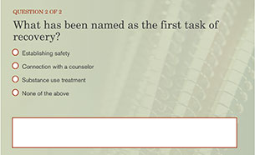
Template | Quiz
Menu Title | Enter the menu title for this page
Quiz | Code Mode Randomize Questions Randomize Answers Points Max Attempts  quiz-1 formative false true 100 2  Question Enter Question 1 Text Here  Correct Feedback Answer Options  true correct-fb Enter Answer 1 Text Here  false incorrect-fb Enter Answer 2 Text Here  false incorrect-fb Enter Answer 3 Text Here  false incorrect-fb Enter Answer 4 Text Here  ID Feedback Text  correct-fb Enter correct feedback here  incorrect-fb Enter incorrect feedback here  Question Enter Question 2 Text Here  Correct Feedback Answer Options  true correct-fb Enter Answer 1 Text Here  false incorrect-fb Enter Answer 2 Text Here  false incorrect-fb Enter Answer 3 Text Here  false incorrect-fb Enter Answer 4 Text Here  ID Feedback Text  correct-fb Enter correct feedback here  incorrect-fb Enter incorrect feedback here
Notes | These will not be included in course output

Quiz Page Title

