Layout | 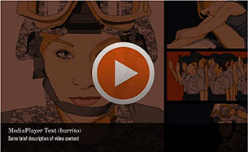
Template | M2
Menu Title | Enter the title for the page as it should appear in the menu
Media Playlist | Playlist Item  Media Path ${MEDIA_ROOT}/${CONTENT_ROOT}/video/videoName.f4v  Media Poster Path /content/shared/images/placeholders/placeholder.jpg  Media Thumbnail /content/shared/images/placeholders/placeholder.jpg  Media Menu Title Media Item Menu Title  Media Display Title Media Item Display Title  Media Description Media Item Display Subtitle  Media CC Title Media Caption Title  Media Captions Text for Caption 1 0:00 Text for Caption 2 0:00 Text for Caption 3 0:00 Text for Caption 4 0:00 Text for Caption 5 0:00  Playlist Item  Media Path ${MEDIA_ROOT}/${CONTENT_ROOT}/video/videoName.f4v  Media Poster Path /content/shared/images/placeholders/placeholder.jpg  Media Thumbnail /content/shared/images/placeholders/placeholder.jpg  Media Menu Title Media Item Menu Title  Media Display Title Media Item Display Title  Media Description Media Item Display Subtitle  Media CC Title Media Caption Title  Media Captions Text for Caption 1 0:00 Text for Caption 2 0:00 Text for Caption 3 0:00 Text for Caption 4 0:00 Text for Caption 5 0:00
Notes | These will not be included in course output

Page Title

