Layout | 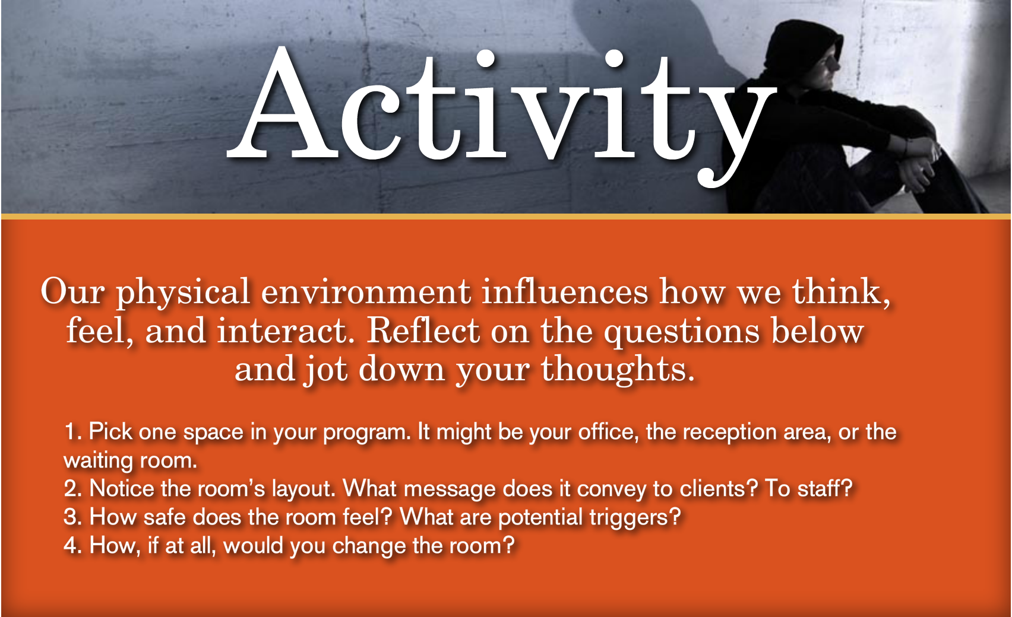
Template | C1-subhead
Menu Title | Enter the title for the page as it should appear in the menu (e.g., Welcome)
Image | /content/shared/images/placeholders/placeholder.jpg
Header | Activity
Body Text | Insert Introductory Text Here (e.g., Welcome to Trauma-Informed Care…)
Subhead | 1. Step 1  2. Step 2  3. Step 3  4. Step 4
Notes | These will not be included in course output

Page Title

