Layout | 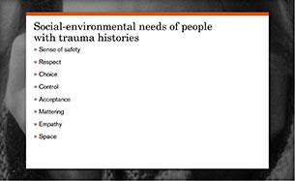
Template | B1
Menu Title | Enter the title for the page as it should appear in the menu
Image | /content/shared/images/placeholders/placeholder.jpg
Header | Insert the header text here (e.g., Hello)
Bullet Title | Insert title for bullet screen here (e.g., In this course you will learn..)
Bullets | Text for bullet 1 0:02  Text for bullet 2 0:02  Text for bullet 3 0:02  Text for bullet 4 0:02  Text for bullet 5 0:02  Text for bullet 6 0:02
Audio File | /content/shared/audio/placeholders/placeholder.mp3
Audio Title | Insert Audio CC Title here
Audio CC | - Insert Audio Caption Text Here  - And another caption here
Notes | These will not be included in course output

Page Title

