Page Title
Layout | 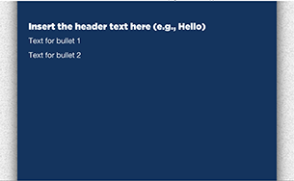
Template | B6-TB-HUD
Menu Title | Menu Title
Bullets | Bullet text 0:00  Bullet text 0:00  Bullet text 0:00  Bullet text Bullet text
Image Sequence 1 | Image Source Time Cue Audio Cue  /content/shared/images/placeholders/placeholder.jpg 0:00
Image Sequence 2 | Image Source Time Cue Audio Cue  /content/shared/images/placeholders/placeholder.jpg 0:00
Image Sequence 3 | Image Source Time Cue Audio Cue  /content/shared/images/placeholders/placeholder.jpg 0:00
Interactive Timeline | Dates Spacing  100
Audio File | /content/shared/audio/placeholders/placeholder.mp3
Audio Title
Audio CC
Notes

