Layout | 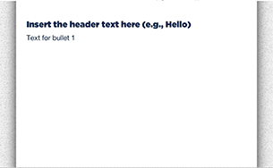
Template | B4-HUD
Menu Title | Enter the title for the page as it should appear in the menu
Header | Insert the header text here (e.g., Hello)
Image | /content/shared/images/placeholders/placeholder.jpg
Bullets | Text for bullet 1 0:02  Text for bullet 2 0:05
Audio File | /content/shared/audio/placeholders/placeholder.mp3
Audio Title | Insert Audio CC Title here
Audio CC | - Insert Audio Caption Text Here  - And another caption here
Notes | These will not be included in course output

Page Title

