Layout | 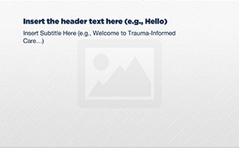
Template | A2-HUD
Menu Title | Enter the title for the page as it should appear in the menu (e.g., Welcome)
Image | /content/shared/images/placeholders/placeholder.jpg
Header | Insert the header text here (e.g., Hello)
Subtitle | Insert Subtitle Here (e.g., Welcome to Trauma-Informed Care…)
Notes | These will not be included in course output

Page Title

