Layout | 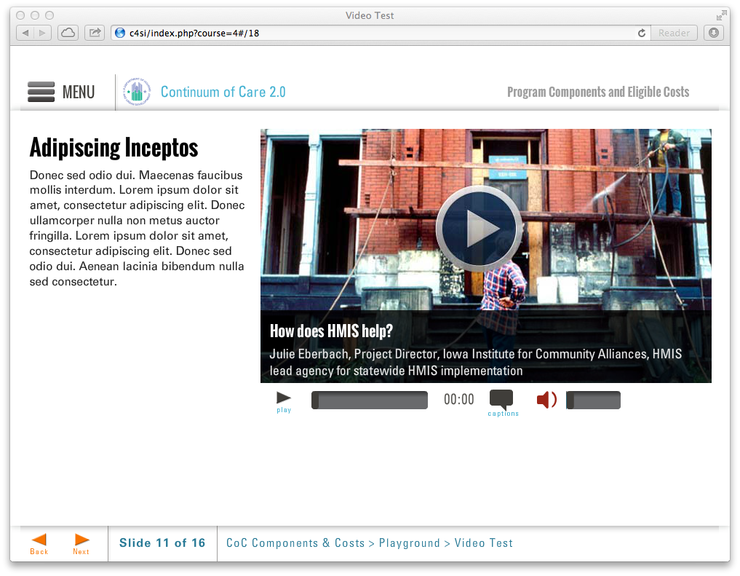
Template | V2-COC
Menu Title | Enter the title for the page as it should appear in the menu
Title | Enter text for page title here
Column1 | Enter text for column 1 here
Media Path | ${CONTENT_ROOT}/video/unitX_video2.f4v
Media Poster Path | /content/shared/images/placeholders/placeholder.jpg
Media Title | Media Player Title
Media Description | Media description subtext
Media CC Title | Media caption title
Captions | Text for caption 1 0:02  Text for caption 2 0:12  Text for caption 3 0:22  Text for caption 4 0:32  Text for caption 5 0:42  Text for caption 6 0:52
Notes | These will not be included in course output

Page Title

