Page Title
Object | Content
Layout | 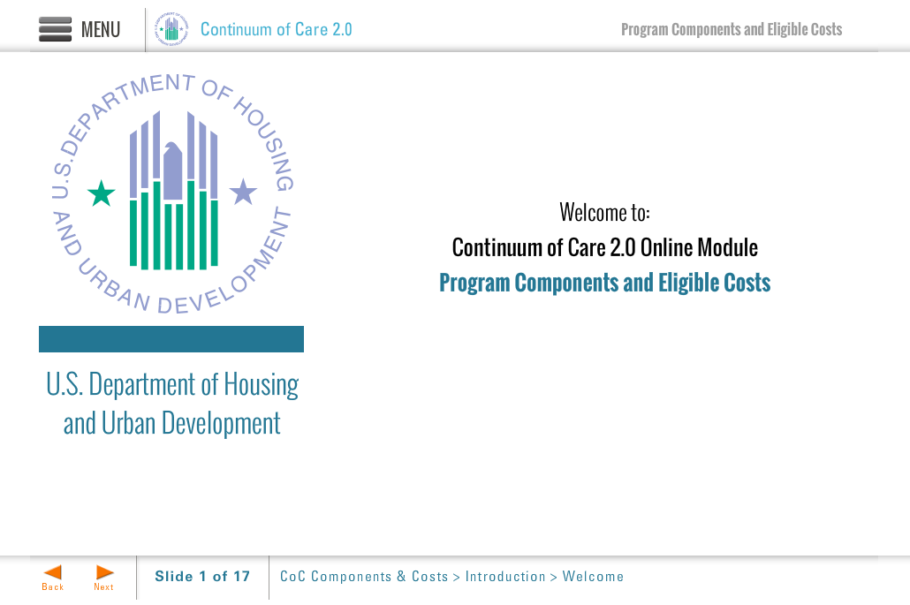
Template | Title-COC
Menu Title | Enter the title for the page as it should appear in the menu
Image | ${CONTENT_ROOT}/images/slideimages/hud-logo.png
Subtitle | U.S. Department of Housing and Urban Development
Welcome Text | Welcome to:
Header Text | Continuum of Care 2.0 Online Module
Module Title | Enter module title here
Notes | These will not be included in course output

