Object | Content
Layout | 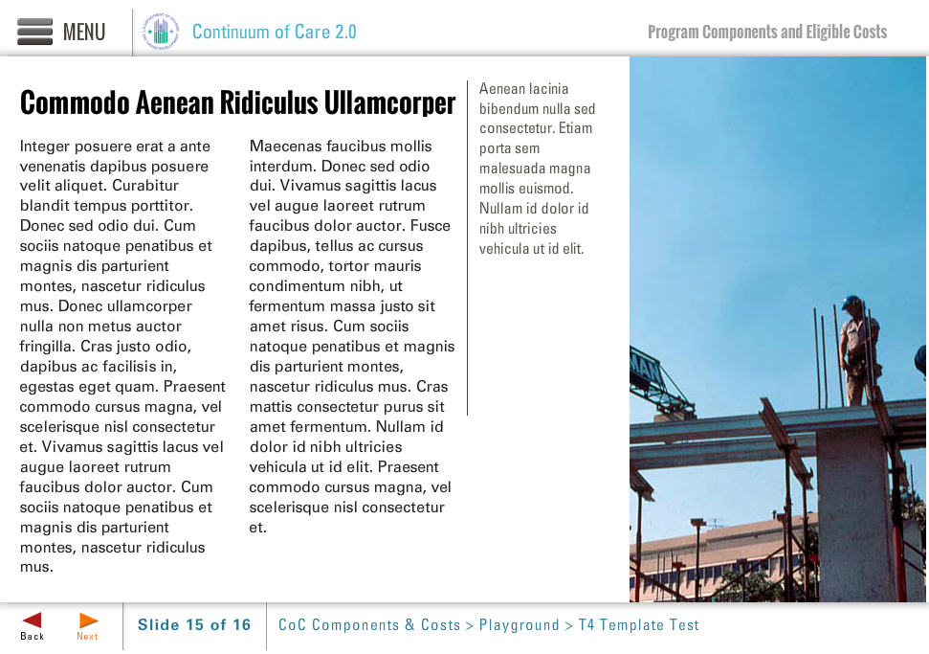
Template | T4-COC
Menu Title | Enter the title for the page as it should appear in the menu (e.g., Welcome to Trauma Informed Care)
Image | /content/shared/images/placeholders/placeholder.jpg
Title | Header Text Here
Column 1 | Column 1 text goes here
Column 2 | Column 2 text goes here
Narrow Column | Narrow column text here
Image Sequence | Image Source Time Cue Audio Cue  /content/shared/images/placeholders/placeholder.jpg 0:00
Notes

Page Title

