Page Title
Object | Content
Layout | 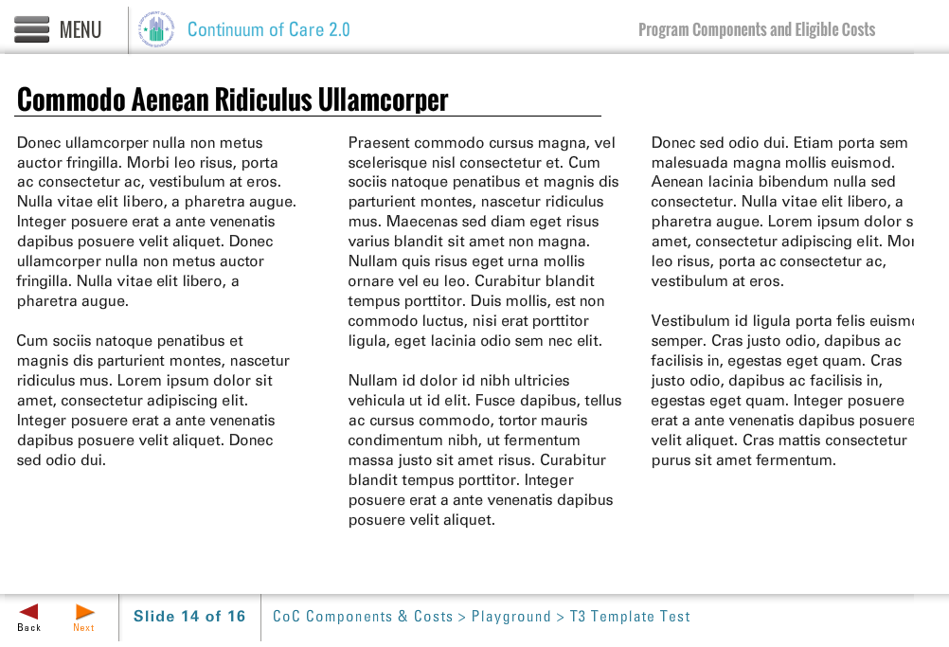
Template | T3-COC
Menu Title | Enter the title for the page as it should appear in the menu
Title | Page Title
Column 1 | Column 1 Text
Column 2 | Column 2 Text
Column 3 | Column 3 Text
Notes | These will not be included in course output

