Page Title
Object | Content
Layout | 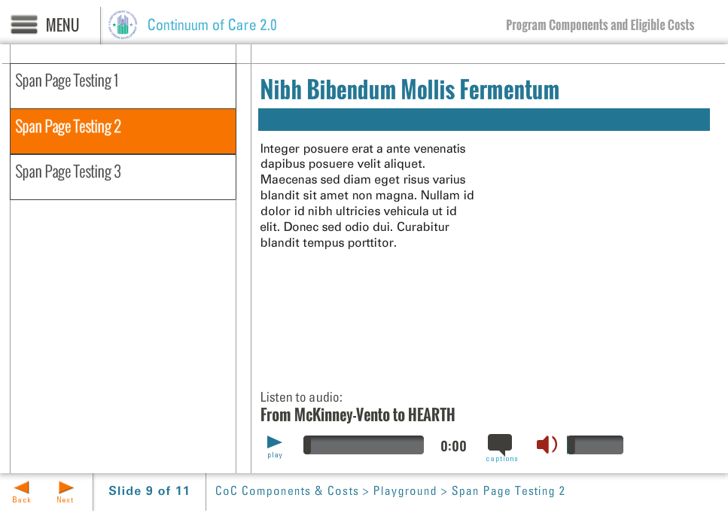
Template | S7-COC
Menu Title | Enter the title for the page as it should appear in the menu
Title | Enter the title text here as it should appear on the slide
Column 1 | Column 1 Text Here
Bullets | Text for bullet 1 0:01  Text for bullet 2 0:03  Text for bullet 3 0:05  Text for bullet 4 0:07
Audio File | /content/shared/audio/placeholders/placeholder.mp3
Audio Title | Audio Title Here
Audio CC | Audio CC Text Here
Notes | These will not be included in course output

