Page Title
Object | Content
Layout | 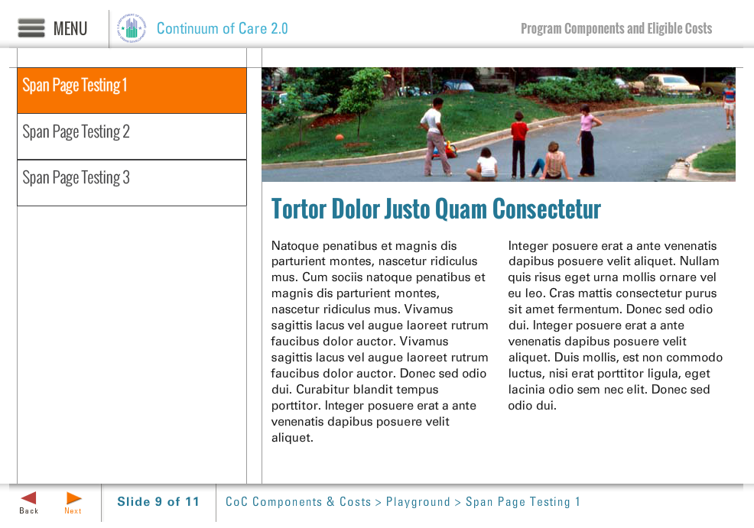
Template | S6-COC
Menu Title | Enter the title for the page as it should appear in the menu
Title | Enter the title text here as it should appear on the slide
Column 1 | Column 1 Text Here
Column 2 | Column 2 Text Here
Image | /content/shared/images/placeholders/placeholder.jpg
Image Sequence | Image Source Time Cue Audio Cue  /content/shared/images/placeholders/placeholder.jpg 0:00
Notes | These will not be included in course output

