Page Title
Object | Content
Layout | 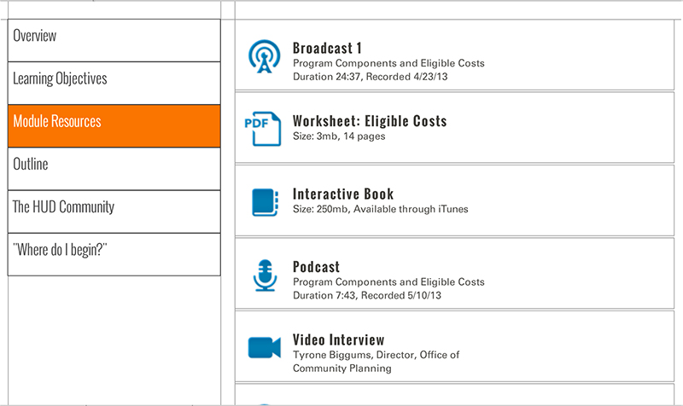
Template | S5-COC
Menu Title | Enter the title for the page as it should appear in the menu
Scrolling List | URL  Label  Icon  Metadata  URL  Label  Icon  Metadata  URL  Label  Icon  Metadata  URL  Label  Icon  Metadata  URL  Label  Icon  Metadata  URL  Label  Icon  Metadata  URL  Label  Icon  Metadata  URL  Label  Icon  Metadata
Notes | These will not be included in course output

