Page Title
Object | Content
Layout | 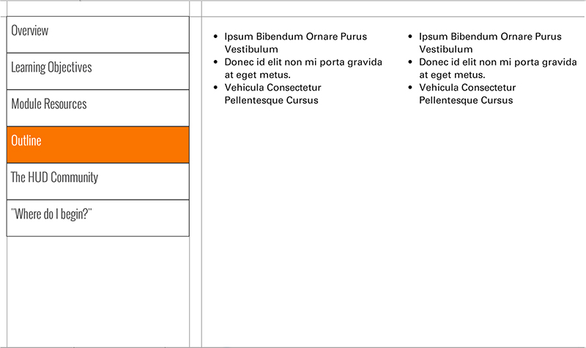
Template | S4-COC
Menu Title | Enter the title for the page as it should appear in the menu
Column 1 | Column 1 Text Here
Column 2 | Column 2 Text Here
Notes | These will not be included in course output

