Page Title
Object | Content
Layout | 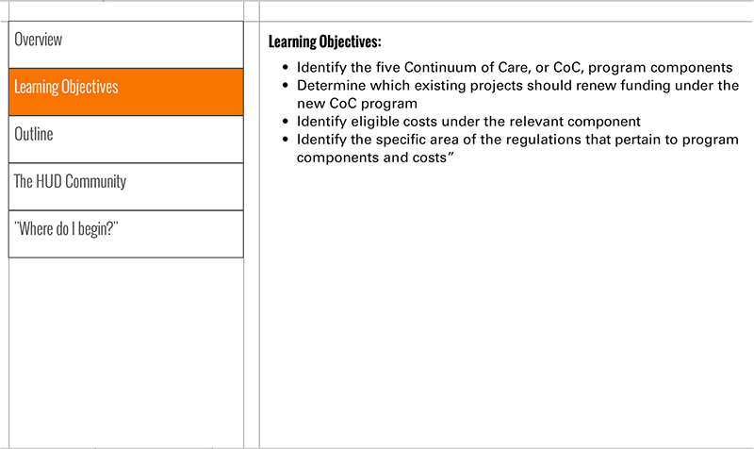
Template | S3-COC
Menu Title | Enter the title for the page as it should appear in the menu
Header | Insert the header text here
Body Text | Insert Body Text Here
Notes | These will not be included in course output

