Drag and Drop
Object | Content
Layout | 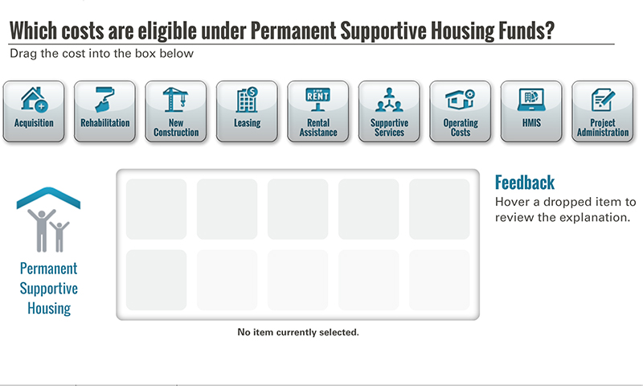
Template | D1-COC
Menu Title | Enter the title for the page as it should appear in the menu (e.g., Welcome)
Drag and Drop | Drag and Drop Static Components  Activity Title Drag and Drop Title  Activity Prompt Instruction text  Feedback Title Feedback  Default Feedback Hover a dropped item to review the explanation.  Default Status No item currently selected.  Activity Graphic /content/shared/images/placeholders/placeholder.jpg  Activity Graphic Label Graphic Label  Drag and Drop Item 1  Label Icon Label  Icon Path /content/shared/images/placeholders/placeholder.jpg  Feedback Icon Feedback  Status Icon Status (rendered below drop box)  Correct true  Drag and Drop Item 2  Label Icon Label  Icon Path /content/shared/images/placeholders/placeholder.jpg  Feedback Icon Feedback  Status Icon Status (rendered below drop box)  Correct true  Drag and Drop Item 3  Label Icon Label  Icon Path /content/shared/images/placeholders/placeholder.jpg  Feedback Icon Feedback  Status Icon Status (rendered below drop box)  Correct true  Drag and Drop Item 4  Label Icon Label  Icon Path /content/shared/images/placeholders/placeholder.jpg  Feedback Icon Feedback  Status Icon Status (rendered below drop box)  Correct true  Drag and Drop Item 5  Label Icon Label  Icon Path /content/shared/images/placeholders/placeholder.jpg  Feedback Icon Feedback  Status Icon Status (rendered below drop box)  Correct true  Drag and Drop Item 6  Label Icon Label  Icon Path /content/shared/images/placeholders/placeholder.jpg  Feedback Icon Feedback  Status Icon Status (rendered below drop box)  Correct true  Drag and Drop Item 7  Label Icon Label  Icon Path /content/shared/images/placeholders/placeholder.jpg  Feedback Icon Feedback  Status Icon Status (rendered below drop box)  Correct true  Drag and Drop Item 8  Label Icon Label  Icon Path /content/shared/images/placeholders/placeholder.jpg  Feedback Icon Feedback  Status Icon Status (rendered below drop box)  Correct true  Drag and Drop Item 9  Label Icon Label  Icon Path /content/shared/images/placeholders/placeholder.jpg  Feedback Icon Feedback  Status Icon Status (rendered below drop box)  Correct true
Notes | These will not be included in course output

