Object | Content
Layout | 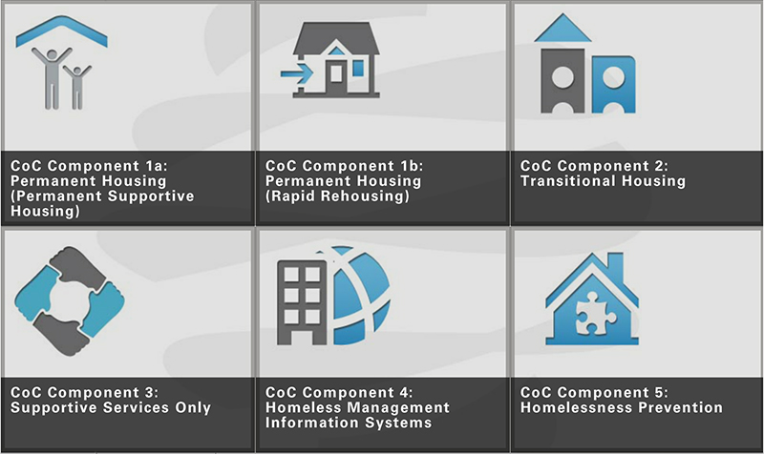
Template | CRG-COC-2x3
Menu Title | Enter the title for the page as it should appear in the menu (e.g., Welcome)
Title | Enter the title for the page as it should appear on the slide
Subtitle | Enter the subtitle, generally should be some kind of directive (ie click the buttons to view more information)
Click and Reveal | Layout Show Tooltip Columns  click-and-reveal-grid-2x3 true 3  Click and Reveal Item 1  Label Click and reveal button label  Reveal Title Click and reveal detail title  Reveal Text Click and reveal detail text  Thumbnail /content/shared/images/placeholders/placeholder.jpg  Reveal Image /content/shared/images/placeholders/placeholder.jpg  Audio File /content/shared/audio/placeholders/placeholder.mp3  Audio CC Title Audio CC Title  Audio CC Audio CC Text  Click and Reveal Item 2  Label Click and reveal button label  Reveal Title Click and reveal detail title  Reveal Text Click and reveal detail text  Thumbnail /content/shared/images/placeholders/placeholder.jpg  Reveal Image /content/shared/images/placeholders/placeholder.jpg  Audio File /content/shared/audio/placeholders/placeholder.mp3  Audio CC Title Audio CC Title  Audio CC Audio CC Text  Click and Reveal Item 4  Label Click and reveal button label  Reveal Title Click and reveal detail title  Reveal Text Click and reveal detail text  Thumbnail /content/shared/images/placeholders/placeholder.jpg  Reveal Image /content/shared/images/placeholders/placeholder.jpg  Audio File /content/shared/audio/placeholders/placeholder.mp3  Audio CC Title Audio CC Title  Audio CC Audio CC Text  Click and Reveal Item 5  Label Click and reveal button label  Reveal Title Click and reveal detail title  Reveal Text Click and reveal detail text  Thumbnail /content/shared/images/placeholders/placeholder.jpg  Reveal Image /content/shared/images/placeholders/placeholder.jpg  Audio File /content/shared/audio/placeholders/placeholder.mp3  Audio CC Title Audio CC Title  Audio CC Audio CC Text  Click and Reveal Item 1  Label Click and reveal button label  Reveal Title Click and reveal detail title  Reveal Text Click and reveal detail text  Thumbnail /content/shared/images/placeholders/placeholder.jpg  Reveal Image /content/shared/images/placeholders/placeholder.jpg  Audio File /content/shared/audio/placeholders/placeholder.mp3  Audio CC Title Audio CC Title  Audio CC Audio CC Text  Click and Reveal Item 6  Label Click and reveal button label  Reveal Title Click and reveal detail title  Reveal Text Click and reveal detail text  Thumbnail /content/shared/images/placeholders/placeholder.jpg  Reveal Image /content/shared/images/placeholders/placeholder.jpg  Audio File /content/shared/audio/placeholders/placeholder.mp3  Audio CC Title Audio CC Title  Audio CC Audio CC Text
Notes | These will not be included in course output

Click and Reveal (Grid mode)

