Object | Content
Layout | 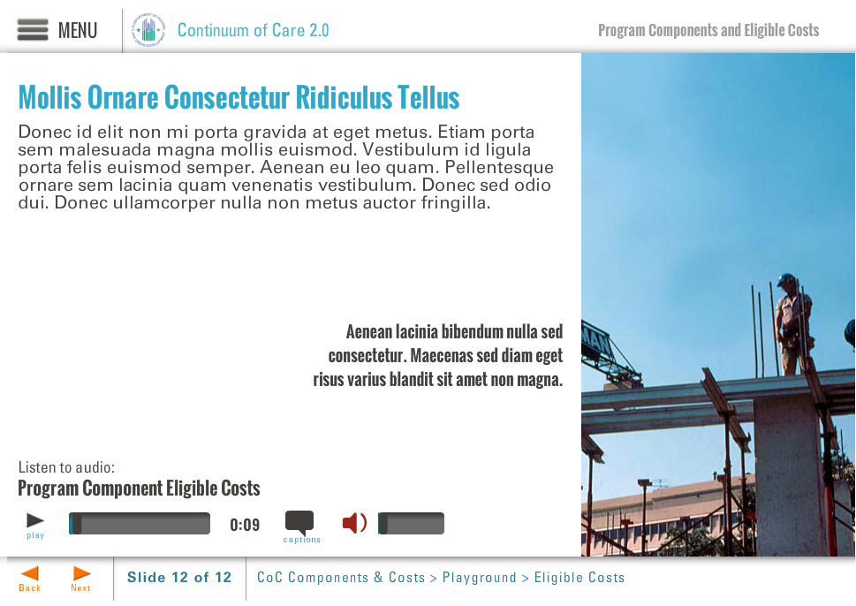
Template | B5-COC
Menu Title | Enter the title for the page as it should appear in the menu (e.g., Welcome to Trauma Informed Care)
Image | /content/shared/images/placeholders/placeholder.jpg
Header | Header Text Here
Column 1 | Body text here, appears just below the header
Bullets | Text for bullet 1 0:01  Text for bullet 2 0:03  Text for bullet 3 0:05  Text for bullet 4 0:07
Image Sequence | Image Source Time Cue Audio Cue  /content/shared/images/placeholders/placeholder.jpg 0:00
Audio File | /content/shared/audio/placeholders/placeholder.mp3
Audio Title | Audio Title Here
Audio CC | Audio CC Text Here
Notes

Page Title

