Page Title
Object | Content
Layout | 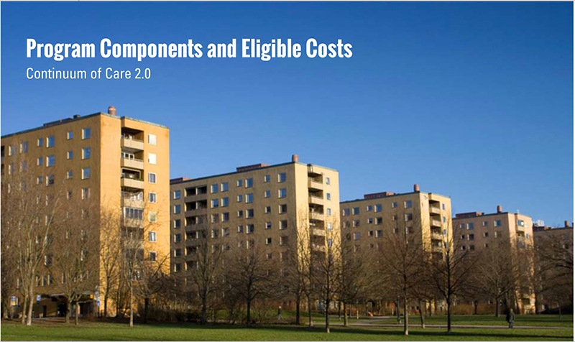
Template | B1-COC
Menu Title | Enter the title for the page as it should appear in the menu
Image | /content/shared/images/placeholders/placeholder.jpg
Header | Insert the header text here
Subtitle | Insert Subtitle Here
Notes | These will not be included in course output

