Course Title (for Word Outline Purposes Only)
Object | Content
Course Title | Course Title entered here
Language Code | en-US
Palette Id | default
Use System Fonts | false
First Page | 001
Completion Page | 001
Contents Page | 001
Module Title | Enter the module title here
Abbreviated Module Title | Enter the abbreviated module title here
Notes | These will not be included in course output

Object | Content
Unit Title | Enter unit title here
Abbreviated Title | Enter unit abbreviated title here
Notes | These will not be included in course output

Page Title
Object | Content
Layout | 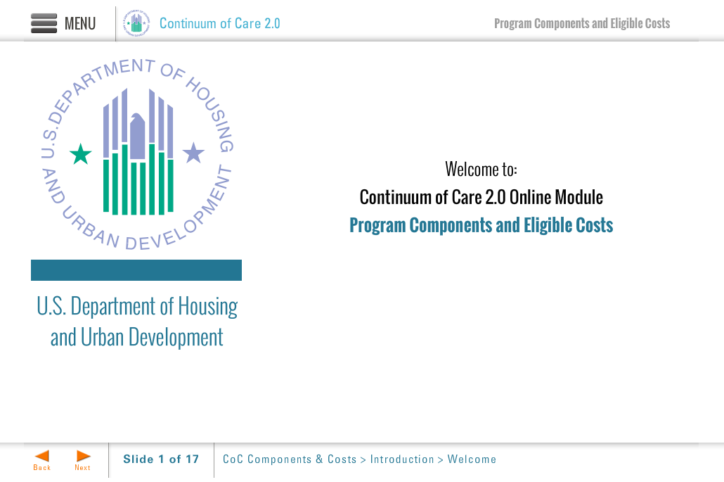
Template | Title-COC
Menu Title | Enter the title for the page as it should appear in the menu
Image | ${CONTENT_ROOT}/images/slideimages/hud-logo.png
Subtitle | U.S. Department of Housing and Urban Development
Welcome Text | Welcome to:
Header Text | Continuum of Care 2.0 Online Module
Module Title | Enter module title here
Notes | These will not be included in course output

Page Title
Object | Content
Layout | 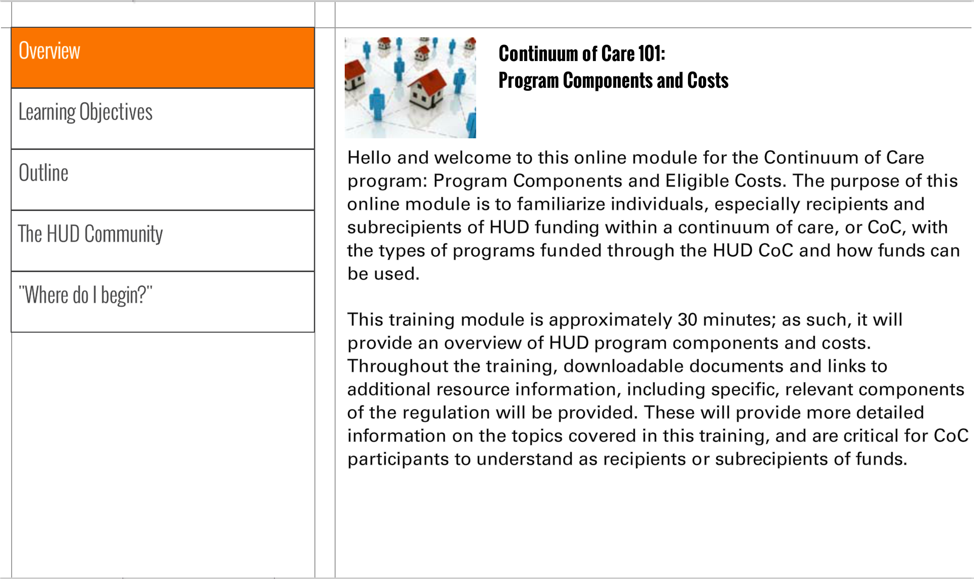
Template | S1-COC
Menu Title | Enter the title for the page as it should appear in the menu
Image | /content/shared/images/placeholders/placeholder.jpg
Header | Insert the header text here
Body Text | Insert Body Text Here
Notes | These will not be included in course output

Page Title
Object | Content
Layout | 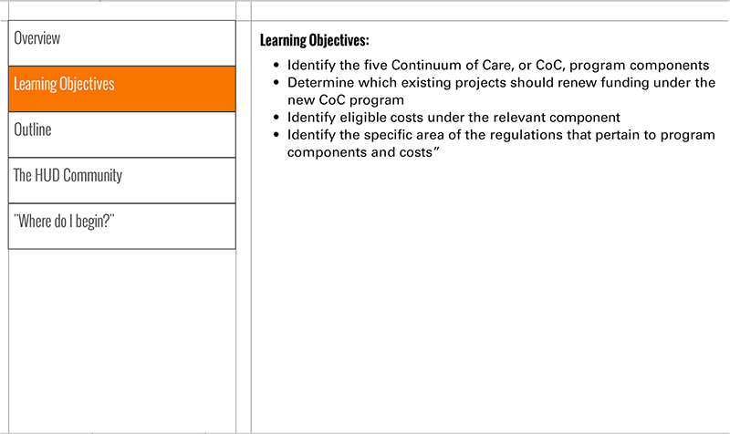
Template | S3-COC
Menu Title | Enter the title for the page as it should appear in the menu
Header | Insert the header text here
Body Text | Insert Body Text Here
Notes | These will not be included in course output

Page Title
Object | Content
Layout | 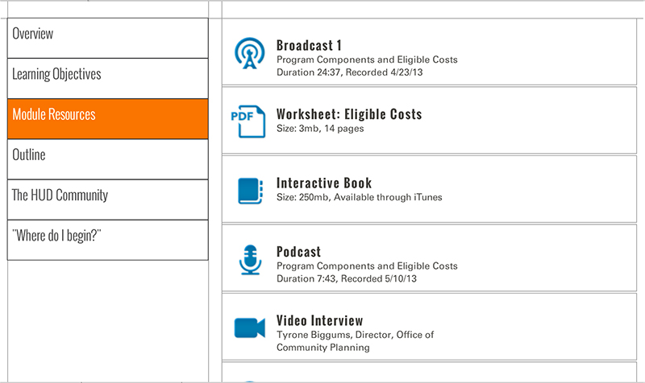
Template | S5-COC
Menu Title | Enter the title for the page as it should appear in the menu
Scrolling List | URL  Label  Icon  Metadata  URL  Label  Icon  Metadata  URL  Label  Icon  Metadata  URL  Label  Icon  Metadata  URL  Label  Icon  Metadata  URL  Label  Icon  Metadata  URL  Label  Icon  Metadata
Notes | These will not be included in course output

Page Title
Object | Content
Layout | 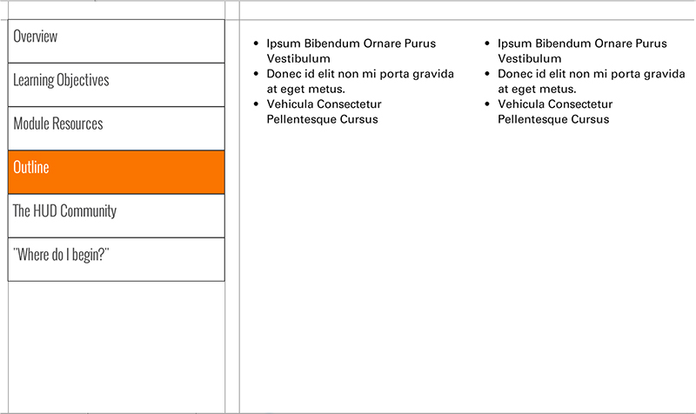
Template | S4-COC
Menu Title | Enter the title for the page as it should appear in the menu
Column 1 | Column 1 Text Here
Column 2 | Column 2 Text Here
Notes | These will not be included in course output

Page Title
Object | Content
Layout
Template | S1-COC
Menu Title | Enter the title for the page as it should appear in the menu
Image | /content/shared/images/placeholders/placeholder.jpg
Header | Insert the header text here
Body Text | Insert Body Text Here
Notes | These will not be included in course output

Object | Content
Unit Title | Enter Unit Title Here
Abbreviated Title | Enter a shortened version of the title here, if necessary
Notes | These will not be included in course output

Unit Title (for Word Outline Purposes Only)

Page Title
Object | Content
Layout | 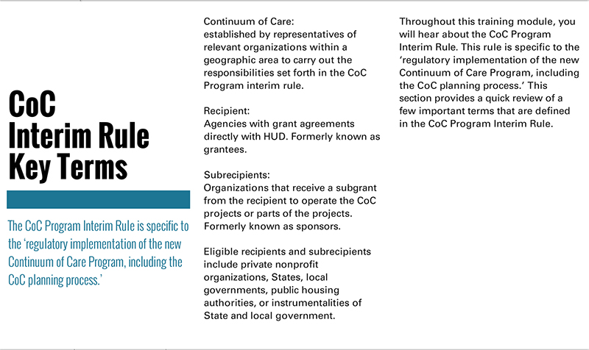
Template | T1a-COC
Menu Title | Enter the title for the page as it should appear in the menu
Title | Page Title
Subtitle | Page Subtitle
Column 1 | Column 1 Text
Column 2 | Column 2 Text
Notes | These will not be included in course output

Page Title
Object | Content
Layout | 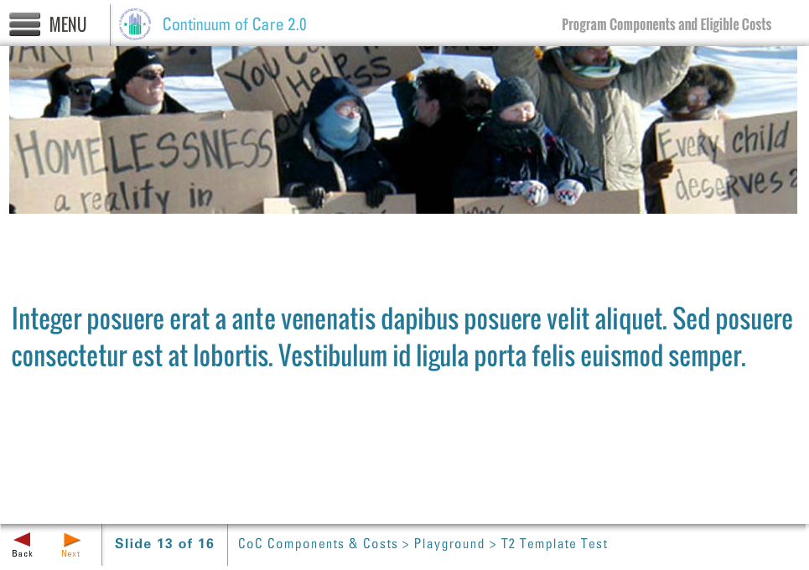
Template | T2-COC
Menu Title | Enter the title for the page as it should appear in the menu
Image | /content/shared/images/placeholders/placeholder.jpg
Title | Insert the header text here
Notes | These will not be included in course output

Page Title
Object | Content
Layout | 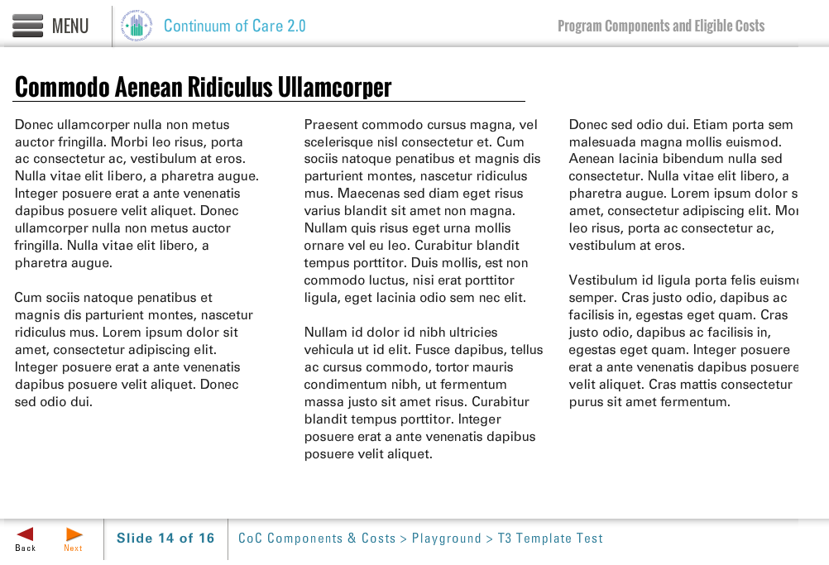
Template | T3-COC
Menu Title | Enter the title for the page as it should appear in the menu
Title | Page Title
Column 1 | Column 1 Text
Column 2 | Column 2 Text
Column 3 | Column 3 Text
Notes | These will not be included in course output

Object | Content
Layout | 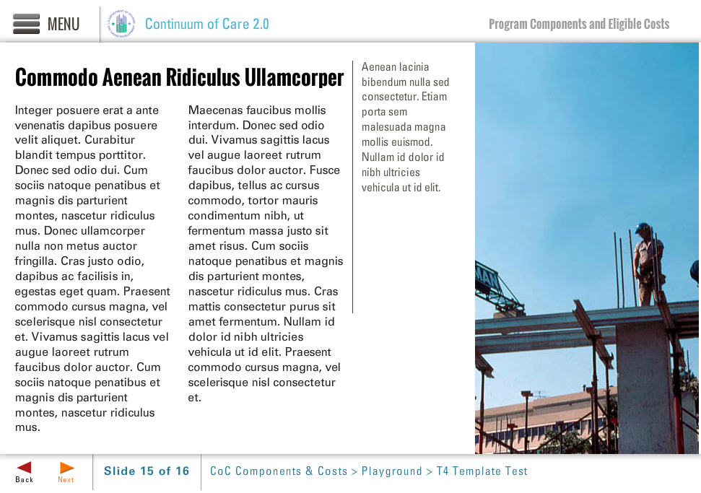
Template | T4-COC
Menu Title | Enter the title for the page as it should appear in the menu (e.g., Welcome to Trauma Informed Care)
Image | /content/shared/images/placeholders/placeholder.jpg
Title | Header Text Here
Column 1 | Column 1 text goes here
Column 2 | Column 2 text goes here
Narrow Column | Narrow column text here
Image Sequence | Image Source Time Cue Audio Cue  /content/shared/images/placeholders/placeholder.jpg 0:00
Notes

Page Title

Object | Content
Layout | 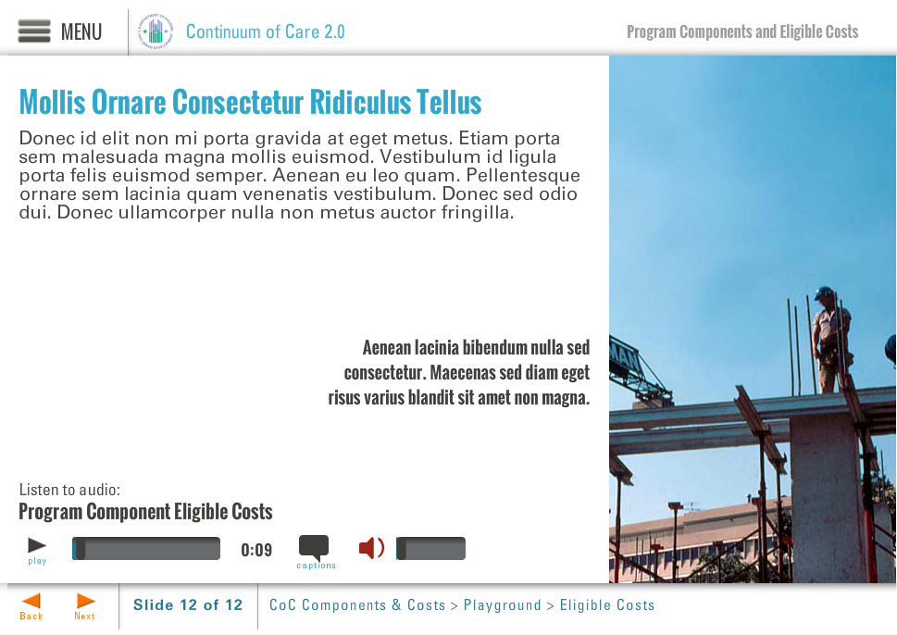
Template | B5-COC
Menu Title | Enter the title for the page as it should appear in the menu (e.g., Welcome to Trauma Informed Care)
Image | /content/shared/images/placeholders/placeholder.jpg
Header | Header Text Here
Column 1 | Body text here, appears just below the header
Bullets | Text for bullet 1 0:01  Text for bullet 2 0:03  Text for bullet 3 0:05  Text for bullet 4 0:07
Image Sequence | Image Source Time Cue Audio Cue  /content/shared/images/placeholders/placeholder.jpg 0:00
Audio File | /content/shared/audio/placeholders/placeholder.mp3
Audio Title | Audio Title Here
Audio CC | Audio CC Text Here
Notes

Page Title

Object | Content
Layout | 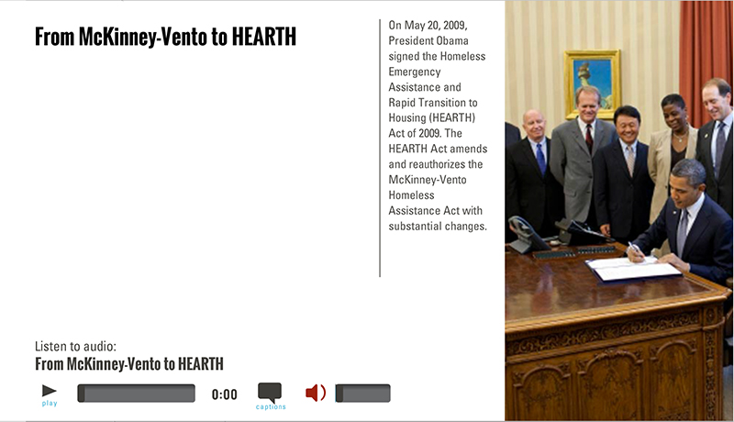
Template | A2-COC
Menu Title | Enter the title for the page as it should appear in the menu (e.g., Welcome to Trauma Informed Care)
Image | /content/shared/images/placeholders/placeholder.jpg
Header | Header Text Here
Column Text | Narrow column text here
Image Sequence | Image Source Time Cue Audio Cue  /content/shared/images/placeholders/placeholder.jpg 0:00
Bullets | Text for bullet 1 0:01  Text for bullet 2 0:03  Text for bullet 3 0:05  Text for bullet 4 0:07
Audio File | /content/shared/audio/placeholders/placeholder.mp3
Audio Title | Audio Title Here
Audio CC | Audio CC Text Here
Notes

Page Title

Object | Content
Layout | 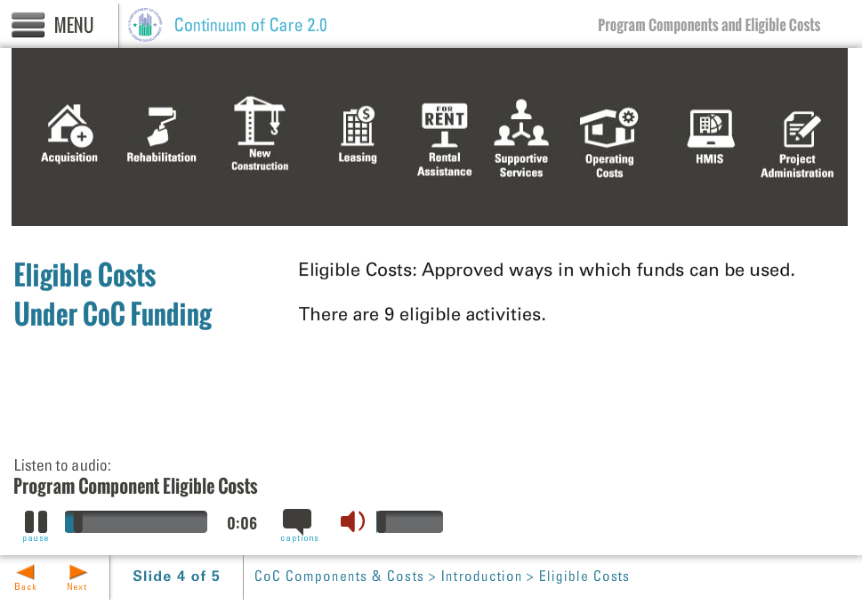
Template | A3-COC
Menu Title | Enter the title for the page as it should appear in the menu (e.g., Welcome to Trauma Informed Care)
Image | /content/shared/images/placeholders/placeholder.jpg
Header | Header Text Here
Bullets | Text for bullet 1 0:01  Text for bullet 2 0:03  Text for bullet 3 0:05  Text for bullet 4 0:07
Image Sequence | Image Source Time Cue Audio Cue  /content/shared/images/placeholders/placeholder.jpg 0:00
Audio File | /content/shared/audio/placeholders/placeholder.mp3
Audio Title | Audio Title Here
Audio CC | Audio CC Text Here
Notes

Page Title

Layout | 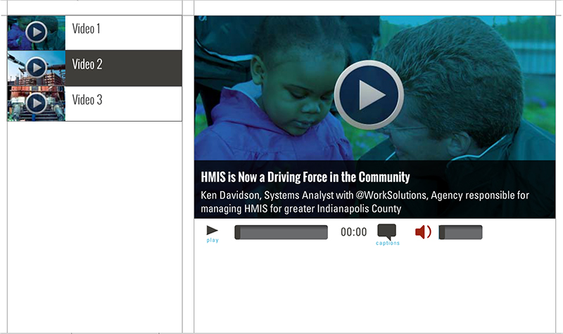
Template | V1-COC
Menu Title | Enter the title for the page as it should appear in the menu
Media Playlist | Playlist Item  Media Path ${MEDIA_ROOT}/${CONTENT_ROOT}/video/videoName.f4v  Media Poster Path /content/shared/images/placeholders/placeholder.jpg  Media Thumbnail /content/shared/images/placeholders/placeholder.jpg  Media Menu Title Media Item Menu Title  Media Display Title Media Item Display Title  Media Description Media Item Display Subtitle  Media CC Title Media Caption Title  Media Captions Text for Caption 1 0:00 Text for Caption 2 0:00 Text for Caption 3 0:00 Text for Caption 4 0:00 Text for Caption 5 0:00  Playlist Item  Media Path ${MEDIA_ROOT}/${CONTENT_ROOT}/video/videoName.f4v  Media Poster Path /content/shared/images/placeholders/placeholder.jpg  Media Thumbnail /content/shared/images/placeholders/placeholder.jpg  Media Menu Title Media Item Menu Title  Media Display Title Media Item Display Title  Media Description Media Item Display Subtitle  Media CC Title Media Caption Title  Media Captions Text for Caption 1 0:00 Text for Caption 2 0:00 Text for Caption 3 0:00 Text for Caption 4 0:00 Text for Caption 5 0:00
Notes | These will not be included in course output

Page Title

Layout | 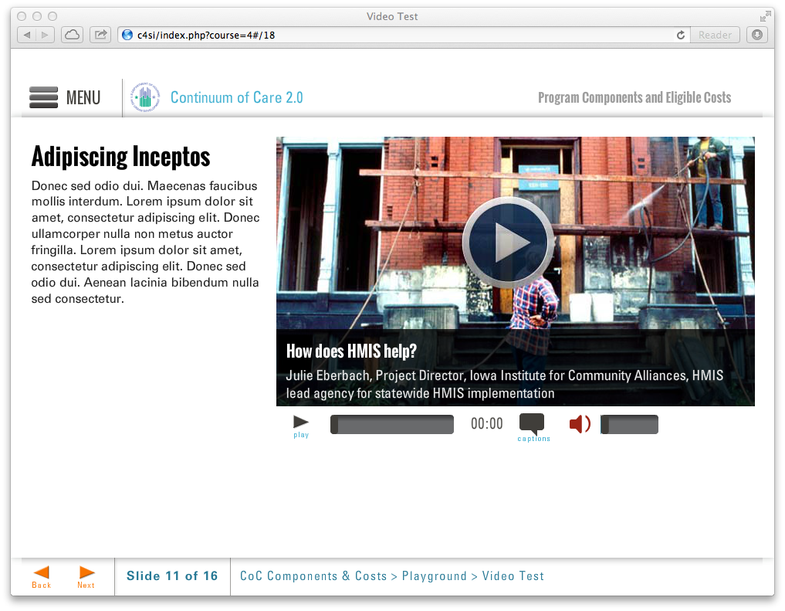
Template | V2-COC
Menu Title | Enter the title for the page as it should appear in the menu
Title | Enter text for page title here
Column1 | Enter text for column 1 here
Media Path | ${CONTENT_ROOT}/video/unitX_video2.f4v
Media Poster Path | /content/shared/images/placeholders/placeholder.jpg
Media Title | Media Player Title
Media Description | Media description subtext
Media CC Title | Media caption title
Captions | Text for caption 1 0:02  Text for caption 2 0:12  Text for caption 3 0:22  Text for caption 4 0:32  Text for caption 5 0:42  Text for caption 6 0:52
Notes | These will not be included in course output

Page Title

Object | Content
Layout | 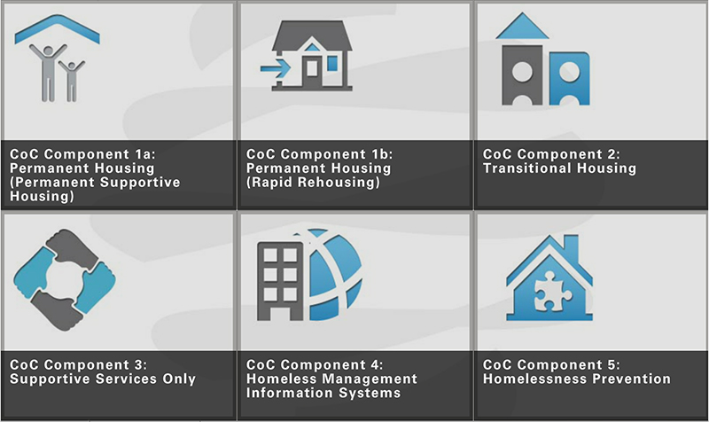
Template | CRG-COC-2x3
Menu Title | Enter the title for the page as it should appear in the menu (e.g., Welcome)
Click and Reveal | Layout Show Tooltip Columns  click-and-reveal-grid-2x3 true 3  Click and Reveal Item 1  Label Click and reveal button label  Reveal Title Click and reveal detail title  Reveal Text Click and reveal detail text  Thumbnail /content/shared/images/placeholders/placeholder.jpg  Reveal Image /content/shared/images/placeholders/placeholder.jpg  Audio File /content/shared/audio/placeholders/placeholder.mp3  Audio CC Title Audio CC Title  Audio CC Audio CC Text  Click and Reveal Item 2  Label Click and reveal button label  Reveal Title Click and reveal detail title  Reveal Text Click and reveal detail text  Thumbnail /content/shared/images/placeholders/placeholder.jpg  Reveal Image /content/shared/images/placeholders/placeholder.jpg  Audio File /content/shared/audio/placeholders/placeholder.mp3  Audio CC Title Audio CC Title  Audio CC Audio CC Text  Click and Reveal Item 4  Label Click and reveal button label  Reveal Title Click and reveal detail title  Reveal Text Click and reveal detail text  Thumbnail /content/shared/images/placeholders/placeholder.jpg  Reveal Image /content/shared/images/placeholders/placeholder.jpg  Audio File /content/shared/audio/placeholders/placeholder.mp3  Audio CC Title Audio CC Title  Audio CC Audio CC Text  Click and Reveal Item 5  Label Click and reveal button label  Reveal Title Click and reveal detail title  Reveal Text Click and reveal detail text  Thumbnail /content/shared/images/placeholders/placeholder.jpg  Reveal Image /content/shared/images/placeholders/placeholder.jpg  Audio File /content/shared/audio/placeholders/placeholder.mp3  Audio CC Title Audio CC Title  Audio CC Audio CC Text  Click and Reveal Item 1  Label Click and reveal button label  Reveal Title Click and reveal detail title  Reveal Text Click and reveal detail text  Thumbnail /content/shared/images/placeholders/placeholder.jpg  Reveal Image /content/shared/images/placeholders/placeholder.jpg  Audio File /content/shared/audio/placeholders/placeholder.mp3  Audio CC Title Audio CC Title  Audio CC Audio CC Text  Click and Reveal Item 6  Label Click and reveal button label  Reveal Title Click and reveal detail title  Reveal Text Click and reveal detail text  Thumbnail /content/shared/images/placeholders/placeholder.jpg  Reveal Image /content/shared/images/placeholders/placeholder.jpg  Audio File /content/shared/audio/placeholders/placeholder.mp3  Audio CC Title Audio CC Title  Audio CC Audio CC Text
Notes | These will not be included in course output

Click and Reveal (Grid mode)

Drag and Drop
Object | Content
Layout | 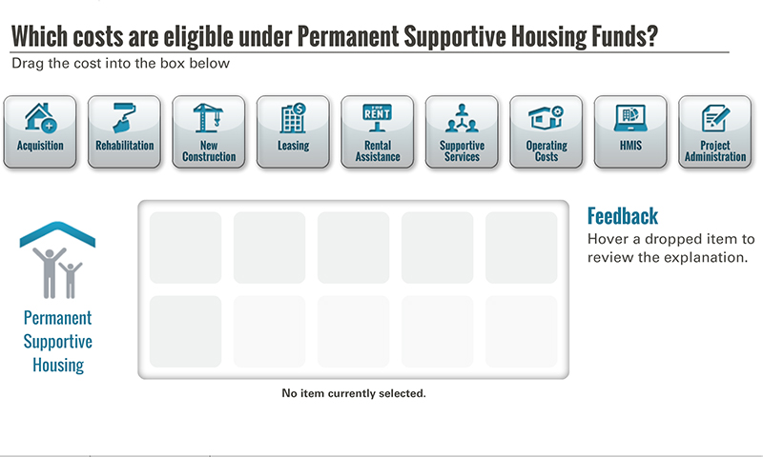
Template | D1-COC
Menu Title | Enter the title for the page as it should appear in the menu (e.g., Welcome)
Drag and Drop | Drag and Drop Static Components  Activity Title Drag and Drop Title  Activity Prompt Instruction text  Feedback Title Feedback  Default Feedback Hover a dropped item to review the explanation.  Default Status No item currently selected.  Activity Graphic /content/shared/images/placeholders/placeholder.jpg  Activity Graphic Label Graphic Label  Drag and Drop Item 1  Label Icon Label  Icon Path /content/shared/images/placeholders/placeholder.jpg  Feedback Icon Feedback  Status Icon Status (rendered below drop box)  Correct true  Drag and Drop Item 2  Label Icon Label  Icon Path /content/shared/images/placeholders/placeholder.jpg  Feedback Icon Feedback  Status Icon Status (rendered below drop box)  Correct true  Drag and Drop Item 3  Label Icon Label  Icon Path /content/shared/images/placeholders/placeholder.jpg  Feedback Icon Feedback  Status Icon Status (rendered below drop box)  Correct true  Drag and Drop Item 4  Label Icon Label  Icon Path /content/shared/images/placeholders/placeholder.jpg  Feedback Icon Feedback  Status Icon Status (rendered below drop box)  Correct true  Drag and Drop Item 5  Label Icon Label  Icon Path /content/shared/images/placeholders/placeholder.jpg  Feedback Icon Feedback  Status Icon Status (rendered below drop box)  Correct true  Drag and Drop Item 6  Label Icon Label  Icon Path /content/shared/images/placeholders/placeholder.jpg  Feedback Icon Feedback  Status Icon Status (rendered below drop box)  Correct true  Drag and Drop Item 7  Label Icon Label  Icon Path /content/shared/images/placeholders/placeholder.jpg  Feedback Icon Feedback  Status Icon Status (rendered below drop box)  Correct true  Drag and Drop Item 8  Label Icon Label  Icon Path /content/shared/images/placeholders/placeholder.jpg  Feedback Icon Feedback  Status Icon Status (rendered below drop box)  Correct true  Drag and Drop Item 9  Label Icon Label  Icon Path /content/shared/images/placeholders/placeholder.jpg  Feedback Icon Feedback  Status Icon Status (rendered below drop box)  Correct true
Notes | These will not be included in course output

Object | Content
Layout | 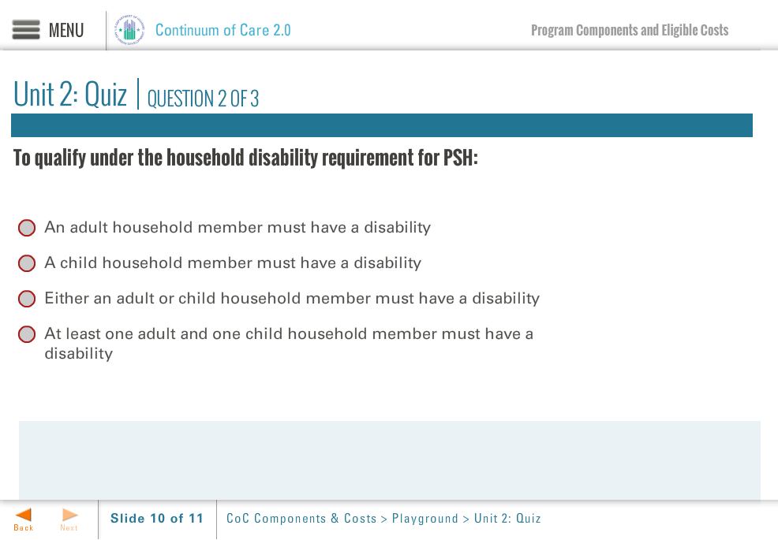
Template | Q1-COC
Menu Title | Enter the menu title for this page
Title | Unit #: Quiz
Quiz | Code Mode Randomize Questions Randomize Answers Points Max Attempts  quiz-1 formative false true 100 2  Question Enter Question 1 Text Here  Correct Feedback Answer Options  true correct-fb Enter Answer 1 Text Here  false incorrect-fb Enter Answer 2 Text Here  false incorrect-fb Enter Answer 3 Text Here  false incorrect-fb Enter Answer 4 Text Here  ID Feedback Text  correct-fb Enter correct feedback here  incorrect-fb Enter incorrect feedback here  Question Enter Question 2 Text Here  Correct Feedback Answer Options  true correct-fb Enter Answer 1 Text Here  false incorrect-fb Enter Answer 2 Text Here  false incorrect-fb Enter Answer 3 Text Here  false incorrect-fb Enter Answer 4 Text Here  ID Feedback Text  correct-fb Enter correct feedback here  incorrect-fb Enter incorrect feedback here
Notes | These will not be included in course output

Quiz Page Title

Object | Content
Unit Title | Enter Unit Title Here
Abbreviated Title | Enter a shortened version of the title here, if necessary
Notes | These will not be included in course output

Unit Title (for Word Outline Purposes Only)

Page Title
Object | Content
Layout | 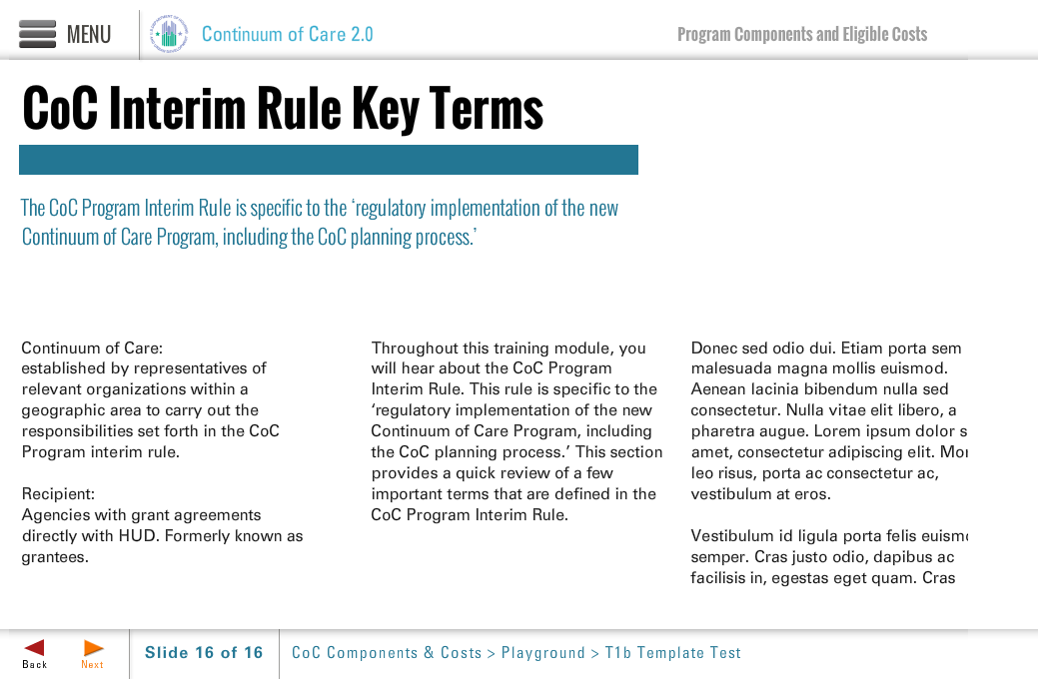
Template | T1b-COC
Menu Title | Enter the title for the page as it should appear in the menu
Title | Page Title
Subtitle | Page Subtitle
Column 1 | Column 1 Text
Column 2 | Column 2 Text
Column 3 | Column 3 Text
Notes | These will not be included in course output

Page Title
Object | Content
Layout | 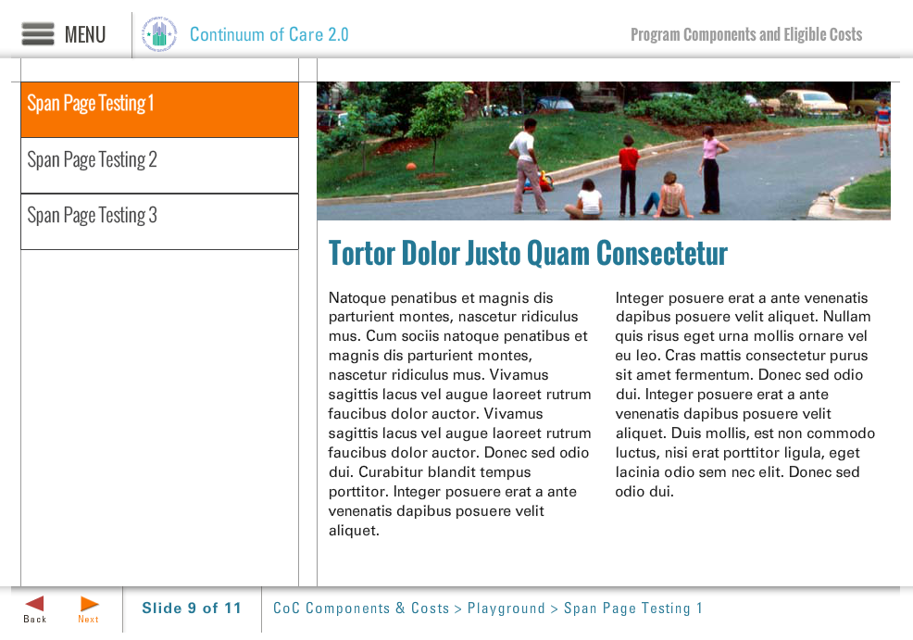
Template | S6-COC
Menu Title | Enter the title for the page as it should appear in the menu
Title | Enter the title text here as it should appear on the slide
Column 1 | Column 1 Text Here
Column 2 | Column 2 Text Here
Image | /content/shared/images/placeholders/placeholder.jpg
Image Sequence | Image Source Time Cue Audio Cue  /content/shared/images/placeholders/placeholder.jpg 0:00
Notes | These will not be included in course output

Page Title
Object | Content
Layout | 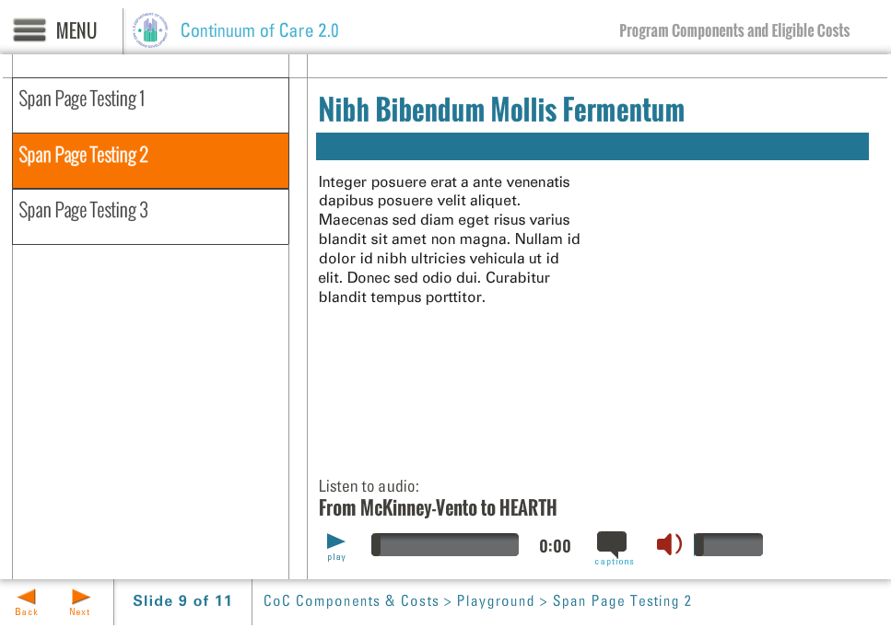
Template | S7-COC
Menu Title | Enter the title for the page as it should appear in the menu
Title | Enter the title text here as it should appear on the slide
Column 1 | Column 1 Text Here
Bullets | Text for bullet 1 0:01  Text for bullet 2 0:03  Text for bullet 3 0:05  Text for bullet 4 0:07
Audio File | /content/shared/audio/placeholders/placeholder.mp3
Audio Title | Audio Title Here
Audio CC | Audio CC Text Here
Notes | These will not be included in course output

Layout | 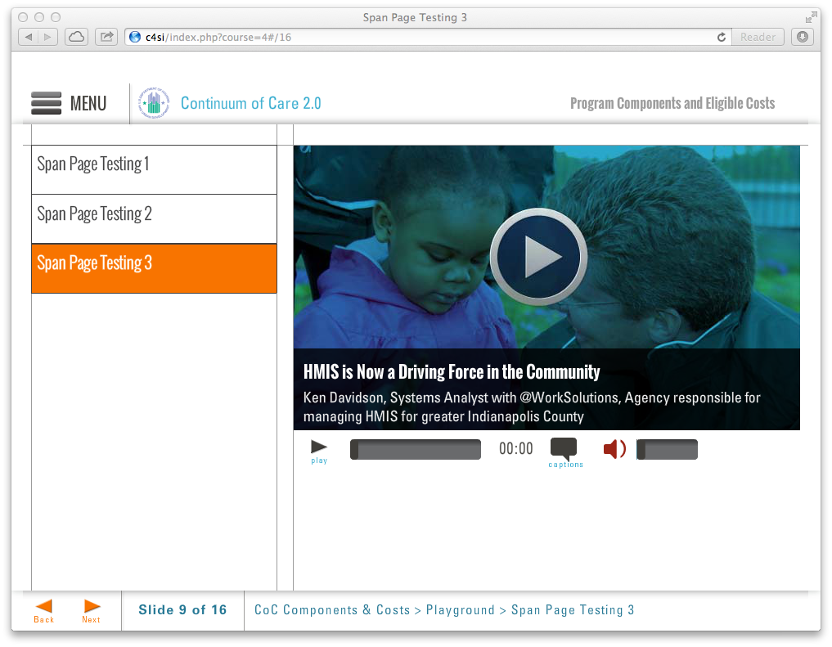
Template | S8-COC
Menu Title | Enter the title for the page as it should appear in the menu
Media Path | ${CONTENT_ROOT}/video/unitX_video2.f4v
Media Poster Path | /content/shared/images/placeholders/placeholder.jpg
Media Title | Media Player Title
Media Description | Media description subtext
Media CC Title | Media caption title
Captions | Text for caption 1 0:02  Text for caption 2 0:12  Text for caption 3 0:22  Text for caption 4 0:32  Text for caption 5 0:42  Text for caption 6 0:52
Notes | These will not be included in course output

Page Title

