Module 2 Unit 1
Object | Content
Course Title | CoC Program: Grant Administration and Program Requirements
Language Code | en-US
Palette Id | coc
Use System Fonts | false
First Page | 001
Completion Page | 001
Contents Page | 001
Module Title | CoC Program: Grant Administration and Program Requirements
Abbreviated Module Title | Grant Admin
Notes | These will not be included in course output

Object | Content
Unit Title | Unit 1: Intro
Abbreviated Title | Unit 1: Intro
Notes | These will not be included in course output

Page Title
Object | Content
Layout | 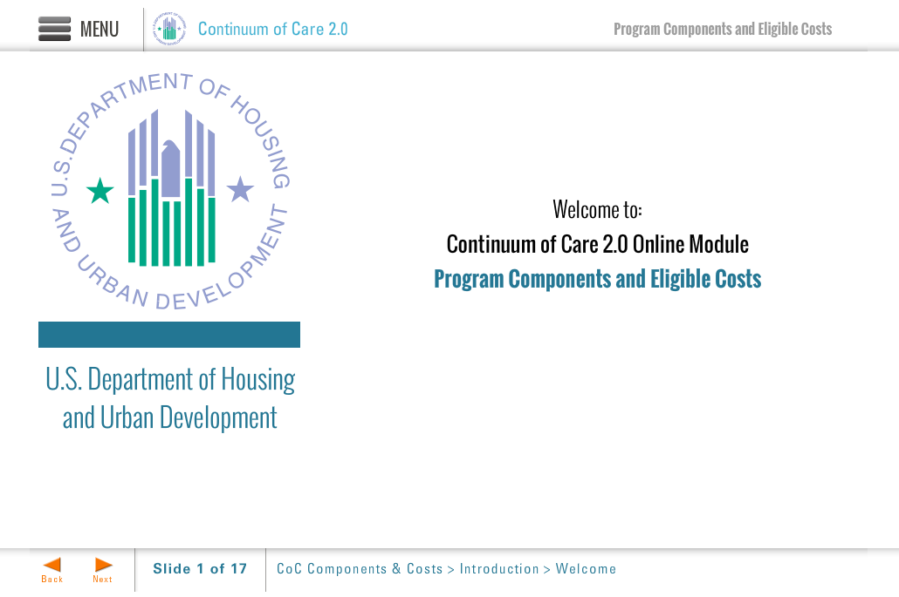
Template | Title-COC
Menu Title | Title Page
Image | ${CONTENT_ROOT}/images/slideimages/hud-logo.png
Subtitle | U.S. Department of Housing and Urban Development
Welcome Text | Welcome to:
Header Text | Continuum of Care Program 2.0 Online Module
Module Title | CoC Program: Grant and Project Administration Requirements
Notes | These will not be included in course output

Page Title
Object | Content
Layout | 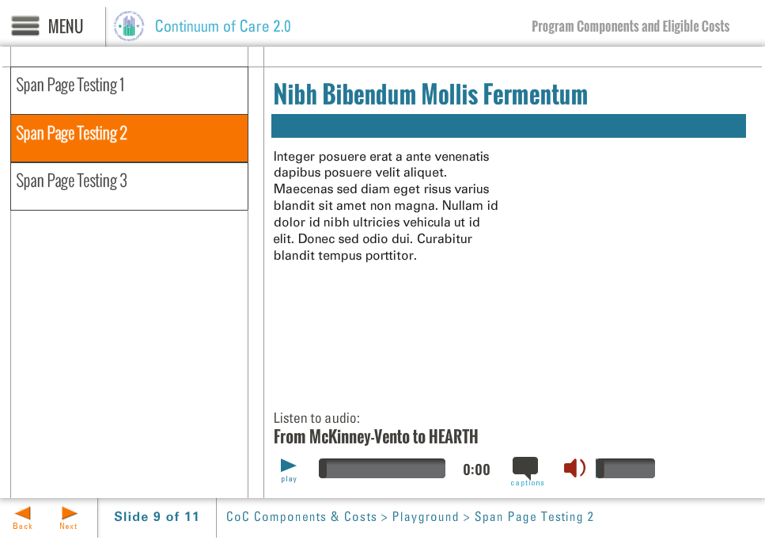
Template | S7-COC
Menu Title | Introduction
Title | CoC Program: Grant and Project Administration Requirements
Column 1 | This online training will provide an overview of the CoC Program requirements related to grant and project administration. The OneCPD website, http://www.onecpd.info, provides detailed information on HUD regulations specific to the CoC Program.
Bullets | This training module takes approximately 30 minutes to complete. 0:33  There may be additional eligibility and documentation requirements that are specific to your project 0:40
Audio File | ${CONTENT_ROOT}/audio/mod2_audio1.mp3
Audio Title | Hello and Welcome
Audio CC | Hello and welcome to this online module on the Continuum of Care Program: Grant and Project Administration Requirements. This online training will provide an overview of requirements related to grant management for recipients and subrecipients of CoC Program funding, and will specifically cover topics such as the responsibilities of the recipient in relation to project operation, recordkeeping, and monitoring. Remember that there may be additional eligibility and documentation requirements that are specific to your project. This training module takes approximately 30 minutes to complete; as such, it will provide only an overview of the relevant requirements. The OneCPD website, www.onecpd.info, provides detailed information on HUD regulations specific to the CoC program.
Notes | These will not be included in course output

Page Title
Object | Content
Layout | 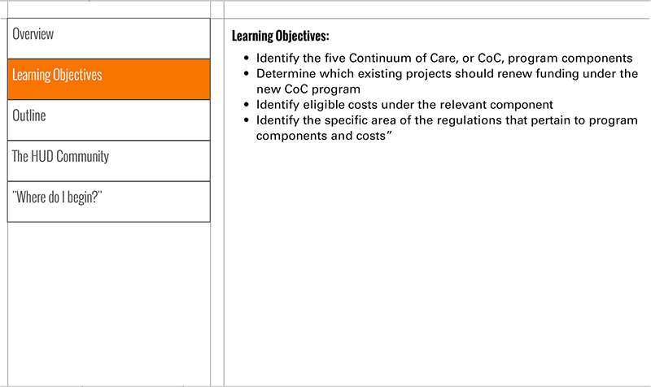
Template | S3-COC
Menu Title | Learning Objectives
Header | Learning Objectives
Body Text | - Identify and understand the role and responsibilities of a recipient of CoC Program funding  - Describe the purpose of record keeping and the types of records that should be collected and stored related to organizational policies, project-level activities, and assistance provided to program participants  - Understand the purpose and expectations for monitoring
Notes | These will not be included in course output

Page Title
Object | Content
Layout | 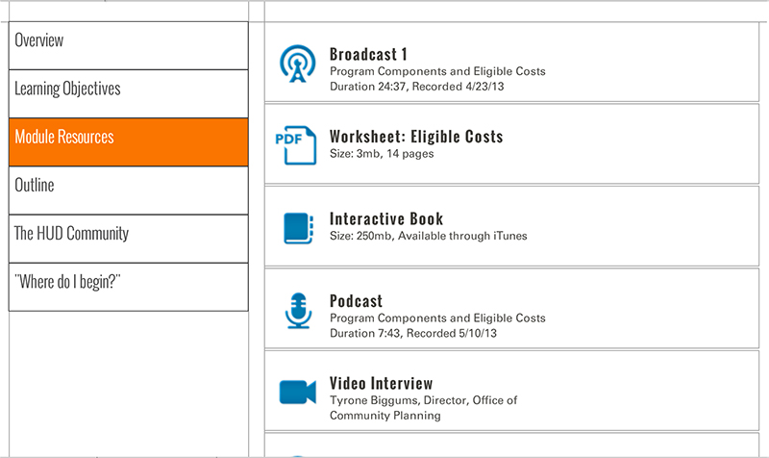
Template | S5-COC
Menu Title | Module Resources
Scrolling List | URL http://www.onecpd.info  Label OneCPD Website  Icon ${CONTENT_ROOT}/images/interactives/icons/weblink.png  Metadata OneCPD Resource Exchange  URL http://www.onecpd.info/resource/2033/hearth-coc-program-interim-rule/  Label CoC Program Interim Rule  Icon ${CONTENT_ROOT}/images/interactives/icons/weblink.png  Metadata Date Published: July 2012  URL http://www.onecpd.info/resource/2946/coc-program-grants-administration-user-guide/  Label Grants Administration User Guide  Icon ${CONTENT_ROOT}/images/interactives/icons/weblink.png  Metadata Date Published: April 2013  URL  Label  Icon  Metadata  URL  Label  Icon  Metadata
Notes | These will not be included in course output

Page Title
Object | Content
Layout | 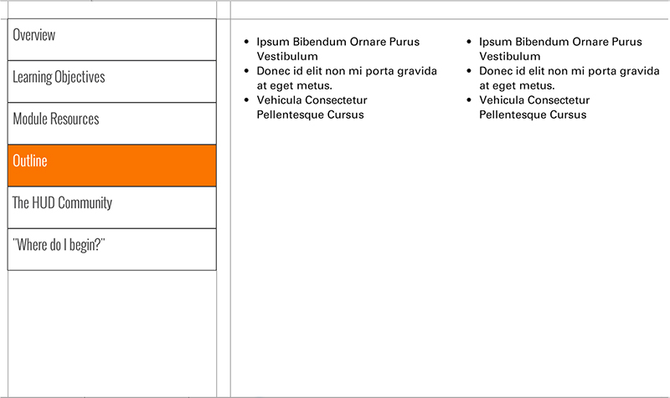
Template | S4-COC
Menu Title | Outline
Column 1 | Unit 1: Introduction  Unit 2: The Role and Responsibilities of the CoC Program Recipient  Overview  Compliance with Standards  Subrecipient Oversight  Operating the Projects in accordance with CoC Policies  Reporting and Monitoring  Quiz: Responsibilities of the Recipient  Grant or Project Changes  Video: Minor or Significant Project Changes  Minor Project Changes  Significant Projects Changes  Quiz: Project Changes  Unit 3: Organizational Requirements and Recordkeeping  Overview  Conflict of Interest Requirements  Conflict of Interest Policy  Quiz: Conflict of Interest  Homeless Consumer Participation  Faith-Based Activities  Faith-Based Activities: Limitations  Fair Housing and Equal Opportunity  Other Federal Requirements
Column 2 | Unit 4: Grant-specific Requirements and Recordkeeping  Overview  Housing Standards  Services Provided  Match Documentation  Additional Requirements  Unit 5: Program Participant Eligibility and Recordkeeping Requirements  Overview  Homeless, Disability, and Income  Rent or Occupancy Charge  Service Provision  Terminations of Assistance  Due Process  Termination of Assistance vs. Eviction  Unit 6: Reporting and Monitoring  Benefits of Reporting  Reporting Overview  Monitoring Overview  Who Monitors Whom?  HUD Monitoring of Recipients  Findings After a HUD Monitoring Visit  Non Compliance: Remedial Actions  Non-Compliance: Sanctions  Recipient Monitoring of Subrecipients  CoC Monitoring of Recipients and Subrecipients
Notes | These will not be included in course output

Page Title
Object | Content
Layout | 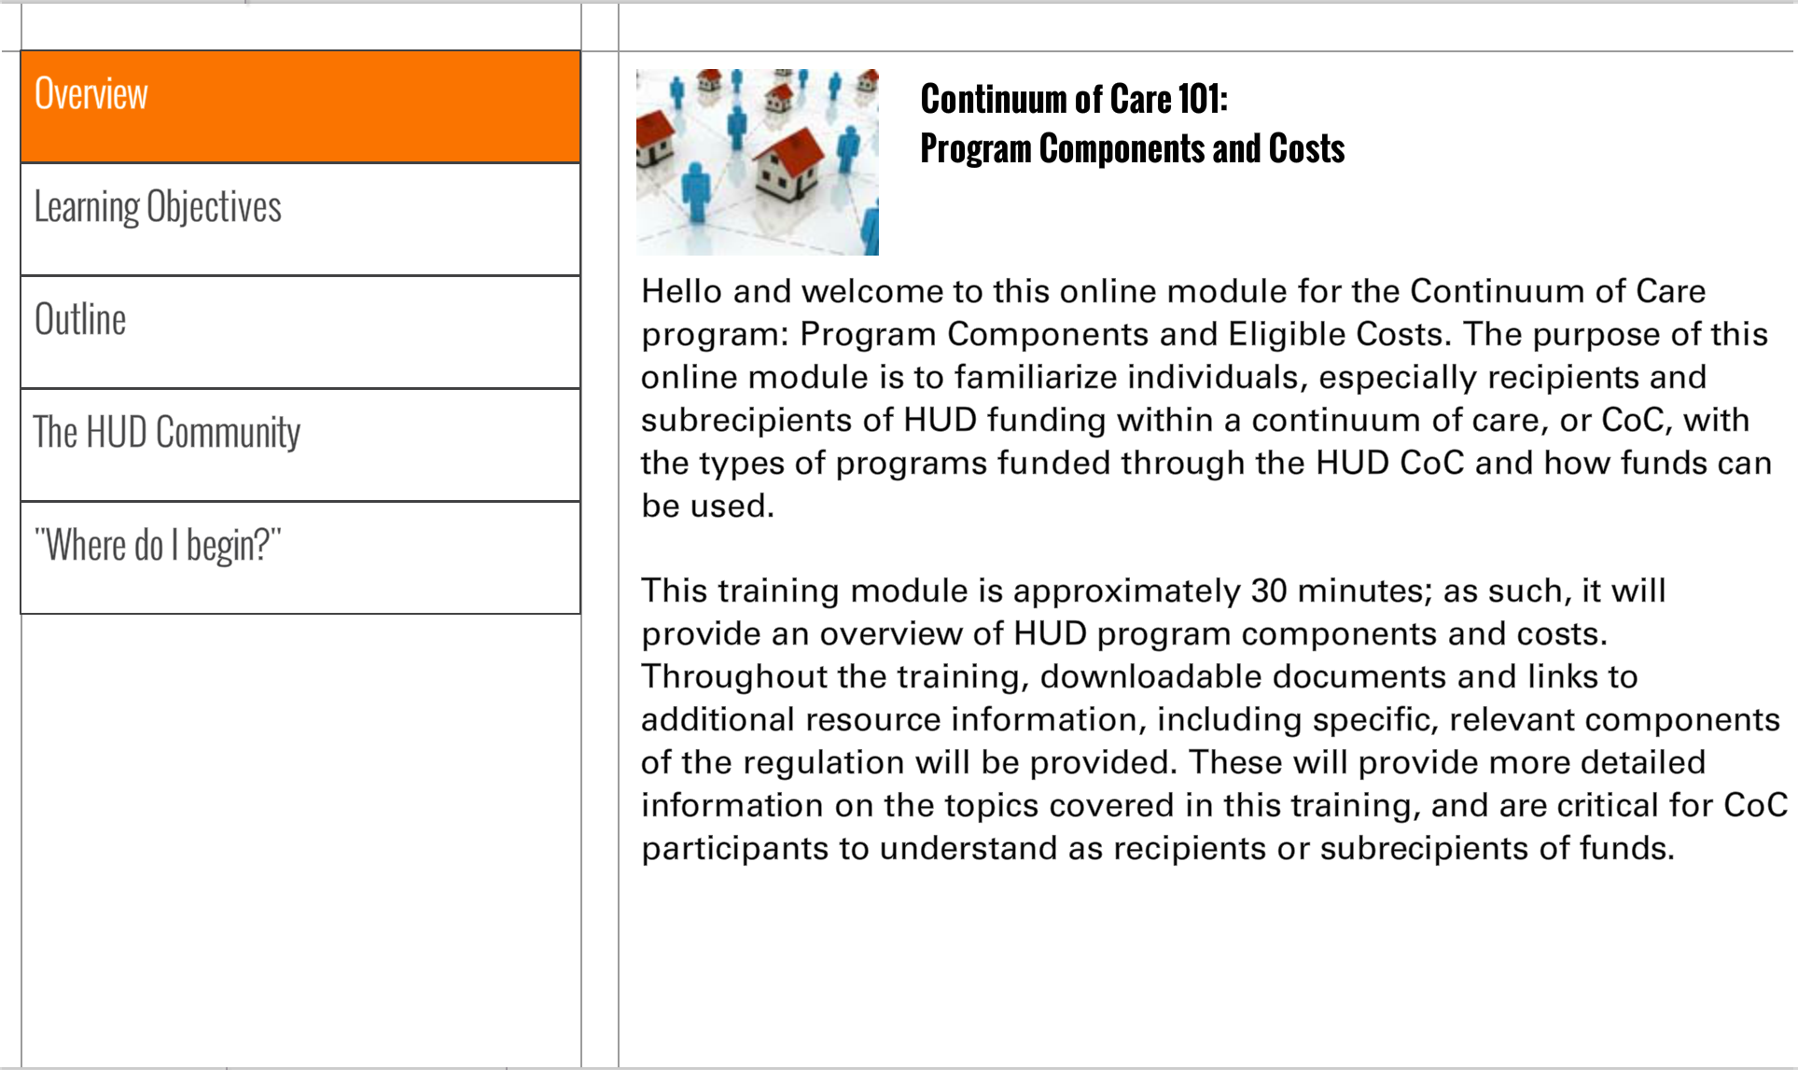
Template | S1-COC
Menu Title | The HUD Community
Image | ${CONTENT_ROOT}/images/slideimages/community-thumb.jpg
Header | U.S. Department of Housing and Urban Development  Social Media
Body Text | Social media is an integral part of HUD’s operations. This page is designed to help the HUD community use social media both in official and unofficial capacities. Visit HUD's Social Media @ Facebook and Twitter for the latest on HUD-related social media activity.
Notes | These will not be included in course output

Page Title
Object | Content
Layout
Template | S1-COC
Menu Title | Where do I begin?
Image | ${CONTENT_ROOT}/images/slideimages/where-to-begin-thumb.jpg
Header | "Where Do I Begin?"
Body Text | The best way to start a course of this nature is to gain an understanding how to effectively navigate the learning environment. The navigational structure in these CoC courses includes a primary and secondary navigation. The primary navigation can be seen by clicking the list menu icon at the top left. When you click that button, the menu will appear on the left of the slide. You can click on any of the page buttons and navigate directly to the page of your choice.  The secondary navigation appears on the bottom left as "prev" and "back" buttons and allows you to move one page forwards and backwards.
Notes | These will not be included in course output

Page Title
Object | Content
Layout | 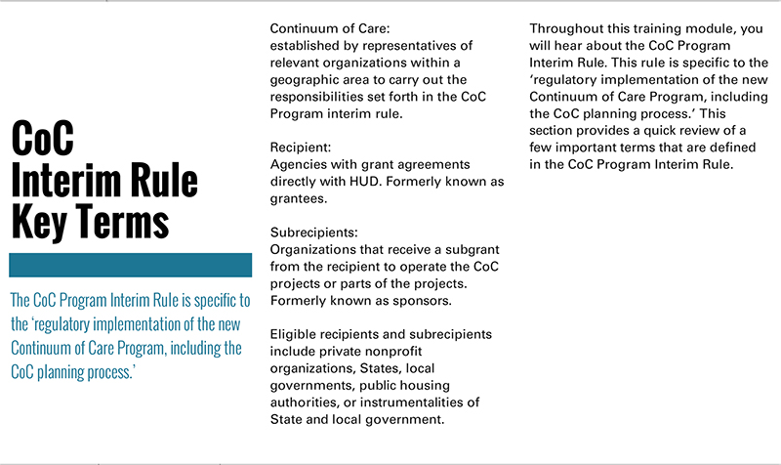
Template | T1a-COC
Menu Title | Key Terms
Title | CoC Program Interim Rule Key Terms
Subtitle | The CoC Program interim rule uses several key terms to describe grant administration responsibilities.
Column 1 | Recipients:  Agencies that execute grant agreements directly with HUD; formerly known as grantees.  Subrecipients:  Organizations that receive a subgrant from the recipient to operate a CoC Program-funded project or part of a project; formerly known as sponsors.  Eligible recipients and subrecipients include private nonprofit organizations, States, local governments, public housing authorities, or instrumentalities of State and local government.  Project:  The explicit group of eligible housing and/or supportive service activities identified in an application to HUD and funded under the CoC Program.
Column 2 | Program Participant:  An individual or family who is assisted with CoC Program funds.
Notes | These will not be included in course output

CoC Module 2 Unit 2
Object | Content
Unit Title | Unit 2: Role and Responsibilities of the CoC Program Recipient
Abbreviated Title | Unit 2: RoR
Notes | These will not be included in course output

Object | Content
Layout | 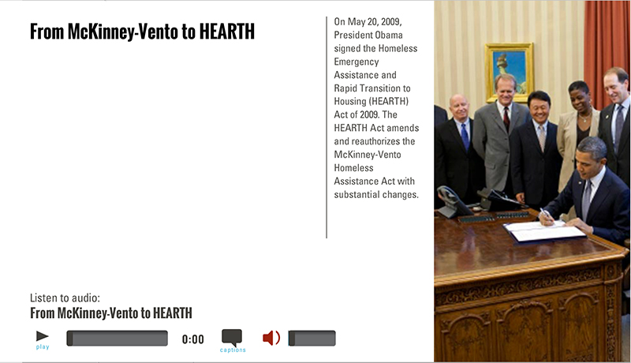
Template | A2-COC
Menu Title | Overview
Image | ${CONTENT_ROOT}/images/slideimages/coc-v-image_0025_iStock_000007690698Small.jpg
Header | Role and Responsibilities of the Recipient
Column Text | Agencies that receive CoC Program funds must execute grant agreements with HUD in which they agree to carry out the responsibilities specified in the CoC Program interim rule.  For details on the grant agreement see:  CoC Program interim rule Subpart C—Application and Grant Award Process  See also:  Broadcast XXXXX
Image Sequence | Image Source Time Cue Audio Cue  /content/shared/images/placeholders/placeholder.jpg 0:00
Bullets | CoC Program Grant Recipient’s responsibilities include: 0:01  - Complying with all standards as outlined in the CoC Program interim rule and related federal requirements 0:05  - Ensuring compliance by any subrecipients 0:07  - Operating the project in accordance with CoC-defined policies 0:09  - Reporting and Monitoring 0:11
Audio File | /content/shared/audio/placeholders/placeholder.mp3
Audio Title | Role and Responsibilities of the Recipient
Audio CC | A CoC Program recipient has many important responsibilities, including that of overall compliance with the CoC Program interim rule, ensuring compliance by its subrecipients, operating the project in accordance with all CoC-defined policies, such as a coordinated assessment system, and reporting and monitoring. This unit provides a general description of the responsibilities of recipients. Additional information on the stages of a grant are detailed in broadcast XXXXXX and are explained in CoC Program interim rule Subpart C, Application and Grant
Notes

Page Title

Page Title
Object | Content
Layout
Template | S3-COC
Menu Title | Recipient Responsibilities
Header | Compliance with Standards
Body Text | Comply with the CoC Program interim rule  Comply with other NOFA terms or conditions.  Comply with all applicable state and local housing codes, licensing requirements, and other jurisdictional requirements.  Comply with all applicable civil rights laws.  Maintain records to document compliance with all applicable requirements.
Notes | These will not be included in course output  Is it odd to have audio on some slides and not others?

Page Title
Object | Content
Layout
Template | S3-COC
Menu Title | Recipient Responsibilities
Header | Subrecipient Oversight
Body Text | Recipients have the option of contracting with other organizations within the community to assist in the day-to-day operations of the project. In this situation, the recipient must enter into a written agreement with each subrecipient to ensure that the subrecipient is aware of and operates the project in compliance with all relevant requirements related to grant and project administration.  The recipient must also obtain certification from subrecipients agreeing to:  - Maintain confidentiality of domestic violence records and the location of family violence projects.  - Designate staff to ensure enrollment in school and linkages of additional services for children and their families.  - Provide information as required by HUD.  - Ensure that it nor its employees or officers are not debarred or suspended from doing business with the Federal government.
Notes | These will not be included in course output

Object | Content
Layout
Template | S3-COC
Menu Title | Recipient Responsibilities
Header | Operating the project in accordance with CoC-defined policies
Body Text | Operate the project in accordance with CoC-established written standards of assistance, including policies and procedures for:  - Evaluating individuals’ and families’ eligibility for assistance  - Determining and prioritizing which individuals and families receive assistance  - Determining what percentage or amount of rent each program participant must pay while receiving rapid rehousing assistance (only for rapid rehousing projects)  Use the coordinated assessment system established by the CoC.  Consider educational needs when housing families
Notes | These will not be included in course output

Object | Content
Layout
Template | S3-COC
Menu Title | Recipient Responsibilities
Header | Reporting and monitoring
Body Text | Enter data on program participants into the CoC-designated HMIS.  Monitor subrecipients for compliance and performance at least annually.  Monitor and report project progress to CoC and HUD through the submission of Annual Performance Reports and other reports, as requested.  Monitor and report matching funds to HUD.
Notes | These will not be included in course output

Object | Content
Layout | 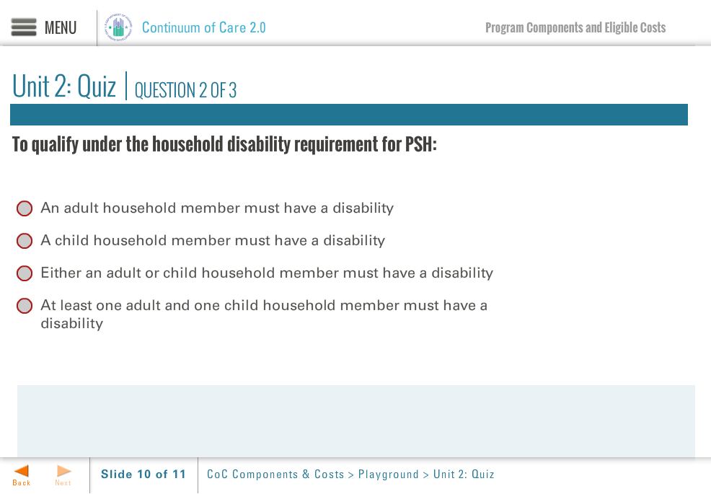
Template | Q1-COC
Menu Title | Roles and Responsibilities of the CoC Program Recipient Quiz
Title | Roles and Responsibilities of the Recipient Quiz
Quiz | Code Mode Randomize Questions Randomize Answers Points Max Attempts  quiz-1 formative false true 100 2  Question A CoC Program grant recipient must operate the funded-project in accordance with the CoC Program interim rule.  Correct Feedback Answer Options  true correct-fb True  false incorrect-fb False  ID Feedback Text  correct-fb Correct, the answer is True. A CoC Program grant recipient must operate the project in accordance with the CoC Program interim rule.  incorrect-fb Incorrect  When a recipient decides to subgrant to subrecipients, HUD enters into a grant agreement directly with each subrecipient to ensure it agrees to comply with all applicable regulations.  Correct Feedback  true incorrect-fb False  false correct-fb True  correct-fb Correct, the statement is False. If a CoC recipient subgrants some or all funds to a subrecipient organization, the recipient enters into a written agreement with the subrecipient. The recipient is still ultimately responsible for ensuring the project is operated in accordance with the CoC Program interim rule.  incorrect-fb Incorrect  Question A CoC Program grant recipient must use the CoC’s coordinated assessment system.  Correct Feedback Answer Options  true correct-fb True  false incorrect-fb False  ID Feedback Text  correct-fb Correct, the answer is True. A CoC Program grant recipient must use a coordinated assessment system.  incorrect-fb Incorrect
Notes | These will not be included in course output

Page Title

Object | Content
Layout
Template | A2-COC
Menu Title | Changes
Image | ${CONTENT_ROOT}/images/slideimages/coc-v-image_0031_iStock_000005535830XSmall.jpg
Header | Grant or Project Changes
Column Text | Sometimes a recipient will need to change the scope of what it has agreed to provide as part of the grant agreement. Changes to a project or grant budget may require a formal grant amendment.  For details see:  CoC Program Interim Rule Subpart G —Grant Administration (Regulation 578.105)
Image Sequence | Image Source Time Cue Audio Cue  /content/shared/images/placeholders/placeholder.jpg 0:00
Bullets | Once a project is operating, there may be instances that changes need to be made to improve performance or address an emerging need. 0:01  Recipients have the ability to make minor changes and to request permission to make more significant changes. 0:03  The CoC Program interim rule specifies what changes are considered ‘significant.’. 0:06  Significant changes require HUD approval and, if approved, will trigger a formal grant amendment. 0:09  For minor changes, the recipient must notify HUD and maintain records of the changes, but HUD approval is not required. 0:12
Audio File | /content/shared/audio/placeholders/placeholder.mp3
Audio Title | Communicate with HUD
Audio CC | Once a project is operating, there may be instances that changes need to be made to improve performance or address an emerging need. Recipients have the ability to make minor changes and to request permission to make more significant changes. Significant changes require HUD approval and, if approved, will trigger a formal grant amendment. For minor changes, the recipient must notify HUD and maintain records of the changes, but HUD approval is not required. Your field office can help you through this process and  communication with HUD is critical to ensure you handle changes properly. Please review the CoC Program interim rule on the OneCPD website for detailed information.

Layout | 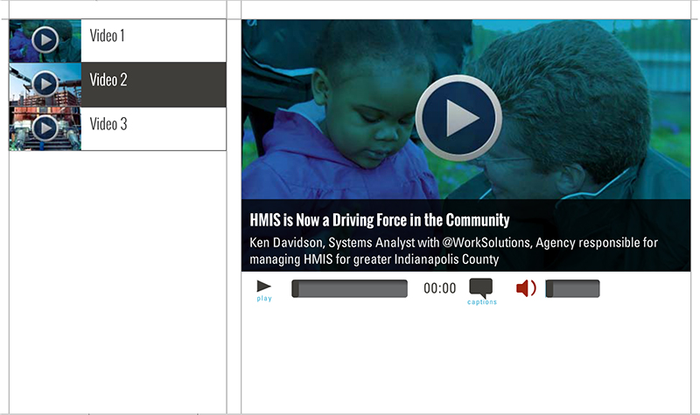
Template | V1-COC
Menu Title | Changes
Media Playlist | Playlist Item  Media Path ${MEDIA_ROOT}/${CONTENT_ROOT}/video/videoName.f4v  Media Poster Path /content/shared/images/placeholders/placeholder.jpg  Media Thumbnail /content/shared/images/placeholders/placeholder.jpg  Media Menu Title Minor and Significant Project Changes  Media Display Title Name of interviewee goes here  Media Description Name of interviewee’s job title goes here  Media CC Title Minor and Significant Project Changes  Media Captions Text for Caption 1 0:00 Text for Caption 2 0:00 Text for Caption 3 0:00 Text for Caption 4 0:00 Text for Caption 5 0:00
Notes | These will not be included in course output

Page Title
Object | Content
Layout
Template | S3-COC
Menu Title | Minor Project Changes
Header | Minor Project Changes
Body Text | Minor changes do not require HUD approval.  Recipient and subrecipients must notify the field office of these changes, especially if the change necessitates an update to the budget in LOCCS.  Recipients and subrecipients must fully document minor changes to an approved grant or project in their records.  Example of a minor change: A shift of less than 10% of the total grant amount from one approved budget category to another.
Notes | These will not be included in course output

Page Title
Object | Content
Layout
Template | S3-COC
Menu Title | Significant Project Changes
Header | Significant project changes
Body Text | Recipients must have HUD approval for:  - Change of recipient  - A shift in a single year of more than 10% of the total grant amount from one approved budget category to another  - A permanent change in the subpopulation served  - A permanent reduction in the total number of units funded by the grant  - A change of project site  - Additions or deletions in eligible costs for the project
Notes | These will not be included in course output

Object | Content
Layout
Template | Q1-COC
Menu Title | Unit 2: Quiz Project Changes
Title | Unit 2: Quiz Project Changes
Quiz | Code Mode Randomize Questions Randomize Answers Points Max Attempts  quiz-1 formative false true 100 2  Question Our House Agency has decided they no longer have the capacity to administer their TH project, Transitions to Success. They have negotiated with Rescue Services to take over the CoC Program grant and project for them. Is this a significant project change?  Correct Feedback Answer Options  true correct-fb Yes  false incorrect-fb No  ID Feedback Text  correct-fb Correct, the answer is Yes. A change of recipient is a significant project change that requires HUD approval and, if approved, will require a grant amendment  incorrect-fb Incorrect  Question Once they’ve taken on the grant, Rescue Services determines they need additional funds for their Case Manager than the project had originally allocated before. As such, they would like to reduce CoC Program funds designated for maintenance and increase the funds available for case management. To make this change, they would need to shift 17% of the total grant amount from Operating to Supportive Services. Is this a significant project change?  Correct Feedback Answer Options  true correct-fb Yes  false incorrect-fb No  ID Feedback Text  correct-fb Correct, the answer is Yes. A shift in a single year of more than 10 percent of the total grant amount from one approved eligible cost to another is a significant project change that requires HUD approval and, if approved, will require a grant amendment  incorrect-fb Incorrect  Question Rescue Services also decides that the original target population for Transitions to Success, individuals with mental illness, should be changed to better fit the needs of the CoC as identified in the latest point in time count. Thus, they would like to change the target population of the project to families with children that have at least one adult member with a mental illness. . Is this a significant project change?  Correct Feedback Answer Options  true correct-fb Yes  false incorrect-fb No  ID Feedback Text  correct-fb Correct, the answer is Yes. A change in target population is a significant project change that requires HUD approval and, if approved, will require a grant amendment  incorrect-fb Incorrect  Question HUD approval is needed for project changes that are not considered ‘significant.’  Correct Feedback Answer Options  false incorrect-fb True  true correct-fb False  ID Feedback Text  correct-fb Correct, the statement is False. Any minor project change must be fully documented in the recipient’s records, and the recipient should notify HUD of the change.  incorrect-fb Incorrect
Notes | Jason – how do we kick the quiz answer choices down in order to accommodate longer question text?

Quiz Page Title

Drag and Drop
Object | Content
Layout | 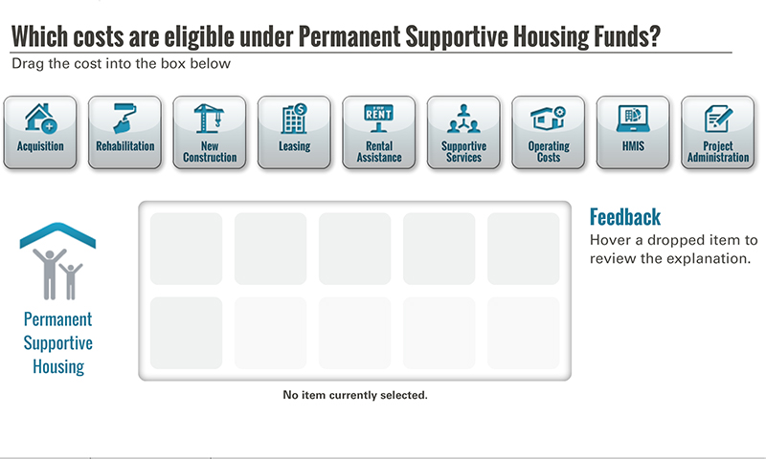
Template | D1-COC
Menu Title | Recordkeeping Activity
Drag and Drop | Drag and Drop Static Components  Activity Title Which items are covered by the recordkeeping requirements under the CoC Program?  Activity Prompt Drag the item into the box below  Feedback Title Feedback  Default Feedback Hover a dropped item to review the explanation.  Default Status No item currently selected.  Activity Graphic ${CONTENT_ROOT}/images/slideimages/span-admin.jpg  Activity Graphic Label Recordkeeping  Drag and Drop Item 1  Label Homeless Status  Icon Path /content/shared/images/placeholders/placeholder.jpg  Feedback For all CoC-funded projects, recipients or subrecipients must document that participants meet the HUD definition of homelessness, or at risk of homelessness for homelessness prevention projects.  Status Record whether a person is homeless or at risk of homelessness.  Correct true  Drag and Drop Item 2  Label Disability Status  Icon Path /content/shared/images/placeholders/placeholder.jpg  Feedback The recipient needs to document eligibility criteria, such as disability status of participants in Permanent Supportive Housing projects.  Status Record a person’s disability status for permanent supportive housing projects funded through the CoC Program  Correct true  Drag and Drop Item 3  Label Threat of Harm  Icon Path /content/shared/images/placeholders/placeholder.jpg  Feedback When a CoC-funded project provides assistance for someone who has been placed in a different CoC’s geographic area due to imminent threat of further domestic violence, dating violence, sexual assault, or stalking, the recipient or subrecipient must retain documentation of the original incidence and imminent threat.  Status Documentation should be gathered and retained when project participants are believed to be in imminent threat of harm and move to a different CoC geographic area  Correct true  Drag and Drop Item 4  Label Services Provided  Icon Path /content/shared/images/placeholders/placeholder.jpg  Feedback The recipient or subrecipient must maintain records for each program participant that document the services and assistance provided to that participant.  Status CoC projects should keep a record of services provided to each program participant.  Correct true  Drag and Drop Item 5  Label Annual Assessment of Services  Icon Path /content/shared/images/placeholders/placeholder.jpg  Feedback Recipients and subrecipients should have evidence that an annual assessment of services has been conducted to ensure that the service offerings are aligned with the services needed byprogram participants. Records should indicate that the service package was adjusted when appropriate.  Status Annual assessment of services should be clearly documented.  Correct true  Drag and Drop Item 6  Label Termination of Assistance  Icon Path /content/shared/images/placeholders/placeholder.jpg  Feedback If a CoC Program participant is terminated from the project, the recipient must maintain records that the project complied with termination requirements, including due process.  Status The CoC project should clearly document termination of assistance.  Correct true
Notes | These will not be included in course output

Object | Content
Unit Title | Unit 3: Requirements and Recordkeeping for Organizations
Abbreviated Title | Unit 3: Organizational Requirements
Notes | These will not be included in course output

Object | Content
Layout
Template | A2-COC
Menu Title | Requirements and Recordkeeping for Organizations
Image | ${CONTENT_ROOT}/images/slideimages/coc-v-image_0026_iStock_000007565657XSmall.jpg
Header | Requirements and Recordkeeping for Organizations
Column Text | To receive CoC Program funds, organizations must establish and follow organizational policies, as specified in the CoC Program interim rule, and must maintain documentation to demonstrate compliance. (Subpart F – Program Requirements)
Image Sequence | Image Source Time Cue Audio Cue  /content/shared/images/placeholders/placeholder.jpg 0:00
Bullets | The recipient must establish and comply with requirements related to: 0:01  Conflict of Interest 0:03  Participation of Homeless Consumers  Faith-based Activities  Fair Housing and Equal Opportunity  Other Federal Laws
Audio File | /content/shared/audio/placeholders/placeholder.mp3
Audio Title | Establishing Organizational Policies
Audio CC | The recipient and its subrecipients must establish policies for ensuring that CoC Program funds are used appropriately and they must document compliance with the general organizational requirements specified in the CoC Program interim rule. At the organizational level, the recipient and subrecipient must follow requirements related to conflict of interest, consumer participation, faith-based activities, fair housing and equal opportunity, as well as other Federal laws.
Notes

Page Title

Object | Content
Layout
Template | A2-COC
Menu Title | Conflict of Interest
Image | ${CONTENT_ROOT}/images/slideimages/coc-v-image_0007_donovan-fenty-p.jpg
Header | Conflict of Interest Requirements
Column Text
Image Sequence | Image Source Time Cue Audio Cue  /content/shared/images/placeholders/placeholder.jpg 0:00
Bullets | People in decision-making positions cannot participate in decisions that benefit the organization they represent or obtain personal benefit or gain from CoC Program funds. 0:01  Agencies must adopt and comply with clear written policies that covers both organizational and individual conflicts of interest 0:04  Recipients and subrecipients must maintain a copy of their conflict of interest policies and must keep records to show compliance with them. 0:07
Audio File | /content/shared/audio/placeholders/placeholder.mp3
Audio Title | What is Conflict of Interest?
Audio CC | What is individual conflict of interest? Simply put, people in decision-making positions in an organization cannot obtain personal benefit or gain from the CoC Program funds. This continues for one year after the position has ended and includes the person, their family members, partner or those they employ.
Notes

Page Title

Object | Content
Layout
Template | A2-COC
Menu Title | Conflict of Interest
Image | /content/shared/images/placeholders/placeholder.jpg
Header | Conflict of Interest Policy
Column Text
Image Sequence | Image Source Time Cue Audio Cue  /content/shared/images/placeholders/placeholder.jpg 0:00
Bullets | Organizational conflicts of interest: An agency cannot make funding decisions that involve his or her agency. An agency cannot conduct a rent reasonableness determination or housing quality standards inspection for property the agency owns. 0:01  Individual conflicts of interest: Agency decision makers cannot obtain personal benefit or gain from CoC Program funds. 0:07
Audio File | /content/shared/audio/placeholders/placeholder.mp3
Audio Title | Two Types of Conflict of Interest
Audio CC | Every CoC-funded project needs to have a written conflict of interest policy.  The CoC Program distinguishes between two types of conflict of interest; one related to organizations (both recipients and subrecipients) that carry out the project, and the other for individuals involved in providing services and day-to-day operations. Organizational conflicts of interest policies ensure that officers or employees of an agency do not inappropriately participate in decisions that affect their agency. Individual conflicts of interest ensure that individuals do not participate in decisions that might result in personal gain.
Notes

Page Title

Page Title
Object | Content
Layout | 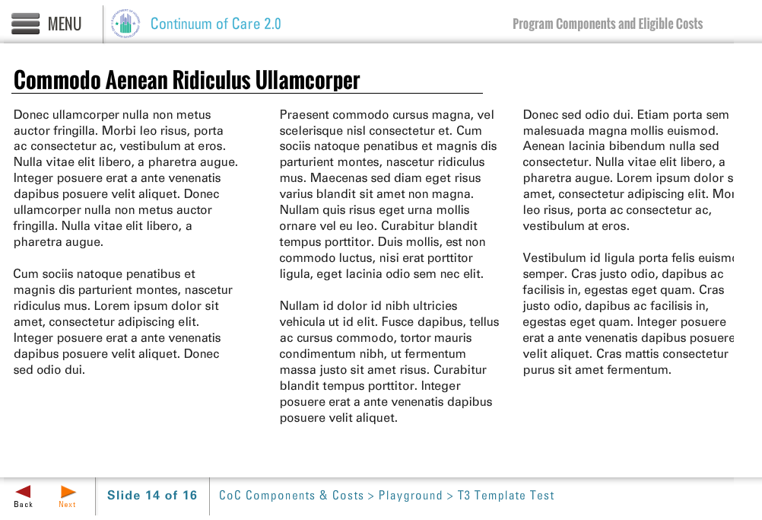
Template | T3-COC
Menu Title | Conflict of Interest Quiz
Title | Quiz: A Scenario
Column 1 | The CoC for the city of “Sunny Street” has selected the review committee for the six CoC Program applications that were submitted, including Bigfund’s new PH project. The review committee will be voting to determine the applications that will be submitted for funding in the new CoC Program competition. The chair of the committee is Ms. Green, a Bigfund board member who excluded all employees of the applicants from the review process to avoid any conflict of interest.
Column 2 | Before starting the ranking process, Ms. Green asked the group if there was anyone with a known conflict of interest. One person raised their hand, stating that they were not comfortable with Ms. Green participating in discussions or voting, knowing she was a board member of Bigfund.
Column 3
Notes | These will not be included in course output

Object | Content
Layout
Template | Q1-COC
Menu Title | Conflict of Interest Quiz
Title | Unit 3: Quiz
Quiz | Code Mode Randomize Questions Randomize Answers Points Max Attempts  quiz-1 formative false true 100 2  Question As a participant in the review process and a current Bigfund board member, does Ms. Green have a conflict of interest?  Correct Feedback Answer Options  false incorrect-fb a) No, there is no conflict of interest  false incorrect-fb b) Yes, but only in voting, not in the discussion  true correct-fb c) Yes, the board member should not participate in the discussion or vote  ID Feedback Text  correct-fb Correct, the answer is C. The CoC Program interim rule specifically calls out this example. “Such an organizational conflict would arise when a board member of an applicant participates in decision of the applicant concerning the award of a grant, or provision of other financial benefits, to the organization that such member represents.” [24 CFR part 587.95]  incorrect-fb Incorrect
Notes | These will not be included in course output

Quiz Page Title

Page Title
Object | Content
Layout
Template | S3-COC
Menu Title | Requirements and Recordkeeping for Organizations
Header | Homeless Consumer Participation
Body Text | At least one homeless individual or formerly homeless individual must participate on the board of directors or other equivalent policymaking body of each recipient and subrecipient.  If a recipient or subrecipient is unable to meet the participation requirement, it may apply to HUD for a waiver by providing an alternate plan to consult with homeless or formerly homeless individuals when considering and making policy decisions.  To the extent possible, recipients and subrecipients of CoC Program funds also must involve homeless individuals and families in through day-to-day operations, such as:  - Employment services  - Volunteer services  - Constructing, rehabilitating, maintaining, and operating the project  - Providing supportive services for the project  The recipient or subrecipient must maintain records to document its compliance with the homeless participation requirements.
Notes | These will not be included in course output

Page Title
Object | Content
Layout
Template | S3-COC
Menu Title | Requirements and Recordkeeping for Organizations
Header | Faith-Based Activities
Body Text | Religious and faith-based organizations are eligible to participate in the CoC Program on the same basis as any other organization.  The CoC Program provides certain standards for these organizations. Any religious organization that receives CoC funds:  - Must retain its independence from Federal, State, and local governments  - May continue to carry out its mission  - May use space in its facilities to provide CoC-funded services without removing religious art or symbols  - Must retain authority over its internal governance  - May retain religious terms in its organization's name, select its board members on a religious basis, and include religious references in its organization's mission statements and other governing documents
Notes | These will not be included in course output

Page Title
Object | Content
Layout
Template | S3-COC
Menu Title | Requirements and Recordkeeping for Organizations
Header | Faith-Based Activities: Limitations
Body Text | However, organizations receiving CoC Program funds may not engage in inherently religious activities, such as worship or religious instruction as part of the projects or services funded by a CoC Program grant. If an organization conducts religious activities, it must:  - Offer the activities separately, in time or location, from the programs or services funded under the CoC Program  - Ensure that participation is voluntary for CoC program participants  - Comply with restrictions on using CoC Program funds to rehabilitate structures of faith-based organizations  Importantly, recipients may not discriminate against a prospective or active program participant on the basis of religion or religious belief.
Notes | These will not be included in course output

Page Title
Object | Content
Layout
Template | S3-COC
Menu Title | Requirements and Recordkeeping for Organizations
Header | Fair Housing and Equal Opportunity
Body Text | Recipients must abide by fair housing and equal opportunity regulations, meaning that they cannot discriminate against protected classes and may only limit who is served by a project under certain circumstances. Recipients and subrecipients should review Section 578.93(b) before establishing any project-specific eligibility criteria.  The CoC program also requires recipients and subrecipients to comply with accessibility requirements for persons with disabilities.
Notes | These will not be included in course output

Page Title
Object | Content
Layout
Template | T3-COC
Menu Title | Requirements and Recordkeeping for Organizations
Title | Other Federal Requirements
Column 1 | The CoC Program is governed by several other statutes and regulations that apply to most HUD programs. Recipients and subrecipients must ensure that they comply with these provisions when they advertise their units, rehabilitate their properties, and operate their projects.
Column 2 | Examples include:  - Nondiscrimination and Equal Opportunity  - Transparency Act Reporting  - Uniform Administrative Requirements  - Environmental Review  - Davis-Bacon Act  - Coastal Barrier Resources Act of 1982  - Procurement of Recovered Materials  - Audit Requirements
Column 3
Notes | These will not be included in course output

Object | Content
Unit Title | Unit 4: Grant-specific Requirements and Recordkeeping
Abbreviated Title | Unit 4: Grant Requirements
Notes | These will not be included in course output

Layout
Template | A2-COC
Menu Title | Grant-specific Requirements and Recordkeeping
Image | ${CONTENT_ROOT}/images/slideimages/coc-v-image_0026_iStock_000007565657XSmall.jpg
Header | Grant-specific Requirements and Recordkeeping
Column Text | The recipient must establish policies for ensuring that projects receiving CoC Program funds are operated in compliance with project requirements in the CoC Program interim rule (Subpart F – Program Requirements). Compliance with these requirements must be documented explicitly for each project.
Image Sequence | Image Source Time Cue Audio Cue  /content/shared/images/placeholders/placeholder.jpg 0:00
Bullets | Each CoC-funded projects must have policies in place for implementing and documenting compliance with requirements related to: 0:01  Housing standards 0:03  Annual assessment of services offered 0:05  Provision of match 0:07  Procurement of Subcontractor and contractors 0:09
Audio File | /content/shared/audio/placeholders/placeholder.mp3
Audio Title | Grant-specific requirements and Recordkeeping
Audio CC | As part of project operations, the recipient must establish policies and document compliance with requirements for the project and grant related to ensuring appropriate housing standards, conducting an annual assessment of the services offered, providing match, and subgranting grant funds to subrecipients. Unlike organizational policies, which apply to the organization as a whole, these requirements only apply to the organization’s project that receive CoC Program funds.
Notes
Page Title
Object | Content
Layout
Template | T3-COC
Menu Title | Housing Standards
Title | Recordkeeping Specific to Housing Standards
Column 1 | When CoC Program funds are used for rental assistance or to lease housing units, the housing must meet housing quality standards (HQS). The recipient, subrecipient, or rental assistance administrator must physically inspect each unit to assure that the unit meets HQS and correct deficiencies. The recipient or subrecipient must retain documentation of compliance with the CoC Program housing standards, including conducting initial, annual, and interim housing inspections..
Column 2 | Housing units that receive CoC Program funding must meet specific suitable dwelling size requirements. The dwelling unit must have at least one bedroom or living/sleeping room for each two persons. Children of opposite sex, other than very young children, may not be required to occupy the same bedroom or living/sleeping room. If the household composition changes, recipients and subrecipients may relocate the household to a more appropriately sized unit.
Column 3 | Lead based paint requirements may apply (see 24CFR part 35 Subparts A, B, H, K, J, and R for details)
Notes | These will not be included in course output

Page Title
Object | Content
Layout
Template | T3-COC
Menu Title | Services Offered
Title | Services Offered
Column 1 | Annually, the recipient or subrecipient must examine and document the types of services offered to program participants during the course of participation in the project and the amounts spent on each service.
Column 2 | The recipient must also consider the typical needs of program participants and whether the services offered align with participant needs.
Column 3 | Recipients must document the annual assessment and any changes to the service package made as a result of the assessment.
Notes | These will not be included in course output

Page Title
Object | Content
Layout
Template | S3-COC
Menu Title | Requirements and Recordkeeping for Projects
Header | Requiring Participation in Services
Body Text | Recipients may require participation in supportive services as long as services are not disability-related. Examples of disability-related services include:  - Mental health services  - Outpatient health services  - Provision of medication  If a primary purpose of a project is to provide substance abuse treatment, recipients may require participation in the substance abuse services as a condition of the project participation. However, if the program purpose is not substance abuse treatment, recipients cannot require participation in substance abuse services as a condition of occupancy.
Notes | These will not be included in course output

Page Title
Object | Content
Layout
Template | T3-COC
Menu Title | Match
Title | Match Requirements
Column 1 | Recipients must match at least 25 percent of the total grant amount received,less amounts received for leasing which do not have a match requirement.
Column 2 | Match can be cash or in-kind contributions and services.  Recipients must provide documentation that this match requirement has been met. Specifically, the recipient must keep records of the source and use of funds and resources used to satisfy match requirements that indicate:  - Grant and fiscal year for which each matching contribution is counted  - Value of in-kind contributions
Column 3 | Note: To the extent feasible, volunteer services must be supported by the same methods that the organization uses to support the allocation of regular personnel costs.
Notes | These will not be included in course output

Page Title
Object | Content
Layout
Template | T3-COC
Menu Title | Subrecipients and Contractors
Title | Requirements related to Subrecipients and Contractors
Column 1 | The recipient must maintain well-documented and accurate project records related to any  CoC Program-funded activities conducted by subrecipients or other contractors.  At a minimum, the records must include:
Column 2 | - Copies of all solicitations of and agreements with subrecipients  - Records of all payment requests by and dates of payments to subrecipients
Column 3 | - Documentation of subrecipient monitoring, including any monitoring findings, corrective actions required, and sanctions imposed, as applicable  - Copies of all procurement contracts issued by the recipient or subrecipients
Notes | These will not be included in course output

Object | Content
Unit Title | Unit 5: Requirements and Recordkeeping related to Program Participant
Abbreviated Title | Unit 5: Program Participant Records
Notes | These will not be included in course output

Object | Content
Layout
Template | A2-COC
Menu Title | Requirements and Recordkeeping related to Program Participants
Image | ${CONTENT_ROOT}/images/slideimages/coc-v-image_0017_iStock_000013964682Small.jpg
Header | Overview
Column Text | There must be policies and documentation related to program participant eligibility and the assistance provided to them, including:
Image Sequence | Image Source Time Cue Audio Cue  /content/shared/images/placeholders/placeholder.jpg 0:00
Bullets | Program participant eligibility: homeless status, disability, status and income 0:01  Rent or occupancy calculations 0:05  Services provided 0:09  Terminations and due process
Audio File | /content/shared/audio/placeholders/placeholder.mp3
Audio Title | Requirements and Recordkeeping related to Program Participants
Audio CC | Recipients must establish and follow policies, consistent with the CoC’s written standards, for determining and documenting program participant eligibility, calculating rent or occupancy charges, providing assistance, and if necessary, for terminating clients and ensuring due process.
Notes

Page Title
Object | Content
Layout
Template | T3-COC
Menu Title | Participant Eligibility
Title | Documenting Homelessness, Disability and Income
Column 1 | Recipients must maintain individual records for each program participant verifying program eligibility, in accordance with HUD requirements and any additional CoC-defined protocols.
Column 2 | Records for each Program Participant should include documentation of:  Homeless status  Disability status, if applicable  Income, if rent or an occupancy charge is imposed
Column 3 | The program participant recordkeeping requirements and acceptable forms of evidence for homeless status as well as disability verification are detailed in resources available on the OneCPD Resource Exchange. Recipients and subrecipients should refer to these materials, as program participant eligibility documentation is a complex topic.
Notes | These will not be included in course output

Page Title
Object | Content
Layout
Template | T3-COC
Menu Title | Rent Calculations
Title | Rent and Occupancy Charge Calculations
Column 1 | For Projects that Provide Rental Assistance or Impose an Occupancy Charge  Additional documentation is required for projects that receive rental assistance or those that receive leasing funds and require program participants to pay an occupancy charge.
Column 2 | At least annually, recipients or subrecipients must re-examine a participant’s income and re-calculate their portion of the rent or occupancy charge – and ensure the calculation is properly documented.
Column 3
Notes | These will not be included in course output

Page Title
Object | Content
Layout
Template | T3-COC
Menu Title | Services Provided
Title | Services Provided
Column 1 | Recipients or subrecipients must document the specific services provided to each program participant, including evidence that the entity conducted an annual assessment of services for the individual and adjusted the service package accordingly.
Column 2 | Rapid Rehousing project recipients must also document that each program participant:  - participated in case management services not less than once per month  - were annually re-evaluated for eligibility for rapid rehousing assistance and the amount and types of assistance needed to retain housing.
Column 3
Notes | These will not be included in course output

Page Title
Object | Content
Layout
Template | T3-COC
Menu Title | Termination of Assistance
Title | Termination of Assistance
Column 1 | The CoC Program interim rule allows for termination of assistance when a program participant violates a program requirement or condition of occupancy. However, HUD intends CoC Program recipients and subrecipients to terminate assistance only in the most severe cases.
Column 2 | When terminating hard-to-house homeless  Recipients and subrecipients must exercise judgment and examine all extenuating circumstances when determining if violations warrant termination.  Example 1:  Termination is likely not appropriate after failure to attend a substance abuse counseling session that is a required component of a transitional housing project.  Example 2:  Termination may be appropriate if a resident has had multiple violations of program terms and has physically abused other residents.
Column 3 | Recipients and subrecipients must:  - Have written termination policies that allow for flexibility and consideration of mitigating circumstances  - Establish a formal termination process and must recognize the rights of the individuals receiving assistance
Notes | Erika, if we were to do this as another S3, like we have for some of the other organizational policy discussions, I think we would have to have 3 pages, so these are simply T3s.

Page Title
Object | Content
Layout
Template | T3-COC
Menu Title | Due Process-Minimum Requirements
Title | Due Process-Minimum Requirements
Column 1 | The termination process must specify, at a minimum, that  At the time of project enrollment, the recipient or subrecipient will:  - Provide written copies of the program rules and conditions of occupancy as well as written copies of the termination process. (Consider having the participant sign the rules.)  •
Column 2 | When initiating termination proceedings, the recipient or subrecipient will:  - Provide the participant with a written notice including the reason(s) for the termination.  - Allow for a review of the termination decision, which includes allowing the participant to provide oral or written objections. Note: The review must be conducted by a person who did not make the original termination decision.  - Provide prompt written notice to the participant after the final determination has been made.
Column 3 | These are minimum termination requirements, and the recipient or subrecipient can additional steps to ensure that the program participant is provided due process or to identify alternate means of resolving the situation rather than termination.
Notes

Page Title
Object | Content
Layout
Template | T3-COC
Menu Title | Termination of Assistance Versus Eviction
Title | Termination of Assistance Versus Eviction
Column 1 | It is important not to confuse “termination of assistance” with eviction. Eviction is an action taken by a landlord for the removal of a tenant from housing due to a lease violation or nonpayment of rent. Projects cannot evict clients from independent housing due to violations of program requirements.
Column 2 | Example:  A rapid rehousing tenant has been provided with temporary rental assistance and supportive services. The process for termination of assistance has been initiated, after extensive attempts to work with the program participant. Although rental assistance and the services may be terminated, the participant is NOT evicted from the housing. The landlord may subsequently proceed with eviction if tenant is unable to pay the rent without the rental assistance, but the two consequences are separate.
Column 3
Notes | Erika, is this too little text? Should we use one with a picture? (maybe someone walking away with a knapsack?) Just kidding.

Unit Title (for Word Outline Purposes Only)
Object | Content
Unit Title | Unit 6: Reporting and Monitoring
Abbreviated Title | Unit 6: Reporting and Monitoring
Notes | These will not be included in course output

Page Title
Object | Content
Layout
Template | A2-COC
Menu Title | Reporting
Image | ${CONTENT_ROOT}/images/slideimages/coc-v-image_0031_iStock_000005535830XSmall.jpg
Header | Reporting allows grant recipients to:
Column Text | For details see:  CoC Program Interim Rule Subpart G —Grant Administration
Image Sequence | Image Source Time Cue Audio Cue  /content/shared/images/placeholders/placeholder.jpg 0:00
Bullets | Improve service 0:01  Track and assess project and system outcomes 0:03  Find cost-efficiencies 0:05  Identify emerging needs and trends 0:08
Audio File | /content/shared/audio/placeholders/placeholder.mp3
Audio Title | Benefits of Reporting
Audio CC | There are many benefits of reporting; reporting allows grant recipients to improve services, track and assess project and system level outcomes, find cost-efficiencies, and identify emerging needs among homeless persons and trends in service utilization that might impact service delivery. Equally important, reporting provides HUD with data to show Congress the value of the CoC Program funding, equips the CoC with data to strategically plan around homelessness, and, provides recipients themselves with information on results to attract additional funders.
Notes

Object | Content
Layout
Template | A2-COC
Menu Title | Reporting Overview
Image | ${CONTENT_ROOT}/images/slideimages/coc-v-image_0031_iStock_000005535830XSmall.jpg
Header | Reporting Overview
Column Text | For details see:  CoC Program Interim Rule Subpart G —Grant Administration
Image Sequence | Image Source Time Cue Audio Cue  /content/shared/images/placeholders/placeholder.jpg 0:00
Bullets | Homeless Management Information System (HMIS): A community wide software program that captures client information. All recipients and subrecipients are required to enter data about each program participant assisted into the CoC-designated HMIS. 0:01  Annual Performance Report (APR): Due to HUD 90 days from end of the operating year, recipients of CoC Program funds must complete and submit an Annual Performance Report 0:03
Audio File | /content/shared/audio/placeholders/placeholder.mp3
Audio Title | Two Types of Reporting
Audio CC | An important part of grant management includes reporting on services provided and persons served. There are two required reporting mechanisms: Homeless Management Information System, or HMIS and the Annual Performance Report, or APR.
Notes

Page Title

Object | Content
Layout
Template | A2-COC
Menu Title | Monitoring Overview
Image | ${CONTENT_ROOT}/images/slideimages/coc-v-image_0029_iStock_000006023013Small.jpg
Header | Monitoring Overview
Column Text | For details see:  CoC Program interim rule Subpart G — Grant Administration (Regulation 578.107)
Image Sequence | Image Source Time Cue Audio Cue  /content/shared/images/placeholders/placeholder.jpg 0:00
Bullets | Two types of monitoring: performance and financial 0:01  Monitoring helps to: 0:05  - Assess effectiveness and compliance 0:07  - Identify concerns 0:09  - Prompt the need for project changes 0:11  - Ensure effective service provision 0:13
Audio File | /content/shared/audio/placeholders/placeholder.mp3
Audio Title | Why Monitor?
Audio CC | Monitoring is a key piece of grant administration and overall project management. Each recipient must monitor itself, as well as any subrecipients. In general, there are two types of monitoring: monitoring of financial records and activities to ensure compliance with the grant agreement and other contractual obligations and monitoring of performance of a project to measure progress toward project and CoC goals. Monitoring also helps recipients assess effectiveness, identify concerns, prompt the need to make project changes, and make other adjustments to ensure effective service provision.
Notes

Page Title

Page Title
Object | Content
Layout
Template | S3-COC
Menu Title | Who Monitors Whom?
Header | Who Monitors Whom?
Body Text | HUD monitors recipients  Recipients monitor subrecipients  The CoC monitors recipients and subrecipients  Recipients and subrecipients should monitor themselves internally
Notes | These will not be included in course output

Page Title
Object | Content
Layout
Template | S3-COC
Menu Title | HUD Monitoring
Header | HUD Monitors Recipients
Body Text | HUD monitors recipients for compliance with the grant agreement and the CoC Program interim rule.  As part of monitoring, HUD verifies records and examines information from on-site monitoring, audit reports, APRs and information generated from HMIS and HUD’s financial and reporting systems (e.g., LOCCS and e-snaps).  After completing the monitoring, HUD sends written correspondence to recipients regarding the results.  .
Notes | These will not be included in course output

Page Title
Object | Content
Layout
Template | T3-COC
Menu Title | Findings
Title | Concerns or Findings After a HUD Monitoring Visit
Column 1 | After monitoring, HUD documents any concerns or findings in a written monitoring report.  When HUD has a concern, they want to bring a potential issue to your attention, and they will make recommendations about how to fix it. A corrective action is not required, but projects should take HUD’s recommendations seriously.
Column 2 | When HUD has a finding, they will bring it to the recipient’s attention and will make recommendations about how to correct the issue. A finding requires a corrective action within a prescribed timeline or funds may be deobligated.
Column 3 | Ask for help from the Field Office if you have questions about how to resolve concerns or findings.
Notes | These will not be included in course output

Page Title
Object | Content
Layout
Template | S3-COC
Menu Title | Remedial Actions
Header | Recipient non-compliance with program requirements: Remedial actions
Body Text | To resolve a finding, HUD may require remedial actions or impose sanctions against the recipient.  Remedial actions, as specified in the CoC Program interim rule, may include:  - Developing and following a schedule of actions for carrying out project activities and projects affected by non-compliance  - Establishing and following a grants management plan that assigns responsibilities for carrying out remedial actions  - Canceling or revising project activities or projects before expending associated grant funds  - Re-programming grant funds not yet expended for given activities or projects to eligible costs or projects  - Suspending funds disbursement  - Reducing or terminating a recipient’s remaining grant funds and re-allocating funds to other subrecipients or returning funds to HUD  - Requiring matching contributions to be made
Notes | These will not be included in course output

Page Title
Object | Content
Layout
Template | S3-COC
Menu Title | Sanctions
Header | Recipient non-compliance with program requirements: Sanctions
Body Text | Possible sanctions, as specified in the CoC Program interim rule, may include:  - Changing method of payment to reimbursement  - Suspending payments to preclude the further expenditure of funds for affected projects or activities  - Continuing the grant with a substitute recipient of HUD’s choosing  - Denying matching credit for all or part of the cost of the affected activities and requiring further matching contributions  - Requiring the recipient to reimburse its line of credit in an amount equal to the funds used for the affected activities  - Reducing or terminating the remaining grant  - Imposing conditions on a future grant  - Imposing other legally available remedies
Notes | These will not be included in course output

Page Title
Object | Content
Layout
Template | S3-COC
Menu Title | Recipient Monitoring
Header | Recipient Monitoring of Subrecipients
Body Text | Recipients are required to monitor subrecipients at least annually.  Recipients must keep documentation of subrecipient monitoring, including findings and required corrective actions.  Recipients may impose the same types of remedial actions and sanctions on subrecipients, as HUD can impose on recipients.  Note: Unified Funding Agency recipients have additional fiscal and monitoring responsibilities related to subrecipient oversight, as described in companion UFA training materials.
Notes | These will not be included in course output

Page Title
Object | Content
Layout
Template | S3-COC
Menu Title | CoC Monitoring
Header | CoC monitoring of recipients and subrecipients
Body Text | The CoC must also monitor recipients and subrecipients with regards to performance.  CoCs measure progress and performance of all funded projects based on HUD-established performance indicators and any additional CoC-established locally-defined indicators.  Results are reported to HUD and used by the CoC for systems planning and to identify any troubled projects.
Notes | These will not be included in course output

Page Title
Object | Content
Layout
Template | S3-COC
Menu Title | Self-Monitoring
Header | Recipient and Subrecipient Self-Monitoring
Body Text | Recipients and subrecipients should institute regular self-monitoring to check for compliance with all requirements.  Self-monitoring should assess compliance with policies and should include file review to verify appropriate documentation is being maintained.  Self-monitoring can identify potential issues and allow the recipient or subrecipient to proactively correct them in advance of external monitoring.
Notes | These will not be included in course output

Object | Content
Layout
Template | Q1-COC
Menu Title | Quiz
Title | Unit 6: Quiz
Quiz | Code Mode Randomize Questions Randomize Answers Points Max Attempts  quiz-1 formative false true 100 2  Question Who monitors recipients for compliance with the grant agreement and CoC Program interim rule?  Correct Feedback Answer Options  true correct-fb HUD  false incorrect-fb Subrecipients  false incorrect-fb The CoC  false incorrect-fb Other recipients (peer monitoring)  ID Feedback Text  correct-fb Correct, the answer is HUD. HUD monitors recipients for compliance with the grant agreement and CoC Program interim rule.  incorrect-fb Incorrect  Question When HUD has a finding after monitoring, the recipient should pay attention but formal corrective action is not necessary, as the recommended steps are only suggestions.  Correct Feedback Answer Options  false incorrect-fb True  true correct-fb False  ID Feedback Text  correct-fb Correct, the statement is False. Findings require a corrective action within a prescribed timeline; if the issue is not corrected, funds may be deobligated.  incorrect-fb Incorrect  Question Recipients are required to monitor subrecipients at least monthly.  Correct Feedback Answer Options  false incorrect-fb True  true correct-fb False  ID Feedback Text  correct-fb Correct, the statement is False. Recipients are required to monitor subrecipients at least annually, although more frequent monitoring is certainly allowed and encouraged for subrecipients with concerns.  incorrect-fb Incorrect
Notes | These will not be included in course output

Quiz Page Title

Page Title
Object | Content
Layout | 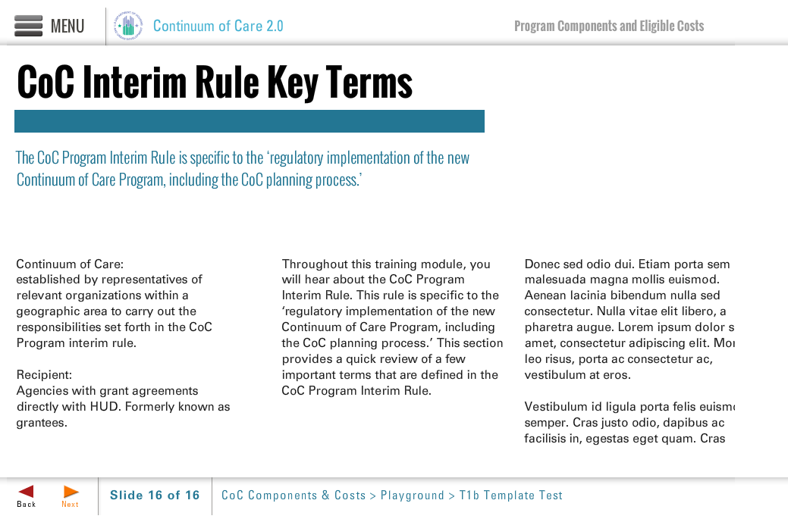
Template | T1b-COC
Menu Title | Thank You
Title | Thank You
Subtitle | This concludes the online training module on the CoC Program: Grant Administration and Program Requirements.
Column 1 | This training provided information on Grant Administration and Program Requirements of the CoC Program. Please be sure to review the other training resources on the One CPD Resource Exchange to ensure that you are aware of and able to comply with the complete array of CoC program requirements. Also visit the CoC Program Grants Administration User Guide.
Column 2
Column 3
Notes | These will not be included in course output

