9Object | Content
Course Title | CoC Program: Eligible Program Components and Costs
Language Code | en-US
Palette Id | coc
Use System Fonts | false
First Page | 001
Completion Page | 011
Contents Page | 001
Module Title | CoC Program: Eligible Program Components and Costs
Abbreviated Module Title | CoC Program Components & Costs
Notes | These will not be included in course output

Course Title (for Word Outline Purposes Only)

Object | Content
Unit Title | Unit 1: Intro
Abbreviated Title | Unit 1: Intro
Notes | These will not be included in course output

Unit Title (for Word Outline Purposes Only)

Page 001
Object | Content
Layout | 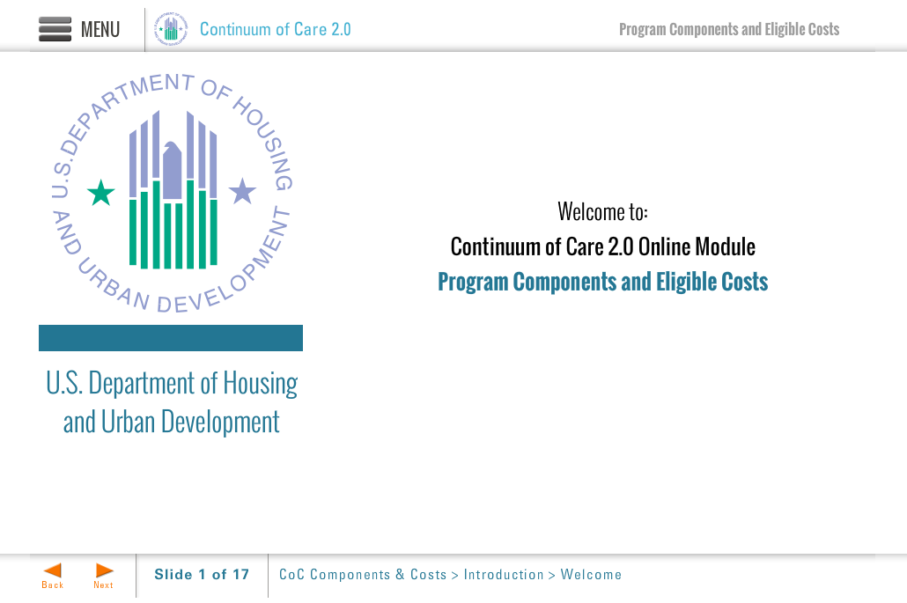
Template | Title-COC
Menu Title | Welcome
Image | ${CONTENT_ROOT}/images/slideimages/hud-logo.png
Subtitle | U.S. Department of Housing and Urban Development
Welcome Text | Welcome to:
Header Text | Continuum of Care Program 2.0
Module Title | Online Module:  Program Components and Eligible Costs
Notes | These will not be included in course output

Layout | 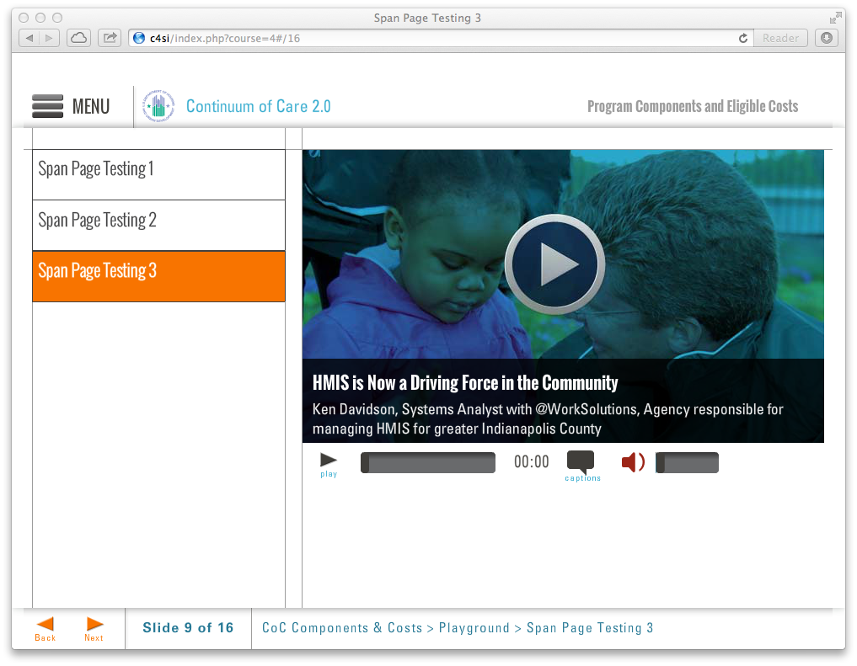
Template | S8-COC
Menu Title | Message from Ann Oliva
Media Path | ${MEDIA_ROOT}/${CONTENT_ROOT}/video/mod1_video_introduction.f4v
Media Poster Path | ${CONTENT_ROOT}/images/vidposters/vidPoster-ann-oliva.jpg
Media Title | A Message from Ann Oliva
Media Description | Office Director, Special Needs Assistance Programs
Media CC Title | A Message from Ann Oliva
Captions | Duis mollis, est non commodo luctus, nisi erat porttitor ligula, eget lacinia odio sem nec elit. Praesent commodo cursus magna, vel scelerisque nisl consectetur et. Donec sed odio dui. 0:02  Cras mattis consectetur purus sit amet fermentum. Nullam id dolor id nibh ultricies vehicula ut id elit. 0:12  Curabitur blandit tempus porttitor. Nullam quis risus eget urna mollis ornare vel eu leo. Vivamus sagittis lacus vel augue laoreet rutrum faucibus dolor auctor. 0:22  Curabitur blandit tempus porttitor. Nullam quis risus eget urna mollis ornare vel eu leo. 0:32  Integer posuere erat a ante venenatis dapibus posuere velit aliquet. Donec ullamcorper nulla non metus auctor fringilla. 0:42  Cras mattis consectetur purus sit amet fermentum. Integer posuere erat a ante venenatis dapibus posuere velit aliquet. 0:52
Notes | These will not be included in course output

Page Title

Page 002
Object | Content
Layout | 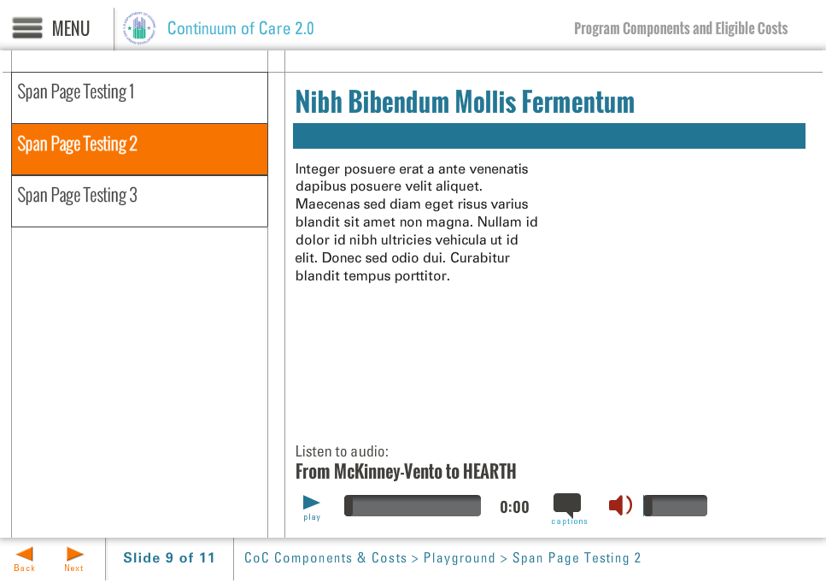
Template | S7-COC
Menu Title | Introduction
Title | Program Components and Eligible Costs
Column 1 | Hello and welcome to this online module for the Continuum of Care Program: Eligible Program Components and Costs.  The purpose of this online module is to familiarize recipients and subrecipients of HUD funding with the type of projects funded through the HUD CoC Program and how funds can be used.
Bullets | - Approximately 30 minutes long 0:22  - You’ll find links to additional resource information 0:30  - You can dive deeper into the topics through the resources 0:38
Audio File | ${CONTENT_ROOT}/audio/mod1_audio1.mp3
Audio Title | Introduction
Audio CC | Hello and welcome to this online module on Program Components and Eligible Costs under the Continuum of Care Program. The purpose of this training is to familiarize individuals, especially prospective recipients and subrecipients, with the types of projects that can be funded through the CoC Program and how grant funds can be used. This module will take approximately 30 minutes to complete; as such, it will only provide an overview of program components and eligible costs. Links to additional resource information, including specific citations within the regulations, are provided throughout. Please review all additional resources that are relevant to your project, as the more detailed requirements are critical for recipients and subrecipients to understand in order comply with the CoC Program regulations.  This slide shows several tabs that will help you understand this training module, such as the learning objectives for the module, an outline of material covered, links to HUD social media, and a brief description of how to navigate the course. In addition, in the top left corner of the screen, you will find a menu icon. This menu allows you to navigate to particular content without needing to go through each slide. For instance, if you are only interested in program components and costs for Permanent Supportive Housing, you may use the drop down menu to view a list of the relevant training contents so you can navigate directly to that material. To exit from the menu, either click on the item you wish to navigate to, or click again on the menu icon to hide the list.
Notes | These will not be included in course output

Page 003
Object | Content
Layout | 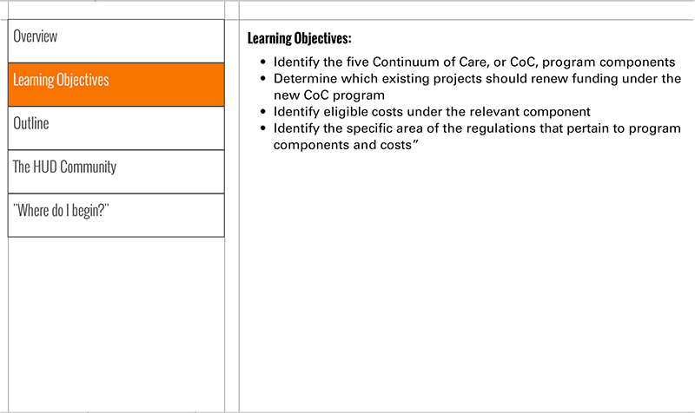
Template | S3-COC
Menu Title | Learning Objectives
Header | Learning Objectives:
Body Text | - Identify the five Continuum of Care, or CoC, Program components  - Identify eligible costs under each program component  - Identify the specific area of the regulations that pertain to each program component and cost
Notes | - Identify the five Continuum of Care, or CoC, Program components  Identify eligible costs under each program component  Identify the specific area of the regulations that pertain to each program component and cost

Page 004
Object | Content
Layout | 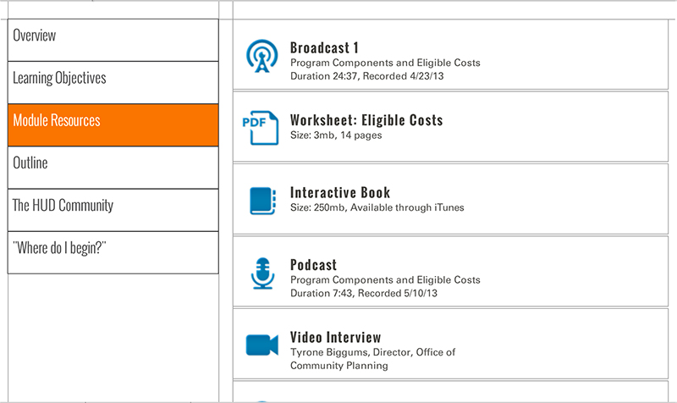
Template | S5-COC
Menu Title | Module Resources
Scrolling List | URL 002  Label Video: Message from Ann Oliva  Icon ${CONTENT_ROOT}/images/interactives/icons/video.png  Metadata Ann Oliva, Office Director, Special Needs Assistance Programs 5mb, Date Published: May 2013  URL 028  Label Video: Brett Gagnon  Icon ${CONTENT_ROOT}/images/interactives/icons/video.png  Metadata Rapid Rehousing in the ESG and CoC Programs 6mb, Date Published: May 2013  URL 038  Label Video: Brett Gagnon and Lisa Hill  Icon ${CONTENT_ROOT}/images/interactives/icons/video.png  Metadata Importance of Leases in the CoC Program 2mb, Date Published: May 2013  URL http://www.onecpd.info  Label OneCPD Website  Icon ${CONTENT_ROOT}/images/interactives/icons/weblink.png  Metadata OneCPD Resource Exchange  URL http://www.onecpd.info/resource/2033/hearth-coc-program-interim-rule/  Label HEARTH Interim Rule  Icon ${CONTENT_ROOT}/images/interactives/icons/weblink.png  Metadata Date Published: July 2012  URL http://www.onecpd.info/resource/1715/mckinney-vento-homeless-assistance-act-amended-by-hearth-act-of-2009/  Label McKinney-Vento as Amended by HEARTH  Icon ${CONTENT_ROOT}/images/interactives/icons/weblink.png  Metadata Date Published: May 2009  URL http://www.onecpd.info/resource/1187/continuum-of-care-101/  Label Continuum of Care 101  Icon ${CONTENT_ROOT}/images/interactives/icons/weblink.png  Metadata Date Published: June 2009  URL http://www.onecpd.info/resource/2040/coc-program-overview-interim-rule-fy-2012-competition-webinar/  Label CoC Program Webinar  Icon ${CONTENT_ROOT}/images/interactives/icons/weblink.png  Metadata Date Published: July 2012  URL http://www.onecpd.info/resource/2044/implementing-the-hearth-act-the-new-continuum-of-care-program-webinar/  Label Implementing the HEARTH Act Webinar  Icon ${CONTENT_ROOT}/images/interactives/icons/weblink.png  Metadata Date Published: July 2012  URL http://www.onecpd.info/resource/2722/fy2012-continuum-of-care-program-nofa-and-application-webcast/  Label FY2012 CoC NOFA and Application Webcast  Icon ${CONTENT_ROOT}/images/interactives/icons/weblink.png  Metadata Date Published: December 2012  URL 002  Label Audio: Introduction  Icon ${CONTENT_ROOT}/images/interactives/icons/podcast.png  Metadata 985kb, Date Published: May 2013  URL 009  Label Audio: Program Component Eligible Costs  Icon ${CONTENT_ROOT}/images/interactives/icons/podcast.png  Metadata 985kb, Date Published: May 2013  URL 011  Label Audio: From McKinney-Vento to HEARTH  Icon ${CONTENT_ROOT}/images/interactives/icons/podcast.png  Metadata 985kb, Date Published: May 2013
Notes | These will not be included in course output

Page 005
Object | Content
Layout | 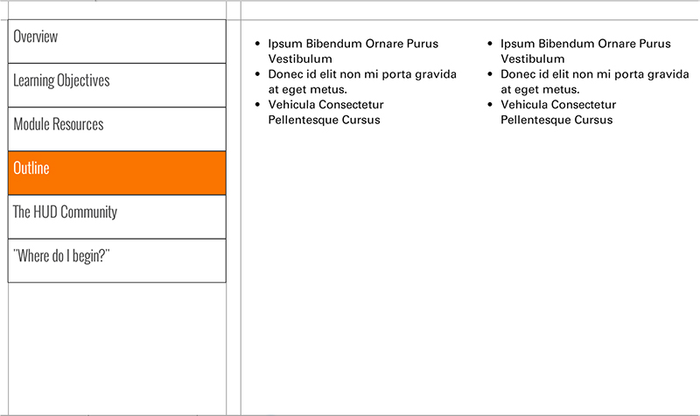
Template | S4-COC
Menu Title | Outline
Column 1 | Unit 1: Introduction  Introduction  From McKinney-Vento to HEARTH  Key Terms  Program Components Overview  Eligible Costs  Unit 2: Permanent Supportive Housing (PSH)  Permanent Housing  Overview  PSH: Defined  Video: Importance of Leases in the CoC Program  PSH: Eligible Costs  Activity  Quiz  Unit 3: Rapid Rehousing (RRH)  Overview  Video: Rapid Rehousing in the ESG and CoC Programs  RRH: Defined  RRH: Eligible Costs  Activity  Quiz
Column 2 | Unit 4: Transitional Housing (TH)  Overview  TH: Leases  Video: Importance of Leases in the CoC  TH: Services  TH: Eligible Costs  Activity  Quiz  Unit 5: Supportive Services Only (SSO)  Overview  SSO: Eligible Costs  Activity  Quiz  Unit 6: Homeless Management Information Systems (HMIS)  Overview  HMIS: Eligible Costs  Quiz  Unit 7: Homelessness Prevention (HP)  Overview  HP: Eligible Costs  Activity  Quiz
Notes | These will not be included in course output

Page 006
Object | Content
Layout | 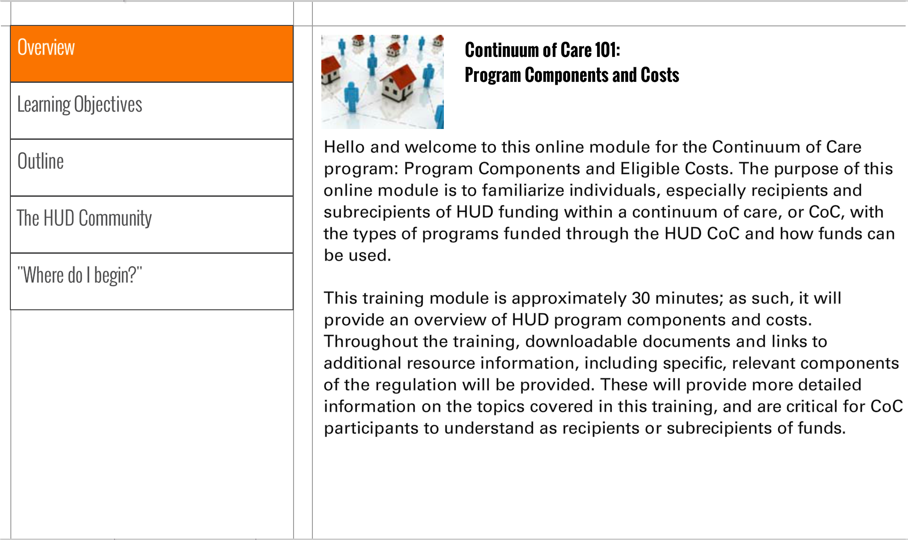
Template | S1-COC
Menu Title | The HUD Community
Image | ${CONTENT_ROOT}/images/slideimages/community-thumb.jpg
Header | U.S. Department of Housing and Urban Development  Social Media
Body Text | Social media is an integral part of HUD’s operations. Visit HUD's Social Media @ Facebook and Twitter for the latest on HUD-related social media activity.
Notes | Need link to HUD's social media? remove this slide entirely?

Page 007
Object | Content
Layout
Template | S1-COC
Menu Title | Where do I begin?
Image | ${CONTENT_ROOT}/images/slideimages/where-to-begin-thumb.jpg
Header | "Where Do I Begin?"
Body Text | The best way to start a course of this nature is to gain an understanding how to effectively navigate the learning environment. The navigational structure in these CoC courses includes a primary and secondary navigation. The primary navigation can be seen by clicking the list menu icon at the top left. When you click that button, the menu will appear on the left of the slide. You can click on any of the page buttons and navigate directly to the page of your choice.  The secondary navigation appears on the bottom left as "prev" and "back" buttons and allows you to move one page forwards and backwards.
Notes | These will not be included in course output

Page 008

Object | Content
Layout | 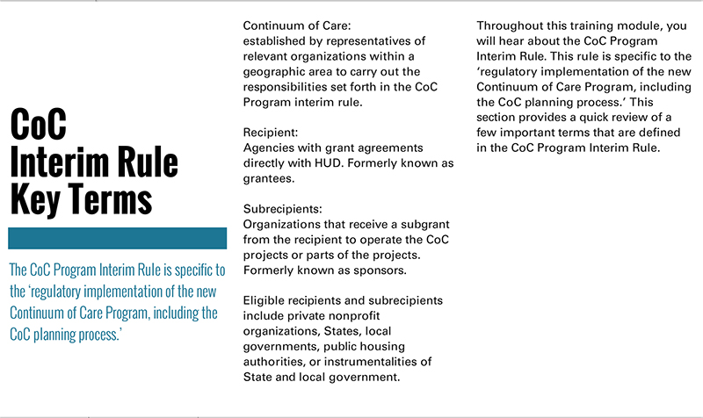
Template | T1a-COC
Menu Title | Key Terms
Title | CoC Program  Interim Rule Key Terms
Subtitle | The CoC Program interim rule establishes the regulations that implement the CoC Program authorized by the HEARTH Act.
Column 1 | Continuum of Care:  The group of relevant organizations within a geographic area organized to carry out the responsibilities set forth in the CoC Program interim rule.  Recipients:  Agencies that execute grant agreements directly with HUD; formerly known as grantees.  Subrecipients:  Organizations that receive a subgrant from the recipient to operate a CoC Program-funded project or part of a project; formerly known as sponsors.  Eligible recipients and subrecipients include private nonprofit organizations, States, local governments, public housing authorities, or instrumentalities of State and local government.
Column 2
Notes | These will not be included in course output

Object | Content
Layout | 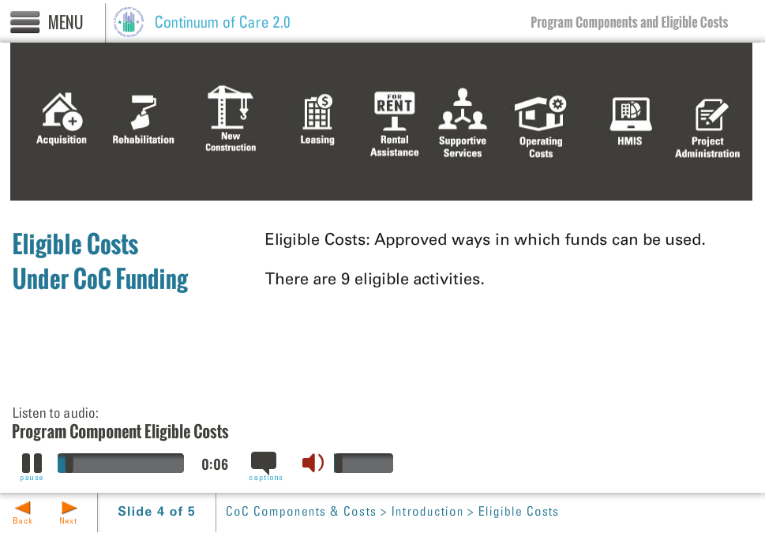
Template | A3-COC
Menu Title | Eligible Costs
Image | ${CONTENT_ROOT}/images/slideimages/eligible-costs-main.jpg
Header | Eligible Costs  Under CoC Program Funding
Bullets | Eligible Costs: Allowable ways in which funds can be used. There are a variety of eligible costs that are allowable under the CoC Program. 0:01  Eligible Cost: Acquisition Up to 100% of the cost of acquiring property to provide housing or supportive services for homeless persons. 0:05  Eligible Cost: Rehabilitation Up to 100% of the cost of rehabilitation of structures to provide housing or supportive services for homeless persons. 0:10  Eligible Cost : New construction Up to 100% of the cost of new construction to be used as housing for homeless persons. 0:15  Eligible Cost: Leasing 100% of the costs of leasing a structure, part of a structure, or individual units in which housing or supportive services are provided to homeless persons. 0:20  Eligible Cost: Rental assistance Rental assistance for homeless individuals and families. Assistance can be short-, medium- or long-term. 0:25  Eligible Cost: Supportive services The costs to provide eligible supportive services that address the special needs of homeless persons. Only the service types specified in the regulations are eligible. 0:30  Eligible Cost: Operating costs The daily costs associated with operating transitional or permanent housing. 0:35  Eligible Cost: Homeless Management Information Systems (HMIS) The costs of contributing or reporting on data to the CoC-designated HMIS. 0:40  Eligible Cost: Project administration Up to 10% of any grant amount to be used for costs related to the administration of the grant. This does not include costs related to the delivery of aforementioned eligible costs. 0:45
Image Sequence | Image Source Time Cue Audio Cue  ${CONTENT_ROOT}/images/slideimages/eligible-costs-1.jpg 0:05  ${CONTENT_ROOT}/images/slideimages/eligible-costs-2.jpg 0:10  ${CONTENT_ROOT}/images/slideimages/eligible-costs-3.jpg 0:15  ${CONTENT_ROOT}/images/slideimages/eligible-costs-4.jpg 0:20  ${CONTENT_ROOT}/images/slideimages/eligible-costs-5.jpg 0:25  ${CONTENT_ROOT}/images/slideimages/eligible-costs-6.jpg 0:30  ${CONTENT_ROOT}/images/slideimages/eligible-costs-7.jpg 0:35  ${CONTENT_ROOT}/images/slideimages/eligible-costs-8.jpg 0:40  ${CONTENT_ROOT}/images/slideimages/eligible-costs-9.jpg 0:45
Audio File | ${CONTENT_ROOT}/audio/mod1_audio2.mp3
Audio Title | Program Component Eligible Costs
Audio CC | There are many different types of costs eligible under the CoC Program. ‘Eligible’ means that these costs are allowable uses of CoC Program funds. The CoC Program regulations specify which types of costs are eligible for each of the program components, and they vary from one program component to another. For instance, some cost types are eligible under Transitional Housing that are not eligible under the Supportive Services Only or Homelessness Prevention program component. A project funded with a CoC Program grant can only be funded for one program component, for example, transitional housing, but each project may have more than one eligible cost, such as funding for new construction, rental assistance, and supportive services. Throughout the rest of the module, we will describe the eligible costs associated with each program component and special requirements associated with each.
Notes

Page 009

Page 010
Object | Content
Layout | 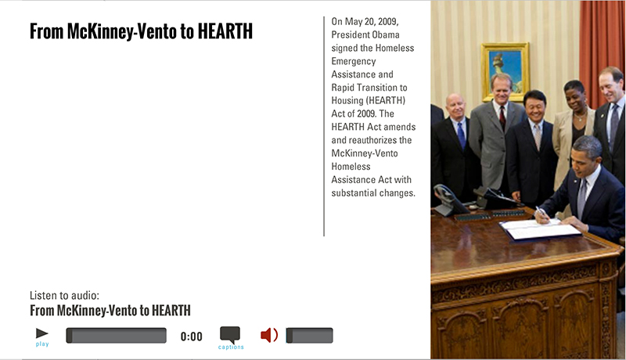
Template | A2-COC
Menu Title | From McKinney-Vento to HEARTH
Image | ${CONTENT_ROOT}/images/slideimages/coc-mod1-v-image5.jpg
Header | From McKinney-Vento to HEARTH
Column Text | On May 20, 2009, President Obama signed the Homeless Emergency Assistance and Rapid Transition to Housing (HEARTH) Act of 2009. The HEARTH Act amends and reauthorizes the McKinney-Vento Homeless Assistance Act with substantial changes.
Bullets | Previously, under the McKinney-Vento Act, HUD awarded funds through three distinct competitive programs: 0:01  1) Supportive Housing Program (SHP) 0:07  2) Shelter Plus Care (S+C) program 0:09  3) Section 8 Moderate Rehabilitation Single Room Occupancy program. 0:11  These are now referred to as ‘legacy’ programs. The HEARTH Act amended the McKinney-Vento Act and consolidates these legacy programs into one grant program, referred to as the CoC Program. This change administratively streamlines access to funding for recipients, increasing the efficiency and effectiveness of the housing and services that are provided to clients. 0:16
Audio File | ${CONTENT_ROOT}/audio/mod1_audio3.mp3
Audio Title | From McKinney-Vento to HEARTH
Audio CC | Under the McKinney-Vento Act, HUD awarded funds under three distinct competitive programs—the Supportive Housing Program, the Shelter Plus Care program, and the Section 8 Moderate Rehabilitation Single Room Occupancy program. The HEARTH Act amends the McKinney-Vento Act and consolidates these three programs into one, now referred to as the CoC Program. This change administratively streamlines access to funding for recipients, thereby increasing the efficiency and effectiveness of the housing and services provided to clients.
Notes

Page 011

Object | Content
Layout | 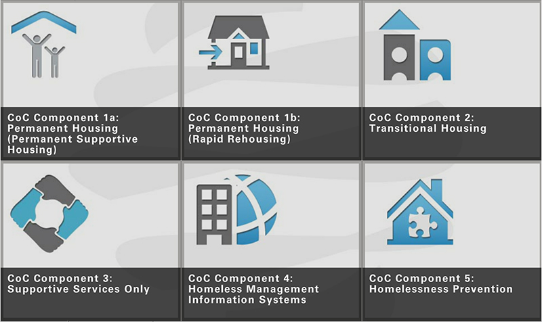
Template | CRG-COC-2x3
Menu Title | CoC Program Components Overview
Title | Interactive: Program Components Overview
Subtitle | Click the thumbnails below to view more information
Click and Reveal | Layout Show Tooltip Columns  click-and-reveal-grid-2x3 true 3  Click and Reveal Item 1  Label Component: Permanent Housing - Permanent Supportive Housing  Reveal Title Component: Permanent Supportive Housing  Reveal Text A model of permanent housing in which supportive services are provided to assist homeless persons with a disability to live independently. This is community-based housing without a designated length of stay.  Thumbnail ${CONTENT_ROOT}/images/interactives/thumb1.jpg  Reveal Image ${CONTENT_ROOT}/images/interactives/detail1.jpg  Audio File ${CONTENT_ROOT}/audio/mod1_audio4a.mp3  Audio CC Title Component: Permanent Supportive Housing  Audio CC Permanent Supportive Housing is one of two different models of permanent housing under the Continuum of Care Program. Permanent supportive housing, or PSH, provides permanent housing and supportive services to assist homeless persons with a disability to live independently. The housing does not have a designated length of stay. The 2nd unit of this training module describes PSH and costs that are eligible under the PSH program component.  Click and Reveal Item 2  Label Component: Permanent Housing - Rapid Rehousing  Reveal Title Component: Rapid Rehousing  Reveal Text A model of permanent housing that provides short or medium-term rental assistance and supportive services to help individuals and families achieve and maintain housing stability as quickly as possible.  Thumbnail ${CONTENT_ROOT}/images/interactives/thumb2.jpg  Reveal Image ${CONTENT_ROOT}/images/interactives/detail2.jpg  Audio File ${CONTENT_ROOT}/audio/mod1_audio4b.mp3  Audio CC Title Component: Rapid Rehousing  Audio CC The second model of permanent housing is Rapid Rehousing, or RRH. Rapid rehousing provides short- or medium-term rental assistance and supportive services to homeless individuals and families placed in permanent housing to help them achieve and maintain housing stability as quickly as possible. The 3rd unit of this training module describes RRH and costs eligible under the RRH program component.  Click and Reveal Item 3  Label Component: Transitional Housing  Reveal Title Component: Transitional Housing  Reveal Text Temporary housing with supportive services to facilitate a household’s successful movement to permanent housing within 24 months.  Thumbnail ${CONTENT_ROOT}/images/interactives/thumb3.jpg  Reveal Image ${CONTENT_ROOT}/images/interactives/detail3.jpg  Audio File ${CONTENT_ROOT}/audio/mod1_audio4c.mp3  Audio CC Title Component: Transitional Housing  Audio CC Transitional housing, or TH, is temporary housing with supportive services to facilitate a household’s successful movement to permanent housing within 24 months. The 4th unit of this training module describes TH and costs eligible under the TH program component.  Click and Reveal Item 4  Label Component: Supportive Services Only  Reveal Title Component: Supportive Services Only  Reveal Text Services for unsheltered and sheltered homeless persons, who are not also receiving housing assistance from the recipient providing the services.  Thumbnail ${CONTENT_ROOT}/images/interactives/thumb4.jpg  Reveal Image ${CONTENT_ROOT}/images/interactives/detail4.jpg  Audio File ${CONTENT_ROOT}/audio/mod1_audio4d.mp3  Audio CC Title CoC Component: Supportive Services Only  Audio CC Through the Supportive Services Only, or SSO, program component, projects provide services for unsheltered and sheltered homeless persons, independent of their housing. The 5th unit of this training module describes SSO and costs eligible under the SSO program component.  Click and Reveal Item 5  Label CoC Component: Homeless Management Information Systems  Reveal Title Component: HMIS (HMIS Lead Agency Only)  Reveal Text The HMIS program component supports the costs associated with establishing and operating the CoC’s designated HMIS. Only the CoC’s designated HMIS Lead Agency is eligible to apply for funds under the HMIS program component.  Thumbnail ${CONTENT_ROOT}/images/interactives/thumb5.jpg  Reveal Image ${CONTENT_ROOT}/images/interactives/detail5.jpg  Audio File ${CONTENT_ROOT}/audio/mod1_audio4e.mp3  Audio CC Title Component: Homeless Management Information Systems  Audio CC The Homeless Management Information System, or HMIS, program component supports costs associated with establishing and operating the CoC’s designated HMIS. Only a CoC designated HMIS Lead Agency is eligible to apply for funds under the HMIS program component. The 6th unit of this training module discusses this program component and costs eligible under it.  Click and Reveal Item 6  Label Component: Homelessness Prevention  Reveal Title Component: Homelessness Prevention  Reveal Text Short- and medium-term rental assistance and housing relocation and stabilization services provided to prevent persons at risk of homelessness from becoming homeless. Only available in CoCs designated by HUD as High Performing Communities.  Thumbnail ${CONTENT_ROOT}/images/interactives/thumb6.jpg  Reveal Image ${CONTENT_ROOT}/images/interactives/detail6.jpg  Audio File ${CONTENT_ROOT}/audio/mod1_audio4f.mp3  Audio CC Title Component: Homelessness Prevention  Audio CC Homelessness Prevention provides short- and medium-term rental assistance and housing relocation and stabilization services to prevent persons at risk of homelessness from becoming homeless. This program component is only available in CoCs that are designated by HUD as High Performing Communities. The 7th unit in the training module provides more information about the Homelessness Prevention program component and the costs eligible under it.
Notes | These will not be included in course output

Click and Reveal (Grid mode)

Object | Content
Unit Title | Unit 2: PSH
Abbreviated Title | Unit 2: PSH
Notes | These will not be included in course output

Unit Title (for Word Outline Purposes Only)

Page 012

Page Title

Object | Content
Layout | 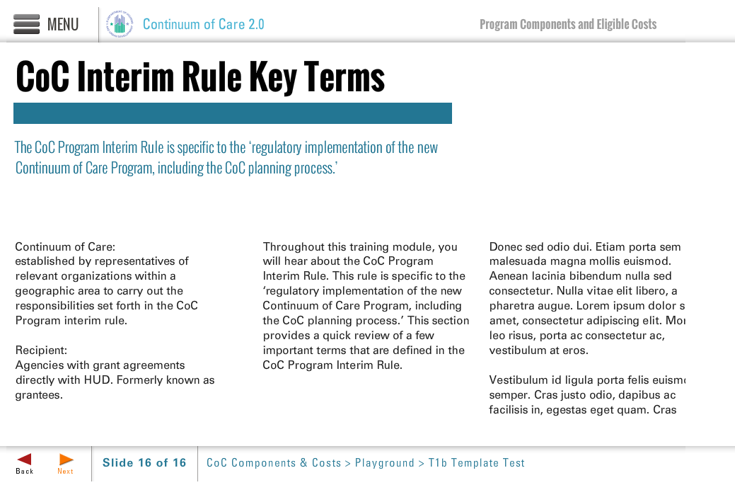
Template | T1b-COC
Menu Title | Permanent Housing Program Components
Title | Permanent Housing Program Components
Subtitle | Overarching principle of Permanent Housing:  Community-based housing without a designated length of stay
Column 1 | A significant portion of this online training focuses on the two models of permanent housing programs and their eligible costs: Permanent Supportive Housing and Rapid Rehousing. You should find this information useful if you are interested in becoming or are currently a recipient or subrecipient of CoC Program funding for permanent housing. It should be noted that the regulations for Permanent Supportive Housing have changed from the
Column 2 | legacy McKinney-Vento programs, and Rapid Rehousing is a completely new program component. Because this module is only able to highlight a few points about each of the program components, it is strongly recommended that you review all regulations, resources, and user guides on the OneCPD website, as recipients and subrecipients are ultimately responsible for ensuring compliance with all applicable regulations.
Column 3
Notes | These will not be included in course output

Page 013

Object | Content
Layout
Template | T1b-COC
Menu Title | PSH: Overview
Title | Permanent Housing—Permanent Supportive Housing (PSH)
Subtitle | A model of permanent housing in which supportive services are provided to assist homeless persons with a disability to live independently.
Column 1 | Permanent Supportive Housing means permanent housing in which supportive services are provided to assist homeless persons with a disability to live independently. Supportive services are designed to meet the needs of participants and must be provided for the entire duration that they are in that housing.  PSH can take many forms. For example, PSH units can be integrated
Column 2 | into a larger building, can be clustered across multiple buildings or be scattered among units in the community. Using CoC Program funds, recipients and subrecipients can build or buy a new building to create PSH units, renovate existing buildings, or rent or lease an entire building or individual units in the community.
Column 3
Notes | These will not be included in course output

Object | Content
Layout
Template | A3-COC
Menu Title | PSH: Defined
Image | ${CONTENT_ROOT}/images/slideimages/psh-h-image1.jpg
Header | Permanent Housing - Permanent Supportive Housing
Bullets | Permanent supportive housing (PSH): Permanent housing in which supportive services are provided to assist homeless persons with a disability to live independently. 0:01  - Household must include a disabled adult or child - Lease must be for a term of at least one year, renewable - Supportive services designed to meet the needs of program participants must be made available - May be single site, scattered sites or clustered, or integrated with affordable or market-rate units 0:10  Key Changes:
Audio File | ${CONTENT_ROOT}/audio/mod1_audio5.mp3
Audio Title | PSH: Defined
Audio CC | Permanent Supportive Housing means permanent housing in which supportive services are provided to assist homeless persons with disabilities to live independently. Supportive services are designed to meet the needs of program participants and must be provided for the entire duration that they are in that housing.
Notes

Page 014

Page 015
Object | Content
Layout
Template | S1-COC
Menu Title | PSH Eligible Cost: Acquisition
Image | ${CONTENT_ROOT}/images/slideimages/span-acquisition.jpg
Header | PSH Eligible Cost:  Acquisition
Body Text | Purchase of a structure to be used to provide housing or services to homeless persons  - Funds may be used to pay up to 100% of the cost of acquisition  - Acquired property must be used for funded purpose for 15 years
Notes | These will not be included in course output

Page 016
Object | Content
Layout
Template | S1-COC
Menu Title | PSH Eligible Cost: Rehabilitation
Image | ${CONTENT_ROOT}/images/slideimages/span-rehab.jpg
Header | PSH Eligible Cost:  Rehabilitation
Body Text | Repair or alteration of structures for homeless persons  - Funds may be used to pay up to 100% of the cost of rehabilitation of structures  - Property must be used for approved purpose for 15 years  - Eligible rehabilitation costs include installing cost-effective energy measures or bringing an existing structure to State and local health and safety standards  - Funds may not be used to rehabilitate leased property
Notes | These will not be included in course output

Page 017
Object | Content
Layout
Template | S1-COC
Menu Title | PSH Eligible Cost: New Construction
Image | ${CONTENT_ROOT}/images/slideimages/span-construction.jpg
Header | PSH Eligible Cost:  New Construction
Body Text | Construction of structures in which homeless persons will reside  - Funds may be used to pay up to 100% of the cost of new construction of a structure or an addition to an existing structure that at least doubles the size of the structure  - Funds may also be used for land associated with the construction  - Constructed structure must be used for funded purpose for 15 years  - Applicant must demonstrate that new construction is less expensive than rehabilitation  - Funds may not be used for new construction on leased property
Notes | These will not be included in course output

Page 018
Object | Content
Layout
Template | S1-COC
Menu Title | PSH Eligible Cost: Leasing
Image | ${CONTENT_ROOT}/images/slideimages/span-leasing.jpg
Header | PSH Eligible Cost:  Leasing
Body Text | Lease of structures or individual units to provide supportive housing or supportive services  - Funds may be used to pay up to 100% of the costs of leasing an individual unit or structure(s)  - Funds may not be used to lease units or structures owned by the recipient, subrecipient, or any related organization  - Lease must be between the property owner and the recipient or subrecipient. Sublease or occupancy agreement must be between the recipient or subrecipient and the program participant.  - Assistance may be used for security deposits and first and last month’s rent
Notes | These will not be included in course output

Page 019
Object | Content
Layout
Template | S1-COC
Menu Title | PSH Eligible Cost: Rental Assistance
Image | ${CONTENT_ROOT}/images/slideimages/span-rental.jpg
Header | PSH Eligible Cost:  Rental Assistance
Body Text | Assistance to pay part of the rent for a unit in which a homeless person will reside  - Assistance may be short- (less than 3 months), medium- (3–24 months), or long- (more than 24 months) term assistance  - Assistance may be tenant-based, project-based or sponsor-based  - Lease must be between the property owner and the program participant.  - Assistance may be used for security deposits, first and last month’s rent, property damages, and vacancy payments
Notes | These will not be included in course output

Page 020
Object | Content
Layout
Template | S1-COC
Menu Title | PSH Eligible Cost: Operating Costs
Image | ${CONTENT_ROOT}/images/slideimages/span-operations.jpg
Header | PSH Eligible Cost:  Operating Costs
Body Text | Day-to-day physical operation of a property in which homeless persons are housed  Funds may be used to pay for the following costs:  - Maintenance and repair of housing  - Building security  - Electricity, gas and water  - Furniture  - Equipment  Funds may also cover the cost of staff and fringe related to these items  Funds may not be used for:  - Emergency shelter or supportive services facilities  - Maintenance and repair costs included in lease  Operating funds may not be combined with rental assistance funds in the same unit or structure.
Notes | These will not be included in course output

Page 021
Object | Content
Layout
Template | S1-COC
Menu Title | PSH Eligible Cost: Supportive Services
Image | ${CONTENT_ROOT}/images/slideimages/span-sso.jpg
Header | PSH Eligible Cost:  Supportive Services
Body Text | Deliver supportive services to assist homeless persons to live as independently as is practicable throughout the duration of their residence in permanent supportive housing  - Services must be necessary to assist program participants obtain and maintain housingFunds may be used to cover the costs of delivering eligible services, including the costs of day-to-day operation of a supportive service facility not contained in a housing structure  Supportive services funds may only be used for services explicitly listed as eligible in the CoC Program interim rule.  - Assessing service needs  - Moving costs  - Case management (including using a coordinated assessment system)  - Child care  - Education services  - Employment assistance & job training  - Food  - Housing search & counseling services  - Legal services  - Life skills training  - Mental health services  - Outpatient health services  - Outreach services  - Substance abuse treatment services  - Transportation  - Utility deposits
Notes | These will not be included in course output

Page 022
Object | Content
Layout
Template | S1-COC
Menu Title | PSH Eligible Cost: HMIS
Image | ${CONTENT_ROOT}/images/slideimages/span-hmis.jpg
Header | PSH Eligible Cost:  Homeless Management Information Systems (HMIS)
Body Text | Costs of contributing and reporting data to the CoC-designated HMIS  Funds may be used to pay for the following costs:  - Purchasing or leasing computer hardware  - Purchasing software or software licenses  - Purchasing or leasing equipment  - Obtaining technical support  - Leasing office space  - Paying utilities necessary to operate or contribute data  - Paying salaries for personnel necessary to contribute or report HMIS data  - Paying for travel for approved training  - Paying staff travel costs to conduct intake  - Paying HMIS participation fees
Notes | These will not be included in course output

Page 023
Object | Content
Layout
Template | S1-COC
Menu Title | PSH Eligible Cost: Project Administration
Image | ${CONTENT_ROOT}/images/slideimages/span-admin.jpg
Header | PSH Eligible Cost:  Project Administration
Body Text | Up to 10% of a CoC Program grant may be used to pay for eligible project administrative costs  Funds may be used to pay for the following costs:  - General management, oversight, and coordination. (Example: Salaries and related costs for preparing budgets, monitoring compliance and evaluating programs.)  - Training on CoC Program requirements. (Example: Costs of providing training on CoC Program requirements and attending HUD-sponsored training.)  - Costs of carrying out the recipient’s environmental review responsibilities.
Notes | These will not be included in course output

Page 024
Object | Content
Layout | 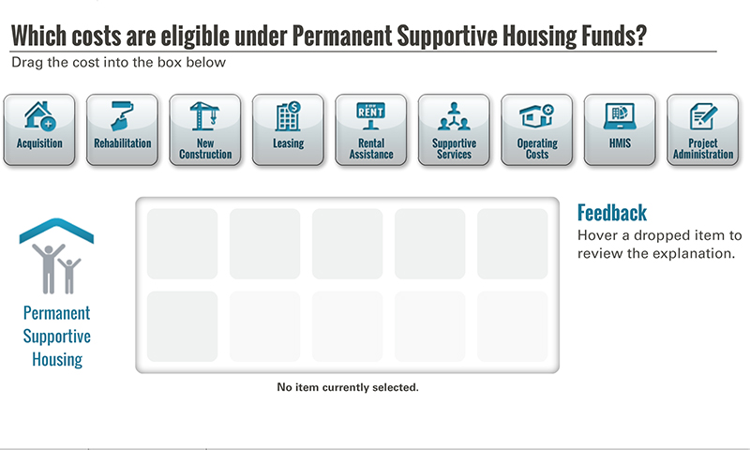
Template | D1-COC
Menu Title | PSH: Activity
Drag and Drop | Drag and Drop Static Components  Activity Title Which costs are eligible under the Permanent Supportive Housing program component?  Activity Prompt Drag the icons into the box below  Feedback Title Feedback  Default Feedback Hover a dropped item to review the explanation.  Default Status No item currently selected.  Activity Graphic ${CONTENT_ROOT}/images/interactives/icons/psh-large.png  Activity Graphic Label Permanent Supportive Housing  Drag and Drop Item 1  Label Acquisition  Icon Path ${CONTENT_ROOT}/images/interactives/icons/acquisition.png  Feedback Purchase of a structure to provide housing to homeless persons is an eligible cost for PSH as long as the acquired property is used for PSH for 15 years.  Status Costs associated with acquiring property to provide housing or supportive services  Correct true  Drag and Drop Item 2  Label Rehabilitation  Icon Path ${CONTENT_ROOT}/images/interactives/icons/rehabilitation.png  Feedback Repair or alteration of structures for homeless persons is an eligible cost under PSH, as long as the property is used for the approved purpose for 15 years. Funding must be used to install cost-effective energy measures or to bring structure to State and local health and safety standards. Funds may not be used to rehabilitate leased property.  Status Costs associated with the renovation of structures to provide housing or supportive services  Correct true  Drag and Drop Item 3  Label New Construction  Icon Path ${CONTENT_ROOT}/images/interactives/icons/new-construction.png  Feedback Construction of structures in which homeless persons will reside is an eligible cost under PSH. This may include an addition to an existing structure. New construction must be less expensive than rehabilitation. Constructed property must be used for PSH for 15 years. Funds may not be used for new construction on leased property.  Status Costs associated with building a new structure to be used as housing  Correct true  Drag and Drop Item 4  Label Leasing  Icon Path ${CONTENT_ROOT}/images/interactives/icons/leasing.png  Feedback Leasing structures or individual units to provide supportive housing is an eligible cost under PSH. Grant may not be used to lease units or structures owned by the grant recipient, subrecipient, or any related organization. Leasing funds may be used for security deposits, first and last months’ rent, and property damages.  Status Costs associated with leasing a structure, part of a structure, or individual units in which housing is provided to homeless persons  Correct True  Drag and Drop Item 5  Label Rental Assistance  Icon Path ${CONTENT_ROOT}/images/interactives/icons/rental-assistance.png  Feedback Assisting with the rent for a unit in which a homeless person will reside is an eligible cost under PSH. Assistance may be short- (less than 3 months), medium- (3-24 months) or long- (more than 24 months) term assistance. Assistance may be tenant-based, project-based or sponsor-based. It may be used for security deposits, first and last months’ rent, property damages, and vacancy payments.  Status Costs associated with providing rental assistance for homeless individuals and families.  Correct True  Drag and Drop Item 6  Label Supportive Services  Icon Path ${CONTENT_ROOT}/images/interactives/icons/supportive-services.png  Feedback Delivering services to assist homeless persons to live as independently as is practicable throughout the duration of their residence in PSH is an eligible cost under PSH. Supportive services include services that assist program participants obtain and maintain housing, however only the services explicitly listed as eligible in the CoC Program interim rule.  Status Costs of providing eligible supportive services that address the special needs of the program participants  Correct True  Drag and Drop Item 7  Label Operating Costs  Icon Path ${CONTENT_ROOT}/images/interactives/icons/operating.png  Feedback Costs associated with the day-to-day physical operation of a property in which homeless persons are housed and staff and fringe costs related to these items are eligible under PSH. Operating funds may not be combined with rental assistance funds in the same unit or structure. Operating funds may not be used to cover the costs related to operating an emergency shelter or supportive services facilities, or for maintenance and repair costs included in a lease.  Status Costs associated with the day-to-day physical operation of a property in which homeless persons are housed  Correct True  Drag and Drop Item 8  Label HMIS  Icon Path ${CONTENT_ROOT}/images/interactives/icons/hmis.png  Feedback Costs of contributing and reporting data to the CoC-designated HMIS are eligible under PSH.  Status Costs associated with contributing or reporting on data to the CoC-designated HMIS.  Correct True  Drag and Drop Item 9  Label Project Administration  Icon Path ${CONTENT_ROOT}/images/interactives/icons/administration.png  Feedback Up to 10% of a CoC Program grant can be used to pay for eligible project administrative costs, including general management, oversight and coordination; training on CoC Program requirements; and costs of carrying out environmental review responsibilities.  Status Costs associated with the administration of the grant  Correct True
Notes | These will not be included in course output

Object | Content
Layout | 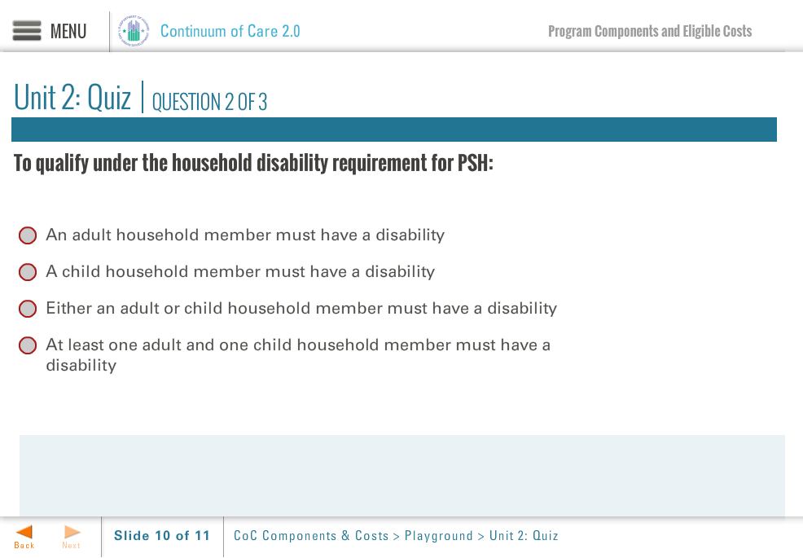
Template | Q1-COC
Menu Title | PSH: Quiz
Title | Unit 2: Quiz
Quiz | Code Mode Randomize Questions Randomize Answers Points Max Attempts  quiz-1 formative false true 100 2  Question In Permanent Supportive Housing, the program participant must be a tenant on the lease for at least one year.  Correct Feedback Answer Options  true correct-fb True  false incorrect-fb False  ID Feedback Text  correct-fb Correct, the answer is true. The program participant must be a tenant on the lease for at least one year.  incorrect-fb Incorrect.  Question To qualify under the household disability requirement for PSH:  Correct Feedback Answer Options  false incorrect-fb An adult household member must have a disability  false incorrect-fb A child household member must have a disability  true correct-fb Either an adult or child household member must have a disability  false incorrect-fb At least one adult and one child household member must have a disability  ID Feedback Text  correct-fb Correct, the answer is: Either an adult or child household member must have a disability  incorrect-fb Incorrect; try again.  Question The first year’s lease can be terminated for any reason as long as the tenant gives 30 days of notice.  Correct Feedback Answer Options  false incorrect-fb True  true correct-fb False  ID Feedback Text  correct-fb Correct, the statement is false. The first year’s lease must be renewable and terminable only for cause.  incorrect-fb Incorrect.
Notes | These will not be included in course output

Page 025

Object | Content
Unit Title | Unit 3: RRH
Abbreviated Title | Unit 3: RRH
Notes | These will not be included in course output

Unit Title (for Word Outline Purposes Only)

Page 026
Object | Content
Layout
Template | T1b-COC
Menu Title | RRH: Overview
Title | Permanent Housing—Rapid Rehousing (RRH)
Subtitle | A model of permanent housing, rapid rehousing provides temporary rental assistance and services to help people who are homeless lease community-based permanent housing.
Column 1 | Permanent Housing-Rapid Rehousing (RRH) is designed to help individuals and families achieve and maintain housing stability as quickly as possible. In support of this goal, recipients and subrecipients may use CoC Program funds to provide supportive services and short-term (up to 3 months) or medium-term (3-24 months) tenant-based rental assistance to homeless households.
Column 2 | Funds cannot be used to buy or renovate a building for the creation of units. Even in cases of short-term rental assistance, the program participant must be placed in permanent housing with a lease that has an initial term of at least one year, renewable and terminable only for cause. An important distinction between PSH and RRH is that while persons assisted may have a disability, it is not a requirement of RRH.
Column 3
Notes | These will not be included in course output

Page 027
Layout | 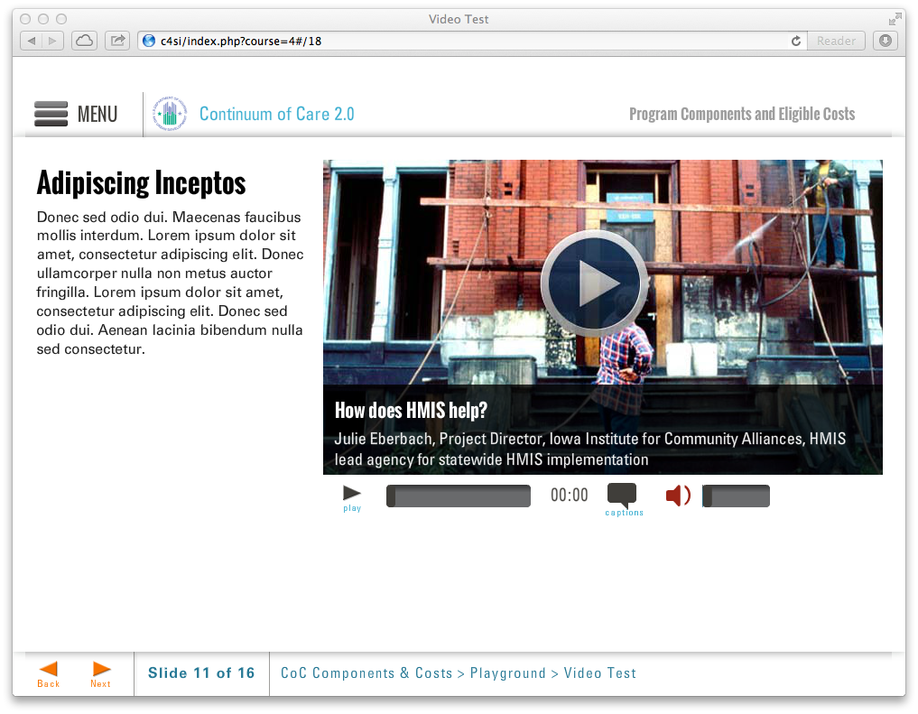
Template | V2-COC
Menu Title | Video: Rapid Rehousing
Title | Video: RRH
Column1 | Rapid Rehousing in the ESG and CoC Programs  RRH is an eligible form of housing under both the Emergency Solutions Grant (ESG) and CoC Programs. However, there are key differences as described by HUD in this video.
Media Path | ${MEDIA_ROOT}/${CONTENT_ROOT}/video/mod1_video_rrh.f4v
Media Poster Path | ${CONTENT_ROOT}/images/vidposters/vidposter-Brett-Gagnon.jpg
Media Title | Brett Gagnon
Media Description | Homeless Programs Specialist
Media CC Title | Rapid Rehousing in the ESG and CoC Programs
Captions | Text for caption 1 0:02  Text for caption 2 0:12  Text for caption 3 0:22  Text for caption 4 0:32  Text for caption 5 0:42  Text for caption 6 0:52
Notes | These will not be included in course output

Page Title

Object | Content
Layout
Template | A3-COC
Menu Title | RRH: Defined
Image | ${CONTENT_ROOT}/images/slideimages/rrh-h-image1.jpg
Header | Rapid Rehousing
Bullets | Characteristics of RRH: - Short- or medium-term tenant-based rental assistance and supportive services designed to help people are homeless obtain and maintain permanent housing - Lease must be between the property owner and the program participant - Initial lease must be for at least one year, renewable and terminable only for cause - Disability is not a requirement for program participants (different from PSH) 0:01  Rapid Rehousing projects must: - Limit rental assistance to no more than 24 months per household - Offer supportive services (any eligible CoC Program supportive services) - Limit supportive services to no more than 6 months after rental assistance stops - Re-evaluate program participants’ income and service needs at least once a year - Require program participant to meet with a case manager at least once a month 0:15  Rapid Rehousing projects may: - Set a maximum amount of rental assistance that a program participant may receive - Set a maximum number of months that a program participant may receive rental assistance, not to exceed 24 months - Set a maximum number of times that a program participant may receive rental assistance - Require program participants to share in the costs of rent 0:20  RRH rental assistance policies must be consistent with the written standards established by the CoC, in consultation with recipients of Emergency Solutions Grants (ESG), and consistently applied. 0:30
Audio File | ${CONTENT_ROOT}/audio/mod1_audio6.mp3
Audio Title | RRH: Defined
Audio CC | This slide describes important characteristics of Rapid Rehousing. These short- or medium-term tenant-based rental assistance and supportive services are intended to help homeless individuals obtain and maintain permanent housing.
Notes | Bullets 2-4 do not have time to build on following the VO. Is this really the best design for this material?
Page 028

Page 029
Object | Content
Layout
Template | S1-COC
Menu Title | RRH Eligible Cost: Rental Assistance
Image | ${CONTENT_ROOT}/images/slideimages/span-rental.jpg
Header | RRH Eligible Cost:  Rental Assistance
Body Text | Funds to pay part of the rent for a unit in which a homeless person will reside  - Rental assistance may be short- (less than 3 months) or medium- (3–24 months)  - Rental assistance must be tenant-based  - Assistance may be used for security deposits, first and last months’ rent, and vacancy payments
Notes | These will not be included in course output

Page 030
Object | Content
Layout
Template | S1-COC
Menu Title | RRH Eligible Cost: Supportive Services
Image | ${CONTENT_ROOT}/images/slideimages/span-sso.jpg
Header | RRH Eligible Cost:  Supportive Services
Body Text | Deliver supportive services to assist homeless persons in the transition from homelessness to permanent housing  - Services must be necessary to assist program participants obtain and maintain housing  - Funds may be used to cover the costs of delivering eligible services, including the costs of day-to-day operation of a supportive service facility not contained in a housing structure  Supportive services funds may only be used for services explicitly listed as eligible in the CoC Program interim rule  - Assessing service needs  - Moving costs  - Case management (including using a coordinated assessment system)  - Child care  - Education services  - Employment assistance & job training  - Food  - Housing search & counseling services  - Legal services  - Life skills training  - Mental health services  - Outpatient health services  - Outreach services  - Substance abuse treatment services  - Transportation  - Utility deposits
Notes | These will not be included in course output

Page 031
Object | Content
Layout
Template | S1-COC
Menu Title | RRH Eligible Cost: HMIS
Image | ${CONTENT_ROOT}/images/slideimages/span-hmis.jpg
Header | RRH Eligible Cost:  Homeless Management Information Systems
Body Text | Costs of contributing and reporting data to the CoC-designated HMIS  Funds may be used to pay for the following costs:  - Purchasing or leasing computer hardware  - Purchasing software or software licenses  - Purchasing or leasing equipment  - Obtaining technical support  - Leasing office space  - Paying utilities necessary to operate or contribute data  - Paying salaries for personnel necessary to contribute or report HMIS data  - Paying for travel for approved training  - Paying staff travel costs to conduct intake  - Paying HMIS participation fees
Notes | These will not be included in course output

Object | Content
Layout
Template | S1-COC
Menu Title | RRH Eligible Cost: Project Administration
Image | ${CONTENT_ROOT}/images/slideimages/span-admin.jpg
Header | RRH Eligible Cost:  Project Administration
Body Text | Up to 10% of a CoC Progam grant may be used to pay for eligible project administrative costs  Funds may be used to pay for the following costs:  - General management, oversight, and coordination. (Example: Salaries and related costs for preparing budgets, monitoring compliance and evaluating programs.)  - Training on CoC Program requirements. (Example: Costs of providing training on CoC Program requirements and attending HUD-sponsored training.)  - Costs of carrying out the recipient’s environmental review responsibilities.
Notes | These will not be included in course output
Page 032
Page 033
Object | Content
Layout
Template | D1-COC
Menu Title | RRH: Activity
Drag and Drop | Drag and Drop Static Components  Activity Title Which costs are eligible under the Rapid Rehousing program component?  Activity Prompt Drag the icons into the box below  Feedback Title Feedback  Default Feedback Hover a dropped item to review the explanation.  Default Status No item currently selected.  Activity Graphic ${CONTENT_ROOT}/images/interactives/icons/rrh-large.png  Activity Graphic Label Rapid Rehousing  Drag and Drop Item 1  Label Acquisition  Icon Path ${CONTENT_ROOT}/images/interactives/icons/acquisition.png  Feedback Purchase of a structure is an eligible cost under Permanent Supportive Housing, Transitional Housing, and Supportive Services Only, but not under Rapid Rehousing.  Status Costs associated with acquiring property to provide housing or supportive services  Correct false  Drag and Drop Item 2  Label Rehabilitation  Icon Path ${CONTENT_ROOT}/images/interactives/icons/rehabilitation.png  Feedback Repair or alteration of structures is an eligible cost under Permanent Supportive Housing, Transitional Housing, and Supportive Services Only, but not under Rapid Rehousing.  Status Costs associated with the renovation of structures to provide housing or supportive services  Correct false  Drag and Drop Item 3  Label New Construction  Icon Path ${CONTENT_ROOT}/images/interactives/icons/new-construction.png  Feedback Construction of new structures is an eligible cost under Permanent Supportive Housing and Transitional Housing only.  Status Costs associated with building a new property to be used as housing  Correct false  Drag and Drop Item 4  Label Leasing  Icon Path ${CONTENT_ROOT}/images/interactives/icons/leasing.png  Feedback Leasing of structures is an eligible cost under Permanent Supportive Housing, Transitional Housing, and Supportive Services Only, but not under Rapid Rehousing.  Status Costs associated with leasing a structure, part of a structure, or individual units in which supportive services or housing are provided to homeless persons  Correct false  Drag and Drop Item 5  Label Rental Assistance  Icon Path ${CONTENT_ROOT}/images/interactives/icons/rental-assistance.png  Feedback Assisting with the rent for a unit in which a homeless person will reside is an eligible cost under RRH. Assistance may be short- (less than 3 months) or medium- (3–24 months) term tenant-based rental assistance. Rental assistance is limited to no more than 24 months per household.  Status Costs associated with providing assistance for homeless individuals and families in paying rent  Correct true  Drag and Drop Item 6  Label Supportive Services  Icon Path ${CONTENT_ROOT}/images/interactives/icons/supportive-services.png  Feedback Delivering services to assist homeless persons in the transition from homelessness to permanent housing is eligible under RRH but service provision, while receiving rental assistance and up to 6 months after rental assistance ends. Supportive services include services that assist program participants to obtain and maintain housing, however only the services explicitly listed as eligible in the CoC Program interim rule.  Status Costs of providing eligible supportive services that address the special needs of the program participants  Correct true  Drag and Drop Item 7  Label Operating Costs  Icon Path ${CONTENT_ROOT}/images/interactives/icons/operating.png  Feedback Costs associated with the day-to-day physical operation of a facility is an eligible cost under Permanent Supportive Housing and Transitional Housing only.  Status Costs associated with the day-to-day physical operation of a property in which homeless persons are housed  Correct false  Drag and Drop Item 8  Label HMIS  Icon Path ${CONTENT_ROOT}/images/interactives/icons/hmis.png  Feedback Costs of contributing and reporting data to the CoC-designated HMIS are eligible under RRH.  Status Costs of contributing and reporting data through CoC-designated HMIS.  Correct True  Drag and Drop Item 9  Label Project Administration  Icon Path ${CONTENT_ROOT}/images/interactives/icons/administration.png  Feedback Up to 10% of a CoC Program grant may be used to pay for eligible project administrative costs, including general management, oversight and coordination; training on CoC Program requirements; and costs of carrying out environmental review responsibilities.  Status Costs associated with the administration of the grant  Correct True
Notes | These will not be included in course output

Object | Content
Layout
Template | Q1-COC
Menu Title | RRH: Quiz
Title | Unit 3: Quiz
Quiz | Code Mode Randomize Questions Randomize Answers Points Max Attempts  quiz-1 formative false true 100 2  Question In Permanent Housing- Rapid Rehousing (RRH), you could serve a homeless family in which no one has a disability.  Correct Feedback Answer Options  true correct-fb True  false incorrect-fb False  ID Feedback Text  correct-fb Correct, the answer is true. Disability is not a requirement for RRH program participants.  incorrect-fb Incorrect.  Question In RRH, projects may provide rental assistance up to 48 months per household.  Correct Feedback Answer Options  false incorrect-fb True  true correct-fb False  ID Feedback Text  correct-fb Correct, the statement is false. Rental assistance is limited to no more than 24 months per household.  incorrect-fb Incorrect.  Question In RRH, it is optional for program participants to meet with a case manager.  Correct Feedback Answer Options  false incorrect-fb True  true correct-fb False  ID Feedback Text  correct-fb Correct, the statement is false. RRH must require program participants to meet with a case manager at least once a month.  incorrect-fb Incorrect.
Notes | These will not be included in course output

Page 034

Object | Content
Unit Title | Unit 4: TH
Abbreviated Title | Unit 4: TH
Notes | These will not be included in course output

Unit Title (for Word Outline Purposes Only)

Page 035
Object | Content
Layout
Template | T1b-COC
Menu Title | TH: Overview
Title | Transitional Housing (TH)
Subtitle | Temporary housing with supportive services designed to facilitate the household’s successful movement to permanent housing within 24 months
Column 1 | Similar to transitional housing funded previously through the Supportive Housing Program, TH funded by the CoC Program may only be provided for up to 24 months. Projects must be operated in alignment with its CoC’s written standards for determining and prioritizing the eligible individuals and families for transitional housing assistance to ensure that the assistance is administered consistently across the CoC.
Column 2
Column 3
Notes | These will not be included in course output

Object | Content
Layout | 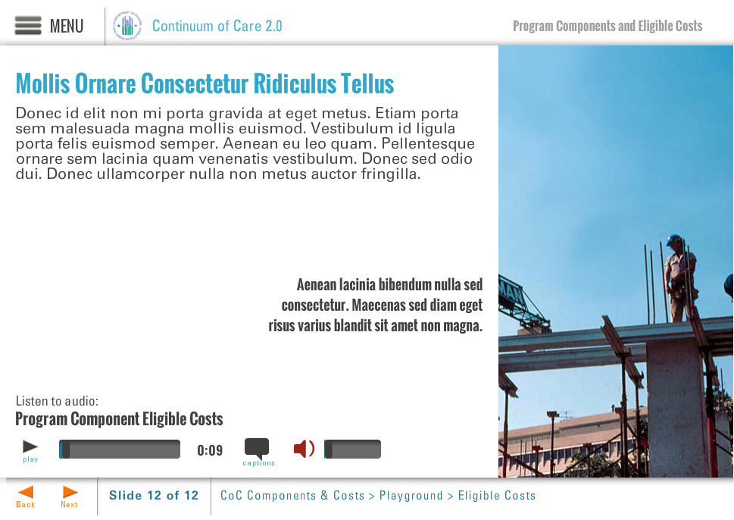
Template | B5-COC
Menu Title | TH: Leases
Image | ${CONTENT_ROOT}/images/slideimages/coc-v-image_0036_iStock_000002418675Small.jpg
Header | Transitional Housing: Leases
Column 1 | Program participants in TH projects must sign a lease or occupancy agreement for a period of at least one month. This agreement must be automatically renewable upon expiration, except on prior notice by either party, up to a maximum term of 24 months.
Bullets | Some homeless people may need to stay in transitional housing longer than 24 months if appropriate permanent housing has not been identified or if more time is needed to achieve independence. 0:00  However, if more than half of the households in a given project have exceeded 24 months of assistance, HUD may discontinue funding to the project. 0:08
Audio File | ${CONTENT_ROOT}/audio/mod1_audio7.mp3
Audio Title | Transitional Housing: Leases
Audio CC | Like permanent housing, program participants must have a lease in transitional housing, that is renewable and terminable for cause; however, unlike leases in permanent housing projects, the initial lease in transitional housing need only be for one month.
Notes

Page 036

Layout
Template | V2-COC
Menu Title | Video: Importance of Leases in the CoC Program
Title | Video: Leases in TH
Column1 | Importance of Leases in the CoC Program  Under the TH program component of the CoC Program, program participants are required to enter into a lease or occupancy agreement. This video provides more information about the importance of this agreement in assisting homeless individuals and families.
Media Path | ${MEDIA_ROOT}/${CONTENT_ROOT}/video/mod1_video_leasing.f4v
Media Poster Path | ${CONTENT_ROOT}/images/vidposters/vidposter-Brett-Gagnon.jpg
Media Title | Brett Gagnon and Lisa Hill
Media Description | Homeless Program Specialists
Media CC Title | Importance of Leases in the CoC Program
Captions | TH program participants must sign a lease or occupancy agreement for a period of at least one month 0:14  Lease/Occupancy agreement must be automatically renewable upon expiration, except on prior notice by either party, up to a maximum term of 24 months 0:20
Notes | These will not be included in course output

Page 037

Object | Content
Layout
Template | B5-COC
Menu Title | TH: Services
Image | ${CONTENT_ROOT}/images/slideimages/coc-v-image_0040_iStock_000000444935Small.jpg
Header | Transitional Housing: Services
Column 1 | To facilitate movement into permanent housing, program participants in TH should have access to a wide range of supportive services the entire time they reside in housing.
Bullets | To help with the delivery and coordination of services, the recipient or subrecipient can require program participants receiving rental assistance in transitional housing to reside in a particular unit or building while receiving assistance. 0:01  Recipients and subrecipients can provide services to former residents of TH for up to six months after leaving TH. This extension of services is to assist in the household’s transition into independent living. 0:10
Audio File | ${CONTENT_ROOT}/audio/mod1_audio8.mp3
Audio Title | Transitional Housing: Services
Audio CC | Program participants in Transitional Housing are intended to have access to a wide range of supportive services while they reside in transitional housing. Services may also extend for up to 6 months beyond a resident’s stay in transitional housing to help stabilize the person in permanent housing.
Notes

Page 038

Object | Content
Layout
Template | S1-COC
Menu Title | TH Eligible Cost: Acquisition
Image | ${CONTENT_ROOT}/images/slideimages/span-acquisition.jpg
Header | TH Eligible Cost:  Acquisition
Body Text | Purchase of a structure to be used to provide housing to homeless persons  - Funds may be used to pay up to100% of the cost of acquisition  - Acquired property must be used for funded purpose for 15 years  Example: An organization buys a building to create transitional housing for homeless women with mental illness and the property remains for this use for 15 years.
Notes | These will not be included in course output
Page 039
Object | Content
Layout
Template | S1-COC
Menu Title | TH Eligible Cost: Rehabilitation
Image | ${CONTENT_ROOT}/images/slideimages/span-rehab.jpg
Header | TH Eligible Cost:  Rehabilitation
Body Text | Repair or alteration of structures for homeless persons  - Funds may be used to pay up to 100% of the cost of rehabilitation of structures  - Property must be used for approved purpose for 15 years  - Eligible rehabilitation costs include installing cost-effective energy measures or bringing an existing structure to State and local health and safety standards  - Funds may not be used to rehabilitate leased property
Notes | These will not be included in course output
Page 040
Object | Content
Layout
Template | S1-COC
Menu Title | TH Eligible Cost: New Construction
Image | ${CONTENT_ROOT}/images/slideimages/span-construction.jpg
Header | TH Eligible Cost:  New Construction
Body Text | Construction of structures in which homeless persons will reside  - Funds may be used to pay up to 100% of the cost of new construction of a structure of an addition to an existing structure that at least doubles the size of the structure  - Constructed structure must be used for funded purpose for 15 years  - Applicant must demonstrate that new construction is less expensive than rehabilitation  - Funds may not be used for new construction on leased property
Notes | These will not be included in course output
Page 041
Object | Content
Layout
Template | S1-COC
Menu Title | TH Eligible Cost: Leasing
Image | ${CONTENT_ROOT}/images/slideimages/span-leasing.jpg
Header | TH Eligible Cost:  Leasing
Body Text | Lease of structures or individual units to provide transitional housing  - Funds may be used to pay up to 100% of the costs of leasing an individual unit or structure(s)  - Funds may not be used to lease units or structures owned by the recipient, subrecipient, or any related organization  - Lease must be between the property owner and the recipient or subrecipient. Sublease or occupancy agreement must be between the recipient or subrecipient and the program participant.  - Assistance may be used for security deposits and first and last month’s rent
Notes | These will not be included in course output
Page 042
Object | Content
Layout
Template | S1-COC
Menu Title | TH Eligible Cost: Rental Assistance
Image | ${CONTENT_ROOT}/images/slideimages/span-rental.jpg
Header | TH Eligible Cost:  Rental Assistance
Body Text | Assistance to pay part of the rent for a unit in which a homeless person will reside  - Assistance may be short- (less than 3 months) or medium- (3–24 months)  - Assistance may be tenant-based, project-based or sponsor-based  - Lease must be between the property owner and the program participant.  - Assistance may be used for security deposits, first and last month’s rent, property damages, and vacancy payments
Notes | These will not be included in course output
Page 043
Object | Content
Layout
Template | S1-COC
Menu Title | TH Eligible Cost: Operating Costs
Image | ${CONTENT_ROOT}/images/slideimages/span-operations.jpg
Header | TH Eligible Cost:  Operating Costs
Body Text | Day-to-day physical operation of a property in which homeless persons are housed  Funds may be used to pay for the following costs:  - Maintenance and repair of housing  - Building security  - Electricity, gas and water  - Furniture  - Equipment  Funds may also cover the cost of staff and fringe related to these items  Funds may not be used for:  - Emergency shelter or supportive services facilities  - Maintenance and repair costs included in lease  Operating funds may not be combined with rental assistance funds in the same unit or structure.
Notes | These will not be included in course output
Page 044
Object | Content
Layout
Template | S1-COC
Menu Title | TH Eligible Cost: Supportive Services
Image | ${CONTENT_ROOT}/images/slideimages/span-sso.jpg
Header | TH Eligible Cost:  Supportive Services
Body Text | Deliver supportive services to assist homeless persons in the transition from homelessness to permanent housing  - Services must be necessary to assist program participants to obtain and maintain housing  - Funds may be used to cover the costs of delivering eligible services, including the costs of day-to-day operation of a supportive service facility not contained in a housing structure  Supportive services funds may only be used for services explicitly listed as eligible in the CoC Program interim rule  - Assessing service needs  - Moving costs  - Case management (including using a coordinated assessment system)  - Child care  - Education services  - Employment assistance & job training  - Food  - Housing search & counseling services  - Legal services  - Life skills training  - Mental health services  - Outpatient health services  - Outreach services  - Substance abuse treatment services  - Transportation  - Utility deposits
Notes | These will not be included in course output
Page 045
Object | Content
Layout
Template | S1-COC
Menu Title | TH Eligible Cost: HMIS
Image | ${CONTENT_ROOT}/images/slideimages/span-hmis.jpg
Header | TH Eligible Cost:  Homeless Management Information Systems
Body Text | Costs of contributing and reporting data to the CoC-designated HMIS  Funds may be used to pay for the following costs:  - Purchasing or leasing computer hardware  - Purchasing software or software licenses  - Purchasing or leasing equipment  - Obtaining technical support  - Leasing office space  - Paying utilities necessary to operate or contribute data  - Paying salaries for personnel necessary to contribute or report HMIS data  - Paying for travel for approved training  - Paying staff travel costs to conduct intake  - Paying HMIS participation fees
Notes | These will not be included in course output
Page 046
Object | Content
Layout
Template | S1-COC
Menu Title | TH Eligible Cost: Project Administration
Image | ${CONTENT_ROOT}/images/slideimages/span-admin.jpg
Header | TH Eligible Cost:  Project Administration
Body Text | Up to 10% of a CoC Program grant may be used to pay for eligible project administrative costs  Funds may be used to pay for the following:  - General management, oversight, and coordination. (Example: Salaries and related costs for preparing budgets, monitoring compliance and evaluating programs.)  - Training on CoC Program requirements. (Example: Costs of providing training on CoC Program requirements and attending HUD-sponsored training.)  - Costs of carrying out the recipient’s environmental review responsibilities.
Notes | These will not be included in course output
Page 047

Page 048
Object | Content
Layout
Template | D1-COC
Menu Title | TH: Activity
Drag and Drop | Drag and Drop Static Components  Activity Title Which costs are eligible under the Transitional Housing program component?  Activity Prompt Drag the icons into the box below  Feedback Title Feedback  Default Feedback Hover a dropped item to review the explanation.  Default Status No item currently selected.  Activity Graphic ${CONTENT_ROOT}/images/interactives/icons/th-large.png  Activity Graphic Label Transitional Housing  Drag and Drop Item 1  Label Acquisition  Icon Path ${CONTENT_ROOT}/images/interactives/icons/acquisition.png  Feedback Purchase of a structure to provide housing or services to homeless persons is an eligible cost for Transitional Housing (TH) as long as the acquired property is used for TH for 15 years.  Status Costs associated with acquiring property to provide housing or supportive services  Correct true  Drag and Drop Item 2  Label Rehabilitation  Icon Path ${CONTENT_ROOT}/images/interactives/icons/rehabilitation.png  Feedback Repair or alteration of structures for homeless persons is an eligible cost under TH, as long as the property is used for the approved purpose for 15 years. Funding must be used to install cost-effective energy measures or to bring structure to State and local health and safety standards. Grant may not be used to rehabilitate leased property.  Status Costs associated with the renovation of structures to provide housing or supportive services  Correct true  Drag and Drop Item 3  Label New Construction  Icon Path ${CONTENT_ROOT}/images/interactives/icons/new-construction.png  Feedback Construction of structures in which homeless persons will reside is an eligible cost under TH. This may include an addition to an existing structure. Applicant must demonstrate that new construction is less expensive than rehabilitation. Constructed property must be used for TH for 15 years. Funds may not be used for new construction on leased property.  Status Costs associated with building a new structure to be used as housing  Correct true  Drag and Drop Item 4  Label Leasing  Icon Path ${CONTENT_ROOT}/images/interactives/icons/leasing.png  Feedback Leasing structures or individual units to provide supportive housing or supportive services is an eligible cost under TH. Funds may not be used to lease units or structures owned by the grant recipient, subrecipient, or any related organization.  Status Costs associated with leasing a structure, part of a structure, or individual units in which supportive services or housing are provided to homeless persons  Correct true  Drag and Drop Item 5  Label Rental Assistance  Icon Path ${CONTENT_ROOT}/images/interactives/icons/rental-assistance.png  Feedback Assisting with the rent for a unit in which a homeless person will reside is an eligible cost under TH. Assistance may be short- (less than 3 months) or medium- (3-24 months) term assistance. Assistance may be tenant-based, project-based or sponsor-based. Funds may be used for security deposits and first and last months’ rent.  Status Costs associated with providing rental assistance for homeless individuals and families  Correct True  Drag and Drop Item 6  Label Supportive Services  Icon Path ${CONTENT_ROOT}/images/interactives/icons/supportive-services.png  Feedback Delivering services to assist homeless persons in the transition from homelessness to permanent housing is an eligible cost under TH. Supportive services include services that assist program participants obtain and maintain housing, however only the services explicitly listed as eligible in the CoC Program interim rule (e.g. education services, case management, mental health services, food, moving costs).  Status Costs of providing eligible supportive services that address the special needs of the program participants  Correct true  Drag and Drop Item 7  Label Operating Costs  Icon Path ${CONTENT_ROOT}/images/interactives/icons/operating.png  Feedback Costs associated with the day-to-day physical operation of a facility in which homeless persons are and staff and fringe costs related to these items are eligible under TH. Operating funds may not be combined with rental assistance funds in the same unit or structure. Operating funds may not be used to cover costs associated with operating an emergency shelter or supportive services facilities, or for maintenance and repair costs that are included in a lease.  Status Costs associated with the day-to-day physical operation of a property in which homeless persons are housed  Correct true  Drag and Drop Item 8  Label HMIS  Icon Path ${CONTENT_ROOT}/images/interactives/icons/hmis.png  Feedback Costs of contributing or reporting data to the CoC-designated HMIS are eligible under TH.  Status Costs associated with contributing or reporting data to the CoC-designated HMIS.  Correct true  Drag and Drop Item 9  Label Project Administration  Icon Path ${CONTENT_ROOT}/images/interactives/icons/administration.png  Feedback Up to 10% of a CoC Program grant may be used to pay for eligible project administrative costs, including general management, oversight and coordination; training on CoC Program requirements; and costs of carrying out environmental review responsibilities.  Status Costs associated with the administration of the grant  Correct true
Notes | These will not be included in course output

Object | Content
Layout
Template | Q1-COC
Menu Title | TH: Quiz
Title | Unit 4: Quiz
Quiz | Code Mode Randomize Questions Randomize Answers Points Max Attempts  quiz-1 formative false true 100 2  Question In Transitional Housing (TH), leases have a minimum term of 12 months.  Correct Feedback Answer Options  false incorrect-fb True  true correct-fb False  ID Feedback Text  incorrect-fb Incorrect.  correct-fb Correct, the statement is false. In TH, leases have a minimum term of 1 month, but must be renewable up to a maximum of 24 months.  Question In Transitional Housing (TH), projects must provide access to supportive services to program participants while they reside in TH.  Correct Feedback Answer Options  true correct-fb True  false incorrect-fb False  ID Feedback Text  correct-fb Correct, the answer is true. Projects must provide access to supportive services to program participants for the entire time they reside in TH.  incorrect-fb Incorrect.  Question In Transitional Housing (TH), projects may provide services to program participants for up to 12 months after leaving TH.  Correct Feedback Answer Options  false incorrect-fb True  true correct-fb False  ID Feedback Text  correct-fb Correct, the statement is false. Projects may provide services to program participants only up to 6 months after leaving TH.  incorrect-fb Incorrect.
Notes | These will not be included in course output
Page 049
Object | Content
Unit Title | Unit 5: SSO
Abbreviated Title | Unit 5: SSO
Notes | These will not be included in course output

Unit Title (for Word Outline Purposes Only)

Page 050
Object | Content
Layout
Template | T1b-COC
Menu Title | SSO: Overview
Title | Supportive Services Only (SSO)
Subtitle | Supportive services for unsheltered and sheltered homeless persons for whom the recipient is not also providing housing or housing assistance.
Column 1 | Similar to the Supportive Services Only (SSO) component under the Supportive Housing Program, the SSO program component under the CoC Program is designed to allow recipients and subrecipients to provide services to homeless individuals and families, independent of their housing. Under the SSO component, recipients or subrecipients can pay for acquisition, rehabilitation, or leasing of a building in which supportive services will be
Column 2 | provided as long as housing is not also provided at that location, such as a drop-in center. SSO projects may be in a structure at one central site, or in multiple buildings at scattered sites where services are delivered. SSO projects may also be operated independent of a building, like street outreach or mobile vans for health care, and in a variety of settings, including in homeless programs operated by other agencies or units
Column 3 | leased by the program participants. For example, a recipient or subrecipient could operate an SSO project that provides employment services to the residents of TH or mainstream resource benefits counseling to residents in an emergency shelter. SSO projects can also provide services to current residents of PH who were homeless in the prior six months to assist in their adjustment to independent living.
Notes | These will not be included in course output

Object | Content
Layout
Template | S1-COC
Menu Title | SSO Eligible Cost: Acquisition
Image | ${CONTENT_ROOT}/images/slideimages/span-acquisition.jpg
Header | SSO Eligible Cost:  Acquisition
Body Text | Purchase of a structure to be used to provide services to homeless persons  - Funds may pay up to 100% of the cost of acquisition  - Acquired property must be used for funded purpose for 15 years
Notes | These will not be included in course output
Page 051
Object | Content
Layout
Template | S1-COC
Menu Title | SSO Eligible Cost: Rehabilitation
Image | ${CONTENT_ROOT}/images/slideimages/span-rehab.jpg
Header | SSO Eligible Cost:  Rehabilitation
Body Text | Repair or alteration of structures for homeless persons  - Funds may be used to pay 100% of the cost of rehabilitation of structures  - Property must be used for approved purpose for 15 years  - Eligible rehabilitation costs include installing cost-effective energy measures or bringing the structure to State and local health and safety standards  - Funds may not be used to rehabilitate leased property
Notes | These will not be included in course output
Page 052
Object | Content
Layout
Template | S1-COC
Menu Title | SSO Eligible Cost: Leasing
Image | ${CONTENT_ROOT}/images/slideimages/span-leasing.jpg
Header | SSO Eligible Cost:  Leasing
Body Text | Lease of structures or individual units to provide supportive services  - Funds may be used to pay up to 100% of the costs of leasing a structure(s) for the delivery of supportive services  - Funds may not be used to lease structures owned by the recipient, subrecipient, or any related organization  - Assistance may be used for security deposits and first and last month’s rent
Notes | These will not be included in course output
Page 053
Object | Content
Layout
Template | S1-COC
Menu Title | SSO Eligible Cost: Supportive Services
Image | ${CONTENT_ROOT}/images/slideimages/span-sso.jpg
Header | SSO Eligible Cost:  Supportive Services
Body Text | Deliver supportive services to assist homeless persons in the transition from homelessness to permanent housing  - Services must be necessary to assist program participants obtain and maintain housing  - Funds may be used to cover the costs of delivering eligible services, including the costs of day-to-day operation of a supportive service facility not contained in a housing structure  Supportive services funds may only be used for services explicitly listed as eligible in the CoC Program interim rule  - Assessing service needs  - Moving costs  - Case management (including using the required coordinated entry system)  - Child care  - Education services  - Employment assistance & job training  - Food  - Housing search & counseling services  - Legal services  - Life skills training  - Mental health services  - Outpatient health services  - Outreach services  - Substance abuse treatment services  - Transportation  - Utility Deposits
Notes | These will not be included in course output
Page 054
Object | Content
Layout
Template | S1-COC
Menu Title | SSO Eligible Cost: HMIS
Image | ${CONTENT_ROOT}/images/slideimages/span-hmis.jpg
Header | SSO Eligible Cost:  Homeless Management Information Systems
Body Text | Costs of contributing and reporting data to the CoC-designated HMIS  Funds may be used to pay for the following costs:  - Purchasing or leasing computer hardware  - Purchasing software or software licenses  - Purchasing or leasing equipment  - Obtaining technical support  - Leasing office space  - Paying utilities necessary to operate or contribute data  - Paying salaries for personnel necessary to contribute or report HMIS data  - Paying for travel for approved training  - Paying staff travel costs to conduct intake  - Paying HMIS participation fees
Notes | These will not be included in course output
Page 055
Object | Content
Layout
Template | S1-COC
Menu Title | SSO Eligible Cost: Project Administration
Image | ${CONTENT_ROOT}/images/slideimages/span-admin.jpg
Header | SSO Eligible Cost:  Project Administration
Body Text | Up to 10% of a CoC Program grant may be used to pay for eligible project administrative costs  Funds may be used to pay for the following costs:  - General management, oversight, and coordination. (Example: Salaries and related costs for preparing budgets, monitoring compliance and evaluating programs.)  - Training on CoC Program requirements. (Example: Costs of providing training on CoC Program requirements and attending HUD-sponsored training.)  - Costs of carrying out the recipient’s environmental review responsibilities.
Notes | These will not be included in course output
Page 056

Page 057

Object | Content
Layout
Template | D1-COC
Menu Title | SSO: Activity
Drag and Drop | Drag and Drop Static Components  Activity Title Which costs are eligible under the Supportive Services Only program component?  Activity Prompt Drag the icons into the box below  Feedback Title Feedback  Default Feedback Hover a dropped item to review the explanation.  Default Status No item currently selected.  Activity Graphic ${CONTENT_ROOT}/images/interactives/icons/sso-large.png  Activity Graphic Label Supportive Services Only  Drag and Drop Item 1  Label Acquisition  Icon Path ${CONTENT_ROOT}/images/interactives/icons/acquisition.png  Feedback Purchase of a structure to provide services to homeless persons is an eligible cost for SSO as long as the acquired property is used for the approved purpose for 15 years.  Status Costs associated with acquiring property to provide supportive services  Correct true  Drag and Drop Item 2  Label Rehabilitation  Icon Path ${CONTENT_ROOT}/images/interactives/icons/rehabilitation.png  Feedback Repair or alteration of structures to deliver services to homeless persons is an eligible cost under SSO, as long as the property is used for the approved purpose for 15 years. Funding must be used to install cost-effective energy measures or to bring structure to State and local health and safety standards. Funds may not be used to rehabilitate leased property.  Status Costs associated with the renovation of structures to provide supportive services  Correct true  Drag and Drop Item 3  Label New Construction  Icon Path ${CONTENT_ROOT}/images/interactives/icons/new-construction.png  Feedback Construction of new structures is an eligible cost under Permanent Supportive Housing and Transitional Housing only.  Status Costs associated with building a new property to be used as housing  Correct false  Drag and Drop Item 4  Label Leasing  Icon Path ${CONTENT_ROOT}/images/interactives/icons/leasing.png  Feedback Leasing structures to provide supportive services is an eligible cost under SSO. Funds may not be used to lease units or structures owned by the grant recipient, subrecipient, or any related organization.  Status Costs associated with leasing a structure, part of a structure, or individual units in which supportive services are provided to homeless persons  Correct true  Drag and Drop Item 5  Label Rental Assistance  Icon Path ${CONTENT_ROOT}/images/interactives/icons/rental-assistance.png  Feedback Assisting with the rent for a unit in which a homeless person will reside is an eligible cost under several program components—Permanent Supportive Housing, Rapid Rehousing, Transitional Housing, and Homelessness Prevention—but not under Supportive Services Only.  Status Costs associated with providing assistance for homeless individuals and families in paying rent  Correct false  Drag and Drop Item 6  Label Supportive Services  Icon Path ${CONTENT_ROOT}/images/interactives/icons/supportive-services.png  Feedback Delivering services to assist homeless persons in the transition from homelessness to permanent housing is an eligible cost under SSO. Supportive services include services that assist program participants obtain and maintain housing, however only the services explicitly listed as eligible in the CoC Program interim rule  Status Costs of providing eligible supportive services that address the special needs of the program participants  Correct true  Drag and Drop Item 7  Label Operating Costs  Icon Path ${CONTENT_ROOT}/images/interactives/icons/operating.png  Feedback Costs associated with the day-to-day physical operation of a facility is an eligible cost under Permanent Supportive Housing and Transitional Housing only. Costs of operating a supportive service facility are considered costs associated with delivering supportive services and are eligible supportive services costs.  Status Costs associated with the day-to-day physical operation of a property in which homeless persons are housed  Correct false  Drag and Drop Item 8  Label HMIS  Icon Path ${CONTENT_ROOT}/images/interactives/icons/hmis.png  Feedback HMIS is an eligible cost under SSO, including the costs associated with contributing or reporting data to the CoC-designated HMIS.  Status Costs associated with contributing or reporting data to the CoC-designated HMIS.  Correct true  Drag and Drop Item 9  Label Project Administration  Icon Path ${CONTENT_ROOT}/images/interactives/icons/administration.png  Feedback Up to 10% of a CoC Program grant may be used to pay for eligible project administrative costs, including general management, oversight and coordination; training on CoC Program requirements; and costs of carrying out environmental review responsibilities.  Status Costs associated with the administration of the grant  Correct true
Notes | These will not be included in course output

Object | Content
Layout
Template | Q1-COC
Menu Title | SSO: Quiz
Title | Unit 5: Quiz
Quiz | Code Mode Randomize Questions Randomize Answers Points Max Attempts  quiz-1 formative false true 100 2  Question Supportive Services Only (SSO) projects may serve homeless persons for whom they are also providing housing assistance.  Correct Feedback Answer Options  false incorrect-fb True  true correct-fb False  ID Feedback Text  incorrect-fb Incorrect.  correct-fb Correct, the statement is false. Supportive Services Only (SSO) projects may not serve program participants for whom they are also providing housing assistance.  Question Supportive Services Only (SSO) projects may provide services at one central site or in multiple sites.  Correct Feedback Answer Options  true correct-fb True  false incorrect-fb False  ID Feedback Text  correct-fb Correct, the answer is true. These services may be provided in a structure at one central site or in multiple buildings at scattered sites.  incorrect-fb Incorrect.
Notes | These will not be included in course output
Page 058
Object | Content
Unit Title | Unit 6: HMIS
Abbreviated Title | Unit 6: HMIS
Notes | These will not be included in course output

Unit Title (for Word Outline Purposes Only)

Page 059
Object | Content
Layout
Template | T1b-COC
Menu Title | HMIS: Overview
Title | HMIS
Subtitle | The HMIS lead designated by the CoC may apply for CoC Program funds to establish and operate the CoC's HMIS.
Column 1 | A CoC addresses the issue of homelessness by identifying local needs and designing a system of housing and services to meet those needs. Integral to its success is the development of complete and accurate data about the extent and nature of homelessness within its geography, which is why HUD requires recipients and subrecipients to participate in the HMIS. Costs associated with using this database are reflected throughout all of
Column 2 | the program components discussed in this training module. However, the HMIS Program Component is specific to actual costs associated with enabling the CoC’s designated HMIS Lead Agency to implement and maintain the CoC’s HMIS.  The costs associated with implementing an HMIS, including leasing and operating costs associated with the building in which the HMIS is
Column 3 | housed, are all eligible activities under the HMIS program component.  Only the HMIS Lead Agency may apply for funds under the HMIS program component.
Notes | These will not be included in course output

Object | Content
Layout
Template | A3-COC
Menu Title | HMIS: Eligible Costs
Image | ${CONTENT_ROOT}/images/slideimages/coc-h-image_0030.jpg
Header | HMIS:  Eligible Costs
Bullets | Eligible HMIS costs under the HMIS program component: 0:45  Leasing and operating the facility in which the HMIS is based 0:53  Hosting and maintaining HMIS software or data 0:58  Backing-up, recovering, or repairing HMIS software or data 1:03  Upgrading, customizing, and enhancing the HMIS 1:06  Integrating and warehousing data 1:07  Administering the system 1:10  Reporting to providers, the Continuum of Care, and HUD 1:12  Conducting HMIS training, including traveling to the training 1:15  Administration of the CoC Program grant 1:20
Image Sequence | Image Source Time Cue Audio Cue  /content/shared/images/placeholders/placeholder.jpg 0:00
Audio File | ${CONTENT_ROOT}/audio/mod1_audio9.mp3
Audio Title | HMIS: Eligible Costs
Audio CC | A CoC addresses the issue of homelessness by identifying local needs and designing a system of housing and services to meet those needs. Integral to the system’s success is the availability of complete and accurate data about homelessness to inform ongoing decision-making, which is why HUD requires recipients and subrecipients to participate in the HMIS. Recipients can fund costs associated with contributing data to the CoC-designated HMIS under any of the program components; however, the HMIS lead agency can apply for additional funds under the HMIS Program Component to cover costs associated with enabling the CoC designated HMIS Lead Agency to implement and maintain the CoC’s HMIS. There are several eligible costs under the HMIS program component that are specific to the HMIS lead agency. They include leasing and operating the facility in which the HMIS is based; hosting and maintaining HMIS software or data; backing-up, recovering, or repairing HMIS software or data; upgrading, the HMIS; integrating and warehousing data; administering the system; reporting to providers, the Continuum of Care, and HUD; conducting HMIS training, including traveling to the training; and cost associated with administration of the CoC program grant.
Notes

Page 060

Page 061
Object | Content
Layout
Template | Q1-COC
Menu Title | HMIS: Quiz
Title | Unit 6: Quiz
Quiz | Code Mode Randomize Questions Randomize Answers Points Max Attempts  quiz-1 formative false true 100 2  Question Any CoC recipient or subrecipient can apply for funds under the HMIS program component.  Correct Feedback Answer Options  false incorrect-fb True  true correct-fb False  ID Feedback Text  correct-fb Correct, the statement is false. Only the HMIS Lead Agency may apply for and receive HMIS program component funds.  incorrect-fb Incorrect.  Question Only the HMIS Lead Agency may receive funds to cover the costs of contributing and reporting data to the CoC-designated HMIS.  Correct Feedback Answer Options  false incorrect-fb True  true correct-fb False  ID Feedback Text  correct-fb Correct, the statement is false. Recipients of funds under other CoC Program component (i.e., TH, PH, SSO) may charge expenses associated with contributing HMIS data (e.g. putting client data into the HMIS) under the HMIS budget line item for that component.  incorrect-fb Incorrect.  Question Eligible costs under the HMIS program component include conducting HMIS training.  Correct Feedback Answer Options  true correct-fb True  false incorrect-fb False  ID Feedback Text  correct-fb Correct, the answer is true. Conducting HMIS training, including traveling to the training, is an eligible cost for the HMIS lead under the HMIS program component.  incorrect-fb Incorrect.  Question Which of the following are eligible HMIS costs under the HMIS program component?  Correct Feedback Answer Options  false incorrect-fb a. Leasing and operating the facility in which the HMIS is based  false incorrect-fb b. Backing-up, recovering, or repairing HMIS software or data  false incorrect-fb c. Upgrading, customizing, and enhancing the HMIS  false incorrect-fb Both a. and c.  true correct-fb All of the above  ID Feedback Text  correct-fb Correct, the answer is all of the above. All of these are eligible costs under the HMIS program component for Lead Agencies.  incorrect-fb Incorrect.
Notes | These will not be included in course output

Object | Content
Unit Title | Unit 7: HP
Abbreviated Title | Unit 7: HP
Notes | These will not be included in course output

Unit Title (for Word Outline Purposes Only)

Page 062
Object | Content
Layout
Template | T1b-COC
Menu Title | HP: Overview
Title | Homelessness Prevention
Subtitle | In CoCs that have been designated by HUD as high-performing communities (HPCs), CoC Program funds may be used for homelessness prevention.
Column 1 | Homelessness Prevention provides short- and medium-term rental assistance and supportive services to prevent persons at risk of homelessness from becoming homeless, consistent with the homelessness prevention activities allowed under the Emergency Solutions Grants Program. To be eligible to use funds for Homelessness Prevention, the recipient must be in a CoC that has been designated by HUD
Column 2 | as a high-performing community. Each year, HUD will select up to 10 CoCs that meet established standards and designate them as High-Performing Communities.
Notes | These will not be included in course output

Object | Content
Layout
Template | S1-COC
Menu Title | HP Eligible Cost: Rental Assistance
Image | ${CONTENT_ROOT}/images/slideimages/span-rental.jpg
Header | Homelessness Prevention Eligible Cost:  Rental Assistance
Body Text | Assistance to pay part of the rent for a unit in which a homeless person will reside  - Assistance may be short- (less than 3 months) or medium- (3–24 months)term assistance  - Assistance may be tenant-based, project-based or sponsor-based  - Lease must be between the property owner and the program participant.  - Assistance may be used for security deposits and first and last months’ rent  - Rental assistance must be administered consistent with the CoC’s written standards, developed in conjunction with the Emergency Solutions Grants recipients
Notes | These will not be included in course output
Page 063

Object | Content
Layout
Template | S1-COC
Menu Title | HP Eligible Cost: Supportive Services
Image | ${CONTENT_ROOT}/images/slideimages/span-sso.jpg
Header | Homelessness Prevention Eligible Cost:  Supportive Services
Body Text | Deliver supportive services to assist persons at risk of homelessness in order to prevent homelessness and achieve housing stability  - Only housing relocation and stabilization services are eligible, consistent with the regulations of the Emergency Shelter Grants Program  - Services must be delivered consistent with the CoC’s written standards, developed in conjunction with the Emergency Solutions Grants recipients
Notes | These will not be included in course output
Page 064

Object | Content
Layout
Template | S1-COC
Menu Title | HP Eligible Cost: HMIS
Image | ${CONTENT_ROOT}/images/slideimages/span-hmis.jpg
Header | Homelessness Prevention Eligible Cost:  Homeless Management Information Systems
Body Text | Costs of contributing and reporting data to the CoC-designated HMIS  Funds may be used to pay for the following costs:  - Purchasing or leasing computer hardware  - Purchasing software or software licenses  - Purchasing or leasing equipment  - Obtaining technical support  - Leasing office space  - Paying utilities necessary to operate or contribute data  - Paying salaries for personnel necessary to contribute or report HMIS data  - Paying for travel for approved training  - Paying staff travel costs to conduct intake  - Paying HMIS participation fees
Notes | These will not be included in course output
Page 065
Object | Content
Layout
Template | S1-COC
Menu Title | HP Eligible Cost: Project Administration
Image | ${CONTENT_ROOT}/images/slideimages/span-admin.jpg
Header | Homelessness Prevention Eligible Cost:  Project Administration
Body Text | Up to 10% of a CoC Program grant may be used to pay for eligible project administrative costs  Funds may be used for the following costs:  - General management, oversight, and coordination. (Example: Salaries and related costs for preparing budgets, monitoring compliance and evaluating programs.)  - Training on CoC Program requirements. (Example: Costs of providing training on CoC Program requirements and attending HUD-sponsored training.)  - Costs of carrying out the recipient’s environmental review responsibilities.
Notes | These will not be included in course output
Page 066

Page 067

Object | Content
Layout
Template | D1-COC
Menu Title | HP: Activity
Drag and Drop | Drag and Drop Static Components  Activity Title Which costs are eligible under the Homelessness Prevention program component?  Activity Prompt Drag the icons into the box below  Feedback Title Feedback  Default Feedback Hover a dropped item to review the explanation.  Default Status No item currently selected.  Activity Graphic ${CONTENT_ROOT}/images/interactives/icons/sso-large.png  Activity Graphic Label Homelessness Prevention  Drag and Drop Item 1  Label Acquisition  Icon Path ${CONTENT_ROOT}/images/interactives/icons/acquisition.png  Feedback Purchase of a structure is an eligible cost under Permanent Supportive Housing, Transitional Housing, and Supportive Services Only, but not under Homelessness Prevention.  Status Up to 100% of the cost of acquiring property to provide one or more structures to provide housing or supportive services.  Correct false  Drag and Drop Item 2  Label Rehabilitation  Icon Path ${CONTENT_ROOT}/images/interactives/icons/rehabilitation.png  Feedback Repair or alteration of structures is an eligible cost under Permanent Supportive Housing, Transitional Housing, and Supportive Services Only, but not under Homelessness Prevention.  Status Up to 100% of the cost of rehabilitation of structures to provide housing or supportive services.  Correct false  Drag and Drop Item 3  Label New Construction  Icon Path ${CONTENT_ROOT}/images/interactives/icons/new-construction.png  Feedback Construction of new structures is an eligible cost under Permanent Supportive Housing and Transitional Housing only.  Status Up to 100% of the cost of new construction to be used as housing.  Correct false  Drag and Drop Item 4  Label Leasing  Icon Path ${CONTENT_ROOT}/images/interactives/icons/leasing.png  Feedback Leasing of structures is an eligible cost under Permanent Supportive Housing, Transitional Housing, and Supportive Services Only, but not under Homelessness Prevention.  Status 100% of the costs of leasing a structure or part of a structure (i.e., units) in which supportive services or housing are provided to homeless persons.  Correct False  Drag and Drop Item 5  Label Rental Assistance  Icon Path ${CONTENT_ROOT}/images/interactives/icons/rental-assistance.png  Feedback Assisting with the rent for a unit in which a person at risk of homelessness will reside is an eligible cost under HP. Assistance may be short- (less than 3 months) or medium- (3-24 months) term tenant-based rental assistance. Rental assistance is limited to no more than 24 months per household.  Status Rental assistance for individuals and families at risk of homelessness. This can be provided on a short- or medium--term basis.  Correct false  Drag and Drop Item 6  Label Supportive Services  Icon Path ${CONTENT_ROOT}/images/interactives/icons/supportive-services.png  Feedback Delivering services to assist persons at risk of homelessnessto avoid homelessness and stabilize in permanent housing is an eligible cost under HP. However, these services are limited to housing relocation and stabilization services as defined under the Emergency Solutions Grants regulation.  Status The costs of eligible supportive services that address the special needs of the program participants.  Correct True  Drag and Drop Item 7  Label Operating Costs  Icon Path ${CONTENT_ROOT}/images/interactives/icons/operating.png  Feedback Costs associated with the day-to-day physical operation of a facility is an eligible cost under Permanent Supportive Housing and Transitional Housing only.  Status The daily costs associated with operating transitional and permanent housing.  Correct False  Drag and Drop Item 8  Label HMIS  Icon Path ${CONTENT_ROOT}/images/interactives/icons/hmis.png  Feedback Costs of contributing and reporting data to the CoC-designated HMIS are eligible under HP.  Status The costs of contributing or reporting data to the CoC-designated HMIS.  Correct True  Drag and Drop Item 9  Label Project Administration  Icon Path ${CONTENT_ROOT}/images/interactives/icons/administration.png  Feedback Up to 10% of the CoC Program grant can be used to pay for eligible project administrative costs, including general management, oversight and coordination; training on CoC Program requirements; and costs of carrying out environmental review responsibilities.  Status Costs associated with the administration of the CoC Program grant.  Correct true
Notes | These will not be included in course output

Object | Content
Layout
Template | Q1-COC
Menu Title | HP: Quiz
Title | Unit 7: Quiz
Quiz | Code Mode Randomize Questions Randomize Answers Points Max Attempts  quiz-1 formative false true 100 2  Question The Homelessness Prevention program component provides long-term rental assistance to prevent persons at risk of homelessness from becoming homeless.  Correct Feedback Answer Options  false incorrect-fb True  true correct-fb False  ID Feedback Text  correct-fb Correct, the statement is false. The Homelessness Prevention program component provides short- and medium-term rental assistance to prevent persons at risk of homelessness from becoming homeless.  incorrect-fb Incorrect.  Question Funds may be used for homelessness prevention only in HUD-designated High Performing Communities (HPC).  Correct Feedback Answer Options  true correct-fb True  false incorrect-fb False  ID Feedback Text  correct-fb Correct, the answer is true. Funds may only be used for homelessness prevention by recipients in HUD-designated High-Performing Communities (HPCs).  incorrect-fb Incorrect.
Notes | These will not be included in course output

Page 068

Page 069
Object | Content
Layout
Template | T1b-COC
Menu Title | Thank You
Title | Thank You
Subtitle | This concludes the online training module on the CoC Program: Program Components and Eligible Costs
Column 1 | This training provided information on the eligible program components and costs that can be funded through the CoC Program. The training did not address the requirements associated with operating projects under these program components. Please be sure to review the other training resources on the OneCPD Resource Exchange to ensure that you are aware of and able to comply with the complete array of CoC Program requirements.
Column 2
Notes | These will not be included in course output

