CoC Module 2 (for Word Outline Purposes Only)
Object | Content
Course Title | Grant Administration and Program Requirements
Language Code | en-US
Palette Id | coc
Use System Fonts | false
First Page | 001
Completion Page | 001
Contents Page | 001
Module Title | Grant Administration and Program Requirements!
Abbreviated Module Title | Grant Admin
Notes | These will not be included in course output

Object | Content
Unit Title | Unit 1: Intro
Abbreviated Title | Unit 1: Intro
Notes | These will not be included in course output

Page Title
Object | Content
Layout | 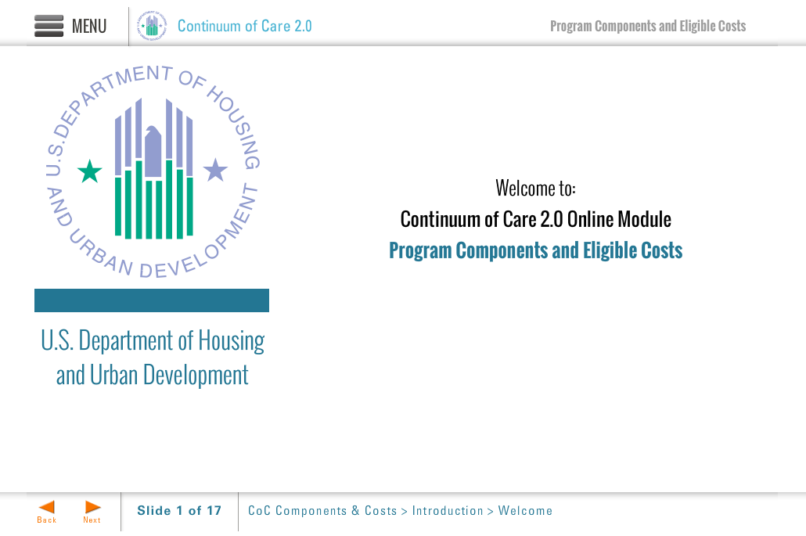
Template | Title-COC
Menu Title | Title Page
Image | ${CONTENT_ROOT}/images/slideimages/hud-logo.png
Subtitle | U.S. Department of Housing and Urban Development
Welcome Text | Welcome to:
Header Text | Continuum of Care 2.0 Online Module
Module Title | Grant Administration and Program Requirements
Notes | These will not be included in course output

Page Title
Object | Content
Layout | 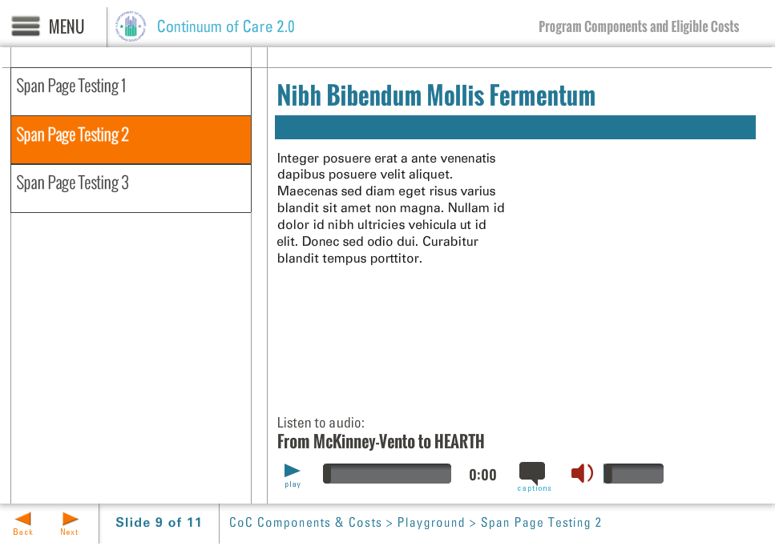
Template | S7-COC
Menu Title | Introduction
Title | Grant Administration and Program Requirements
Column 1 | Hello and welcome to this online module for the continuum of care program: Grant Administration and Program Requirements. This training module takes approximately 30 minutes to complete. The OneCPD website, http://www.onecpd.info, provides detailed information on HUD regulations specific to the CoC program.
Bullets | This online training will provide an overview of HUD requirements related to grant management 0:01  This will specifically cover topics such as the role of the Continuum of Care, or CoC, recipient, monitoring requirements, recordkeeping, and required organizational policies. 0:10
Audio File | /content/shared/audio/placeholders/placeholder.mp3
Audio Title | Hello and Welcome
Audio CC | Hello and welcome to this online module for the continuum of care program: Grant Administration and Program Requirements. This online training will provide an overview of HUD requirements related to grant management for recipients and subrecipients of HUD funding within a continuum of care, and will specifically cover topics such as the role of the Continuum of Care, or CoC, recipient, monitoring requirements, recordkeeping, and required organizational policies. Remember that your program may have additional eligibility and documentation requirements that are specific to your program. This training module takes approximately 30 minutes to complete; as such, it will provide an overview of Continuum of Care Grant Administration and Program Requirements. The OneCPD website, www.onecpd.info, provides detailed information on HUD regulations specific to the CoC program.
Notes | These will not be included in course output

Page Title
Object | Content
Layout | 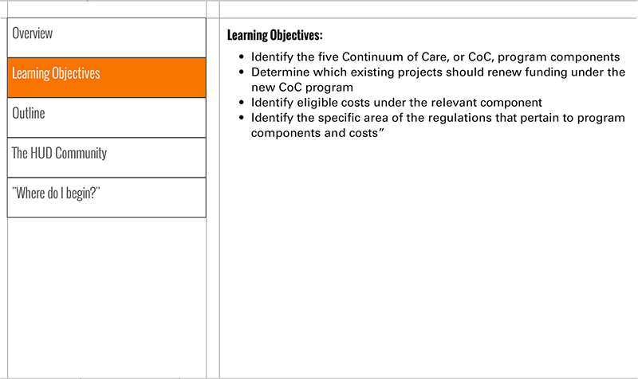
Template | S3-COC
Menu Title | Learning Objectives
Header | Learning Objectives
Body Text | Identify and understand the role/responsibilities of a recipient of funding within a CoC Program  Understand the purpose of monitoring and who is involved in the monitoring process  Describe the purpose of record keeping and the types of records that should be collected and stored  Understand the types of organizational policies a CoC program recipient is required to have
Notes | These will not be included in course output

Page Title
Object | Content
Layout | 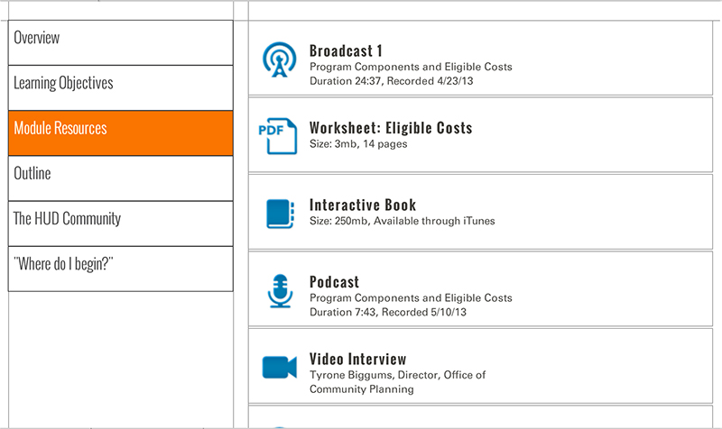
Template | S5-COC
Menu Title | Module Resources
Scrolling List | URL http://www.onecpd.info  Label OneCPD Website  Icon ${CONTENT_ROOT}/images/interactives/icons/weblink.png  Metadata OneCPD Resource Exchange  URL http://www.onecpd.info/resource/2033/hearth-coc-program-interim-rule/  Label HEARTH Interim Rule  Icon ${CONTENT_ROOT}/images/interactives/icons/weblink.png  Metadata Date Published: July 2012  URL http://www.onecpd.info/resource/2946/coc-program-grants-administration-user-guide/  Label Grants Administration User Guide  Icon ${CONTENT_ROOT}/images/interactives/icons/weblink.png  Metadata Date Published: April 2013  URL  Label  Icon  Metadata  URL  Label  Icon  Metadata
Notes | These will not be included in course output

Page Title
Object | Content
Layout | 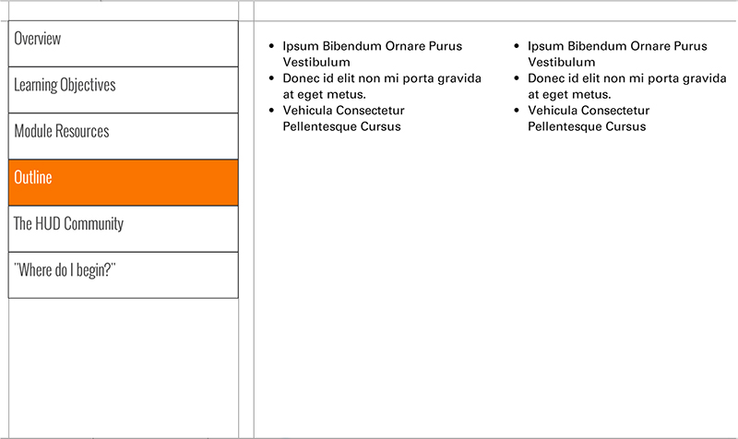
Template | S4-COC
Menu Title | Outline
Column 1 | Unit 1: Introduction  Unit 2: The Role of the CoC Recipient  Unit 3: Monitoring  Unit 4: Recordkeeping  Unit 5: Required Organizational Policies
Column 2
Notes | These will not be included in course output

Page Title
Object | Content
Layout | 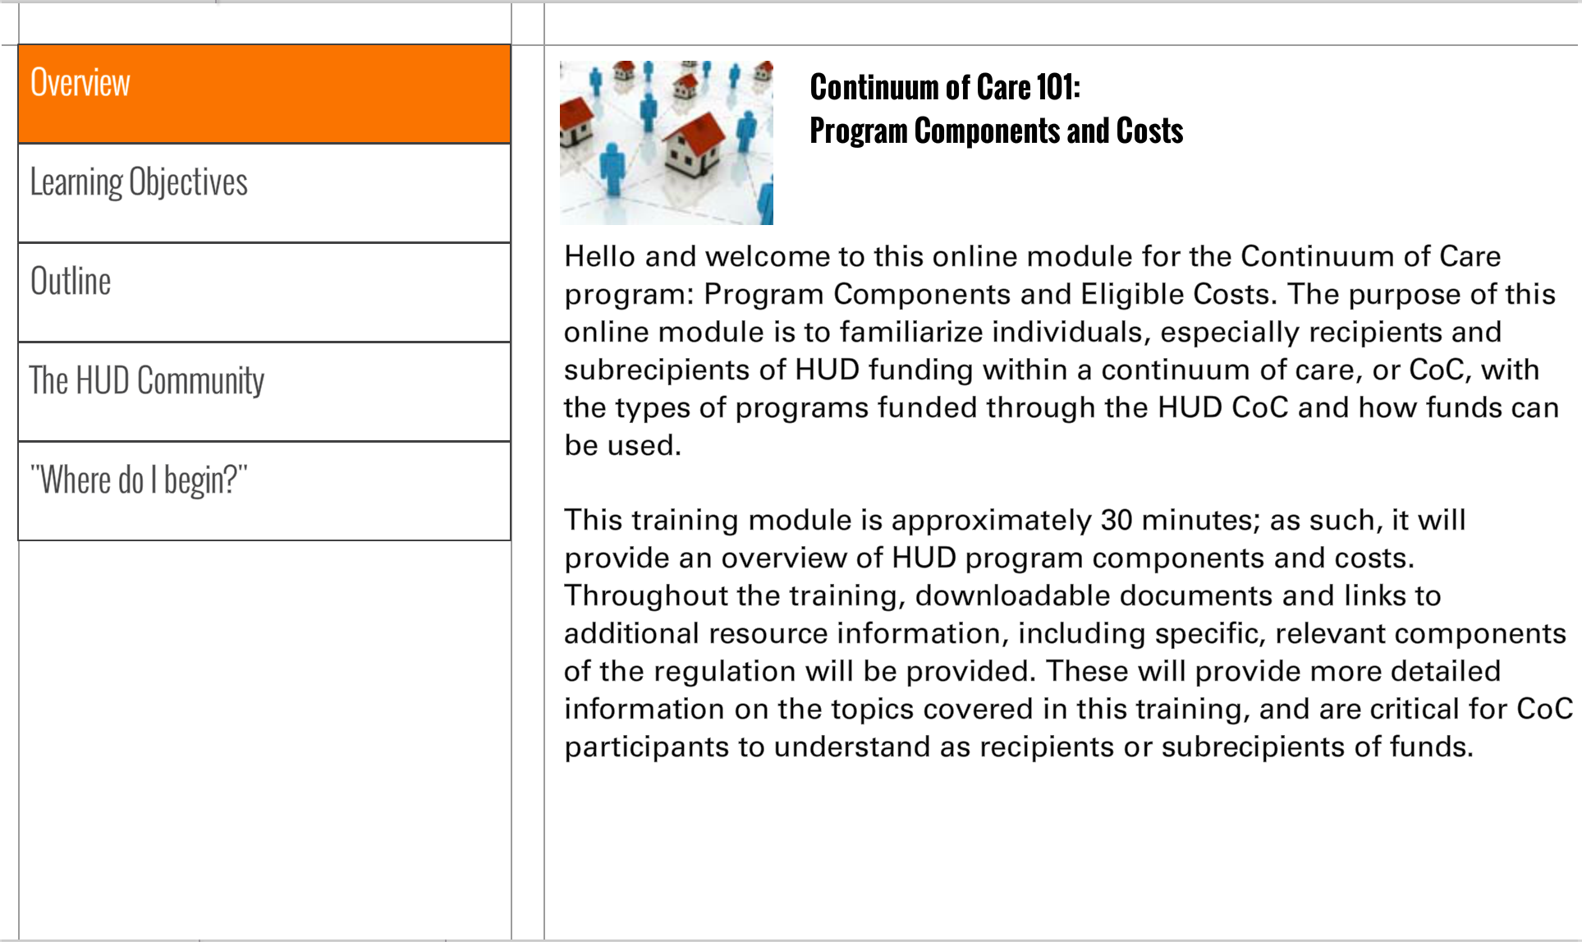
Template | S1-COC
Menu Title | The HUD Community
Image | ${CONTENT_ROOT}/images/slideimages/community-thumb.jpg
Header | U.S. Department of Housing and Urban Development's  Social Media
Body Text | Social media is an integral part of the Department of Housing and Urban Development's operations. This page is designed to help the HUD community use social media responsibly and effectively; both in official and unofficial capacities. Visit HUD's Social Media @ Facebook and Twitter for the latest on HUD-related social media activity.
Notes | These will not be included in course output

Page Title
Object | Content
Layout
Template | S1-COC
Menu Title | Where do I begin?
Image | ${CONTENT_ROOT}/images/slideimages/where-to-begin-thumb.jpg
Header | "Where Do I Begin?"
Body Text | The best way to start a course of this nature is to gain an understanding how to effectively navigate the learning environment. The navigational structure in these CoC courses includes a primary and secondary navigation. The primary navigation can be seen by clicking the list menu icon at the top left. When you click that button, the menu will appear on the left of the slide. You can click on any of the page buttons and navigate directly to the page of your choice.  The secondary navigation appears on the bottom left as "prev" and "back" buttons and allows you to move one page forwards and backwards.
Notes | These will not be included in course output

Page Title
Object | Content
Layout | 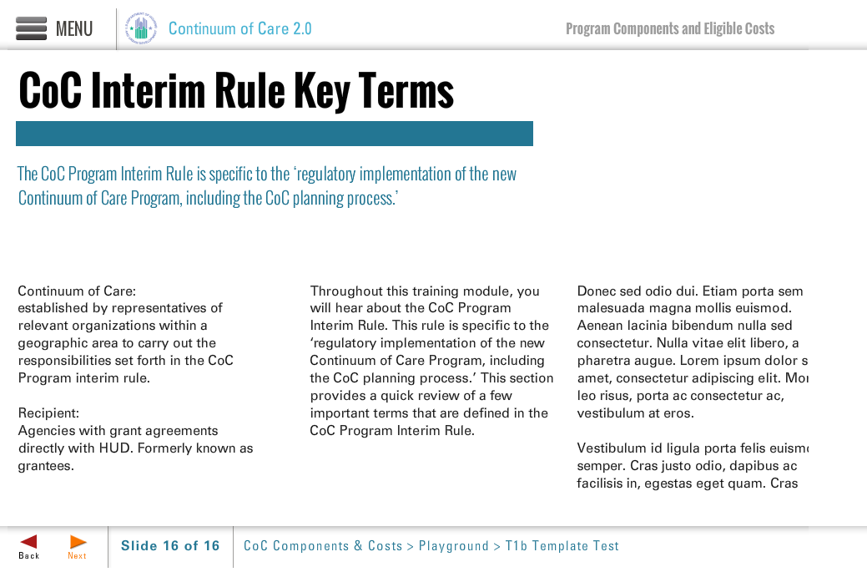
Template | T1b-COC
Menu Title | Key Terms
Title | CoC EA & PR Key Terms
Subtitle | The CoC Program interim rule offers specific terms regarding who is eligible to apply for funds and the specific roles of various entities.
Column 1 | Applicant:  Designated by the CoC to apply for funds and carry out projects  Collaborative applicant:  Designated by the CoC to submit the CoC application and apply for CoC planning funds  Unified Funding Agency (UFA):  Designated by the CoC to apply for and manage a single grant for the entire CoC
Column 2 | Recipient:  Grantee (signs grant agreement with HUD)  Subrecipient:  Project Sponsor (receives a subgrant from the recipient to operate a project)
Column 3 | Eligible entities:  private nonprofit organizations, States, local governments, public housing agencies, or instrumentalities of State and local government
Notes | Jason, the full title doesn’t fit either template Slide T1a or T1b. Suggestions?

Layout | 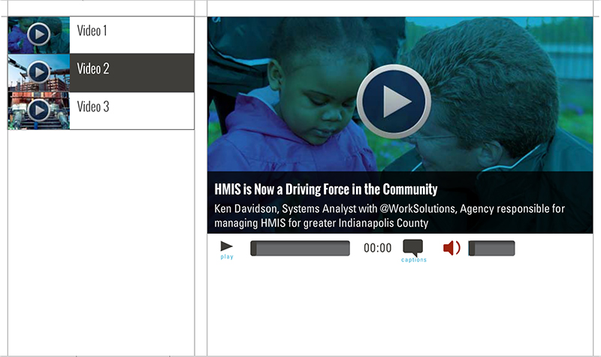
Template | V1-COC
Menu Title | Video: Collaborative Applicant
Media Playlist | Playlist Item  Media Path ${MEDIA_ROOT}/${CONTENT_ROOT}/video/videoName.f4v  Media Poster Path /content/shared/images/placeholders/placeholder.jpg  Media Thumbnail /content/shared/images/placeholders/placeholder.jpg  Media Menu Title Collaborative Applicant  Media Display Title Name of interviewee to go here  Media Description Title of interviewee to go here  Media CC Title Collaborative Applicant  Media Captions Text for Caption 1 0:00 Text for Caption 2 0:00 Text for Caption 3 0:00 Text for Caption 4 0:00 Text for Caption 5 0:00
Notes | These will not be included in course output

Object | Content
Unit Title | Unit 2: Role of Recipient
Abbreviated Title | Unit 2: RoR
Notes | These will not be included in course output

Object | Content
Layout | 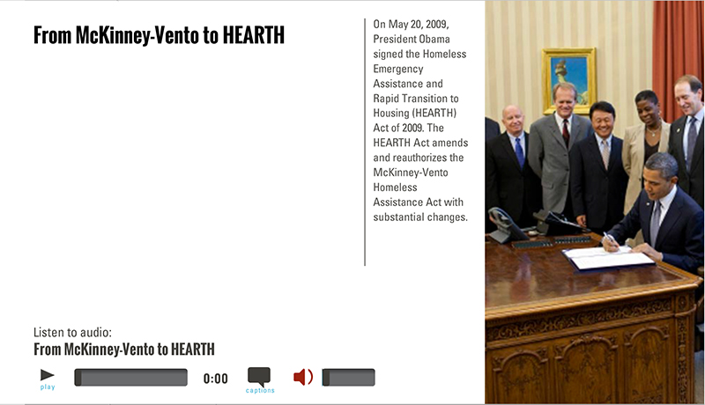
Template | A2-COC
Menu Title | Overview
Image | ${CONTENT_ROOT}/images/slideimages/coc-v-image_0025_iStock_000007690698Small.jpg
Header | Role of the Recipient
Column Text | For details see:  CoC Program interim rule Subpart C—Application and Grant Award Process  See also:  Broadcast XXXXX
Image Sequence | Image Source Time Cue Audio Cue  /content/shared/images/placeholders/placeholder.jpg 0:00
Bullets | CoC Recipient’s responsibilities include: 0:01  - Overall compliance with the CoC Program Interim Rule 0:05  - Ensuring compliance by subrecipients 0:07  - Reporting and monitoring 0:09  - Complying with all licensing requirements and housing standards 0:11
Audio File | /content/shared/audio/placeholders/placeholder.mp3
Audio Title | The Recipient’s Role in a CoC
Audio CC | A CoC project recipient has many important responsibilities, including that of overall compliance with the CoC Program Interim rule, ensuring compliance by subrecipients, reporting and monitoring, and complying with all licensing requirements and housing standards. This unit describes some of the responsibilities of recipients. Detailed information on the stages of a grant and responsibilities of various CoC Program entities are detailed in broadcast XXXXXX and are explained in CoC Program interim rule Subpart C, Application and Grant Award Process.
Notes

Page Title

Object | Content
Layout | 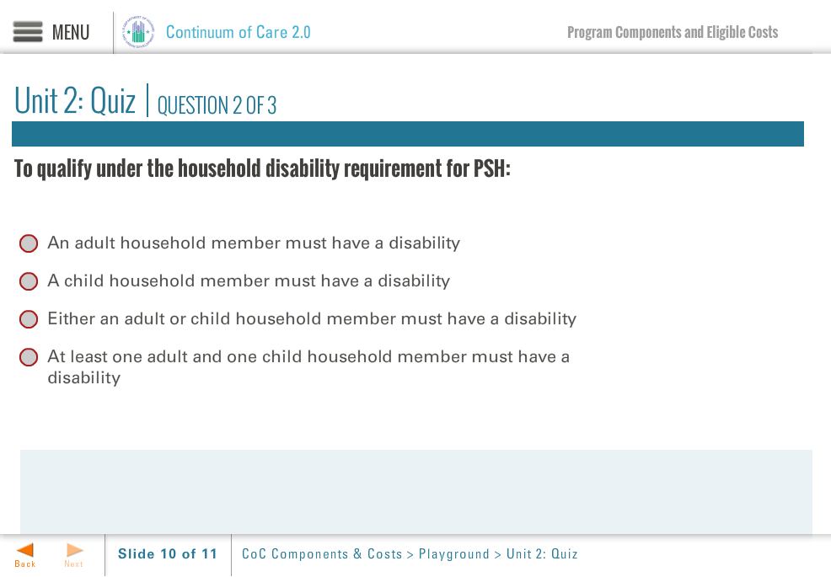
Template | Q1-COC
Menu Title | RoR Quiz
Title | Unit 2: Quiz
Quiz | Code Mode Randomize Questions Randomize Answers Points Max Attempts  quiz-1 formative false true 100 2  Question A CoC project recipient must operate the project in accordance with the CoC Program interim rule.  Correct Feedback Answer Options  true correct-fb True  false incorrect-fb False  ID Feedback Text  correct-fb Correct, the answer is True. A CoC project recipient must operate the project in accordance with the CoC Program interim rule.  incorrect-fb Incorrect  Question It is not necessary for a CoC project recipient to involve individuals and families experiencing homelessness in project operation.  Correct Feedback Answer Options  false incorrect-fb True  true correct-fb False  ID Feedback Text  correct-fb Correct, the answers is False. It is required that a CoC project recipient involve individuals and families experiencing homelessness in project operation.  incorrect-fb Incorrect  Question A CoC project recipient must use a coordinated assessment system.  Correct Feedback Answer Options  true correct-fb True  false incorrect-fb False  ID Feedback Text  correct-fb Correct, the answer is True. A CoC project recipient must use a coordinated assessment system.  incorrect-fb Incorrect
Notes | These will not be included in course output

Quiz Page Title

Page Title
Object | Content
Layout
Template | S3-COC
Menu Title | Recipient Responsibilities
Header | Compliance with Standards
Body Text | Follow written CoC standards of assistance.  Enter into subrecipient agreements requiring subrecipient to comply.  Comply with other NOFA terms or conditions.  Comply with all applicable state and local housing codes, licensing requirements, and other jurisdictional requirements.  Abide by housing quality standards and suitable dwelling size.  Comply with applicable civil rights law.
Notes | These will not be included in course output

Page Title
Object | Content
Layout
Template | S3-COC
Menu Title | Recipient Responsibilities
Header | Certification from subrecipients agreeing to:
Body Text | Maintain confidentiality of domestic violence records.  Designate staff to ensure enrollment in school and linkages of additional services for children and their families.  Document eligibility and otherwise ensure HUD reporting requirements will be met.
Notes | These will not be included in course output

Object | Content
Layout
Template | S3-COC
Menu Title | Recipient Responsibilities
Header | Monitoring
Body Text | Monitor and report project progress to CoC and HUD.  Monitor and report matching funds to HUD.  Monitor subrecipients annually.
Notes | These will not be included in course output

Object | Content
Layout
Template | S3-COC
Menu Title | Recipient Responsibilities
Header | Program implementation
Body Text | Use a coordinated assessment system.  Consider educational needs when housing families.  Assess supportive services on an ongoing basis.  Provide residential supervision.
Notes | These will not be included in course output

Layout
Template | V1-COC
Menu Title | Establishing a CoC
Media Playlist | Playlist Item  Media Path ${MEDIA_ROOT}/${CONTENT_ROOT}/video/videoName.f4v  Media Poster Path /content/shared/images/placeholders/placeholder.jpg  Media Thumbnail /content/shared/images/placeholders/placeholder.jpg  Media Menu Title Establishing a CoC  Media Display Title Speaker’s name goes here  Media Description Speaker’s job title goes here  Media CC Title Media Caption Title  Media Captions Text for Caption 1 0:00 Text for Caption 2 0:00 Text for Caption 3 0:00 Text for Caption 4 0:00 Text for Caption 5 0:00
Notes | These will not be included in course output

Object | Content
Layout
Template | A2-COC
Menu Title | Reporting
Image | ${CONTENT_ROOT}/images/slideimages/coc-v-image_0031_iStock_000005535830XSmall.jpg
Header | Reporting
Column Text | For details see:  CoC Program Interim Rule Subpart G —Grant Administration
Image Sequence | Image Source Time Cue Audio Cue  /content/shared/images/placeholders/placeholder.jpg 0:00
Bullets | Homeless Management Information System (HMIS): A community wide software program that captures client information. It must follow HUD standards for collecting, entering, and sharing data. 0:01  Annual Performance Report (APR): Due 90 days from end of program year. HUD can terminate a grant renewal if APR is late or if it is unacceptable or shows noncompliance. 0:03
Audio File | /content/shared/audio/placeholders/placeholder.mp3
Audio Title | Two Types of Reporting
Audio CC | An important part of grant management includes reporting. There are two reporting mechanisms for CoC-funded projects: the Homeless Management Information Systems (HMIS) and Annual Performance Reports (APRs).
Notes

Page Title

Page Title
Object | Content
Layout
Template | A2-COC
Menu Title | Reporting
Image | ${CONTENT_ROOT}/images/slideimages/coc-v-image_0031_iStock_000005535830XSmall.jpg
Header | Reporting allows grant recipients to:
Column Text | For details see:  CoC Program Interim Rule Subpart G —Grant Administration
Image Sequence | Image Source Time Cue Audio Cue  /content/shared/images/placeholders/placeholder.jpg 0:00
Bullets | Improve service 0:01  Track and assess outcomes 0:03  Find cost-efficiencies 0:05
Audio File | /content/shared/audio/placeholders/placeholder.mp3
Audio Title | Benefits of Reporting
Audio CC | There are many benefits of reporting, including giving HUD data to show Congress the benefit of funding CoC programs, using CoC data to strategically plan around homelessness, and for one’s own organization to attract additional investors. Most importantly, reporting allows grant recipients to improve service, track and assess outcomes, and find cost-efficiencies.
Notes

Page Title

[NOTE: Gave the above to Emily on 5-13-13 at 2:35 PM]

Object | Content
Layout
Template | A2-COC
Menu Title | Changes
Image | ${CONTENT_ROOT}/images/slideimages/coc-v-image_0031_iStock_000005535830XSmall.jpg
Header | Grant or Project Changes
Column Text | For details see:  CoC Program Interim Rule Subpart G —Grant Administration (Regulation 578.105)
Image Sequence | Image Source Time Cue Audio Cue  /content/shared/images/placeholders/placeholder.jpg 0:00
Bullets | Regulation specifies what changes are considered “significant” versus minor. Significant changes require HUD approval through a formal grant amendment. Recipient must maintain records of minor changes and HUD should be notified. 0:01
Audio File | /content/shared/audio/placeholders/placeholder.mp3
Audio Title | Communicate with HUD
Audio CC | Communication with HUD throughout the grant process is critical. This includes not only reporting, but also making HUD aware of any project changes the recipient would like to make. Rules around project changes are briefly discussed here, but please review the CoC Program Interim Rule on the OneCPD website for detailed information.
Notes

Page Title

Layout
Template | V1-COC
Menu Title | Changes
Media Playlist | Playlist Item  Media Path ${MEDIA_ROOT}/${CONTENT_ROOT}/video/videoName.f4v  Media Poster Path /content/shared/images/placeholders/placeholder.jpg  Media Thumbnail /content/shared/images/placeholders/placeholder.jpg  Media Menu Title Grant or Project Changes  Media Display Title Name of interviewee goes here  Media Description Name of interviewee’s job title goes here  Media CC Title Grant or Project Changes  Media Captions Text for Caption 1 0:00 Text for Caption 2 0:00 Text for Caption 3 0:00 Text for Caption 4 0:00 Text for Caption 5 0:00
Notes | These will not be included in course output

Page Title
Object | Content
Layout
Template | S3-COC
Menu Title | Significant Changes
Header | Significant changes for CoCs with more than one recipient
Body Text | A change of project site  Additions or deletions in eligible costs for the project  Change of recipient  A shift in a single year of more than 10% of the total grant amount from one approved budget category to another  A permanent change in the subpopulation served  A permanent reduction in the total number of units funded by the grant
Notes | These will not be included in course output

Page Title
Object | Content
Layout
Template | S3-COC
Menu Title | Significant Changes
Header | Significant changes for CoCs with only one recipient
Body Text | Change of recipient  A shift in a single year of more than 10% of the total grant amount from one approved budget category to another  A permanent change in the subpopulation served  A permanent reduction in the total number of units funded by the grant
Notes | These will not be included in course output

Object | Content
Layout
Template | Q1-COC
Menu Title | RoR Quiz
Title | Unit 2: Quiz
Quiz | Code Mode Randomize Questions Randomize Answers Points Max Attempts  quiz-1 formative false true 100 2  Question Our House Agency has decided they no longer have the capacity to administer their TH project, Transitions to Success. They have negotiated with Rescue Services to take over the CoC program grant and project for them. Does this scenario require a grant amendment?  Correct Feedback Answer Options  true correct-fb Yes  false incorrect-fb No  ID Feedback Text  correct-fb Correct, the answer is Yes. This is a change of recipient.  incorrect-fb Incorrect  Question Once they’ve taken on the grant, Rescue Services decides they need additional funds for their Case Manager than the project had before. They want to reduce the maintenance line item and increase the case management line item. To make this change, they would need to shift 17% of the total grant amount from Operating to Supportive Services. Does this scenario require a grant amendment?  Correct Feedback Answer Options  true correct-fb Yes  false incorrect-fb No  ID Feedback Text  correct-fb Correct, the answer is Yes. This is a shift in a single year of more than 10 percent of the total grant amount for one approved eligible.  incorrect-fb Incorrect  Question Rescue Services also decides that the original target population for Transitions to Success, individuals with mental illness, should be changed to better fit the needs of the CoC as identified in the latest CoC Point in Time Count. Thus, they would like to change the target population of the project to families with children that have at least one adult member with a mental illness. Does this scenario require a grant amendment?  Correct Feedback Answer Options  true correct-fb Yes  false incorrect-fb No  ID Feedback Text  correct-fb Correct, the answer is Yes. This is a permanent reduction in the total number of units funded by the grant.  incorrect-fb Incorrect  Question No action is needed for changes that are not considered “significant.”  Correct Feedback Answer Options  false incorrect-fb True  true correct-fb False  ID Feedback Text  correct-fb Correct, the answer is False. Any insignificant or minor change must be fully documented in the recipient’s or subrecipient’s records, and the recipient should notify HUD of the change.  incorrect-fb Incorrect
Notes | Jason – how do we kick the quiz answer choices down in order to accommodate longer question text?

Quiz Page Title

Object | Content
Unit Title | Unit 3: Monitoring
Abbreviated Title | Unit 3: Monitoring
Notes | These will not be included in course output

Object | Content
Layout
Template | A2-COC
Menu Title | Monitoring
Image | ${CONTENT_ROOT}/images/slideimages/coc-v-image_0029_iStock_000006023013Small.jpg
Header | Monitoring as Program Management
Column Text | For details see:  CoC Program interim Rule Subpart G — Grant Administration (Regulation 578.107)
Image Sequence | Image Source Time Cue Audio Cue  /content/shared/images/placeholders/placeholder.jpg 0:00
Bullets | Two types of monitoring: program and financial 0:01  Monitoring helps to: 0:05  - Assess effectiveness 0:07  - Identify concerns 0:09  - Surface the need for grant amendments 0:11  - Ensure effective service provision 0:13
Audio File | /content/shared/audio/placeholders/placeholder.mp3
Audio Title | Why Monitor?
Audio CC | Monitoring is a key piece of program management. Each recipient must engage in program monitoring and financial monitoring to make sure that they are fulfilling contractual requirements and meeting performance goals. Monitoring will also help recipients assess effectiveness, identify concerns, prompt the need to submit grant amendments, and make other adjustments to ensure effective service provision.
Notes

Page Title

Page Title
Object | Content
Layout
Template | S3-COC
Menu Title | Who Monitors Whom?
Header | Who Monitors Whom?
Body Text | HUD monitors recipients  Recipients monitor subrecipients  The CoC monitors recipients and subrecipients  Recipients and subrecipients should monitor themselves internally
Notes | These will not be included in course output

Page Title
Object | Content
Layout
Template | S3-COC
Menu Title | Who Monitors Whom?
Header | Monitoring by HUD
Body Text | HUD monitors recipients for compliance with Grant Agreement and CoC Program interim rule.  HUD will verify records and information submitted to HUD in reports, will examine information from on-site monitoring, audit reports, and information generated from HMIS and HUD’s financial and reporting systems and HUD’s financial and reporting systems (e.g., LOCCS and e-snaps).  After completing the monitoring, HUD will send written correspondence to recipients regarding the results.  Note: HUD may or may not give advance notice that they will be performing monitoring or giving a performance review.
Notes | These will not be included in course output

Page Title
Object | Content
Layout
Template | S3-COC
Menu Title | Who Monitors Whom?
Header | Fiscal and financial Monitoring by Unified Financial Agency (UFA)
Body Text | UFA maintains capacity and fiscal control to disperse federal funds to projects sponsors in accordance with generally accepted accounting principles.  UFA conducts an annual survey, audit or evaluation of financial records of each project.
Notes | These will not be included in course output

Page Title
Object | Content
Layout
Template | S3-COC
Menu Title | Who Monitors Whom?
Header | Monitoring of subrecipients by recipients
Body Text | Recipients are required to monitor subrecipients at least annually.  Recipients must keep documentation of subrecipient monitoring, including findings and required corrective actions.  Allowable remedial actions/sanctions outlined in CoC Program interim rule.  Note: Recipients and subrecipients should monitor themselves for grant compliance with programmatic and financial requirements.
Notes | These will not be included in course output

Page Title
Object | Content
Layout | 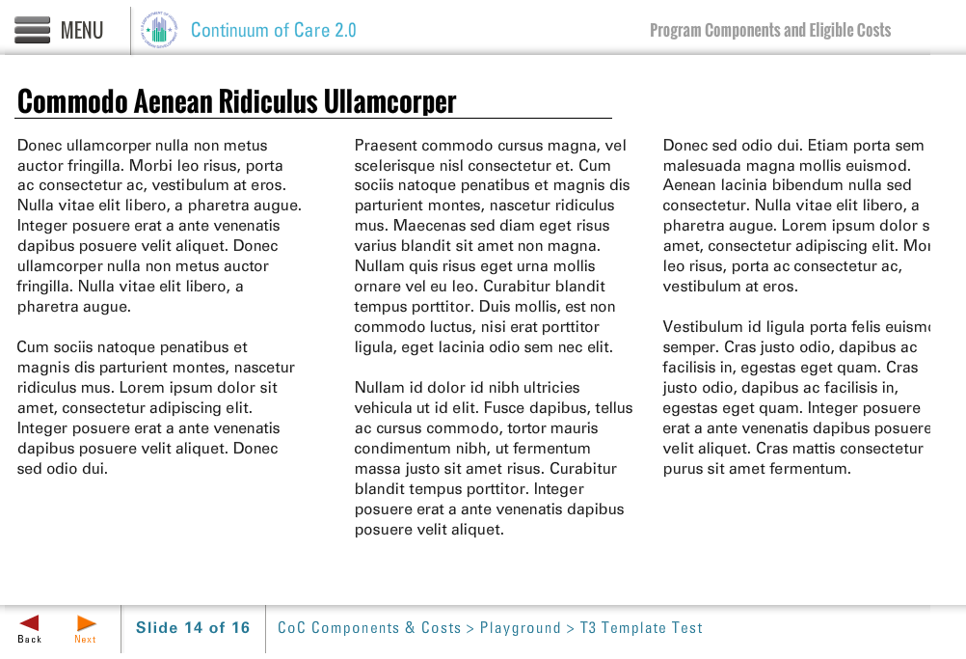
Template | T3-COC
Menu Title | Findings
Title | Findings After a Monitoring Visit
Column 1 | When HUD has a concern, they will bring it to the recipient’s attention and will make recommendations about how to correct the issue.  The finding requires a corrective action within a prescribed timeline.  Note: Do NOT ignore findings – ask for help if necessary. If not corrected, funds may be deobligated.
Column 2 | The CoC must monitor recipients’ progress and performance across:  - The Continuum on HUD indicators  - Additional locally-defined indicators
Column 3 | Performance results are reported to HUD.
Notes | These will not be included in course output

Page Title
Object | Content
Layout
Template | T3-COC
Menu Title | Findings
Title | Examples of past HUD performance indicators
Column 1 | 77% of participants remained housed in HUD PH for at least 6 months  65% of participants exit TH to PH  20% of participants exit employed  Participants use mainstream resources
Column 2
Column 3
Notes | These will not be included in course output

Object | Content
Layout
Template | Q1-COC
Menu Title | Quiz
Title | Unit 3: Quiz
Quiz | Code Mode Randomize Questions Randomize Answers Points Max Attempts  quiz-1 formative false true 100 2  Question Who monitors recipients for compliance with Grant Agreement and CoC Program interim rule?  Correct Feedback Answer Options  true correct-fb HUD  false incorrect-fb Subrecipients  false incorrect-fb The COC  false incorrect-fb Other recipients (peer monitoring)  ID Feedback Text  correct-fb Correct, the answer is HUD. HUD monitors recipients for compliance with Grant Agreement and CoC Program interim rule.  incorrect-fb Incorrect  Question When HUD has a concern after monitoring, and they bring the findings to the recipient’s attention, it is okay to ignore these findings, as they are only suggestions.  Correct Feedback Answer Options  false incorrect-fb True  true correct-fb False  ID Feedback Text  correct-fb Correct, the answer is False. Findings require a corrective action within a prescribed timeline; if not corrected, funds may be deobligated.  incorrect-fb Incorrect  Question HUD will always give advance notice that they will be performing monitoring or giving a performance review.  Correct Feedback Answer Options  false incorrect-fb True  true correct-fb False  ID Feedback Text  correct-fb Correct, the answer is False. HUD may or may not give advance notice that they will be performing monitoring or giving a performance review.  incorrect-fb Incorrect  Question Recipients are required to monitor subrecipients at least monthly.  Correct Feedback Answer Options  false incorrect-fb True  true correct-fb False  ID Feedback Text  correct-fb Correct, the answer is False. Recipients are required to monitor subrecipients at least annually.  incorrect-fb Incorrect
Notes | These will not be included in course output

Quiz Page Title

[gave the above to Emily at EOD 5-13-13]

Object | Content
Unit Title | Unit 4: Recordkeeping
Abbreviated Title | Unit 4: Recordkeeping
Notes | These will not be included in course output

Object | Content
Layout
Template | A2-COC
Menu Title | About Recordkeeping
Image | ${CONTENT_ROOT}/images/slideimages/coc-v-image_0017_iStock_000013964682Small.jpg
Header | Recordkeeping for CoC Projects
Column Text | For details see:  CoC Interim Rule Subpart G — Grant Administration (Regulation 578.103)
Image Sequence | Image Source Time Cue Audio Cue  /content/shared/images/placeholders/placeholder.jpg 0:00
Bullets | Advantages of Recordkeeping: Documentation tracks success. Helps the application process and reporting to funders. 0:01  Who Keeps Records? CoC project recipients who work with HUD. Subrecipients who operate the program. 0:05  Recordkeeping Includes: Documenting what is done. Maintaining access to documentation. Annual monitoring for compliance. 0:09
Audio File | /content/shared/audio/placeholders/placeholder.mp3
Audio Title | Keep Careful Documentation
Audio CC | A key piece of overall program management is documentation. It allows you to track what works and what does not, enables you to measure the services provided, and makes it easier and quicker to apply and report to funders. Keep in mind that this is relevant for the recipient – who works directly with HUD – as well as the project subrecipients who are operating the program. Everyone has to participate and support the effort, especially for the activities for which they are responsible! Recordkeeping includes documenting what you do, keeping it on file, and monitoring annually for compliance.
Notes

Page Title
Object | Content
Layout
Template | T3-COC
Menu Title | Recordkeeping Requirements
Title | Recordkeeping requirements
Column 1 | Recordkeeping requirements for CoC recipients include:  Obtain documentation from qualified sources.  Maintain the records in your files.  Monitor at least annually for compliance.
Column 2 | Additional documentation is required for participants who pay rent or occupancy charge, or who receive rapid re-housing.  Participants who pay rent or occupancy charge:  At least annually, document participant’s income, rent and/or occupancy charge calculations.  Recipients of rapid re-housing:  At least annually, re-evaluate the participant’s eligibility and the amount and types of assistance needed to retain housing.
Column 3
Notes | These will not be included in course output

Drag and Drop
Object | Content
Layout | 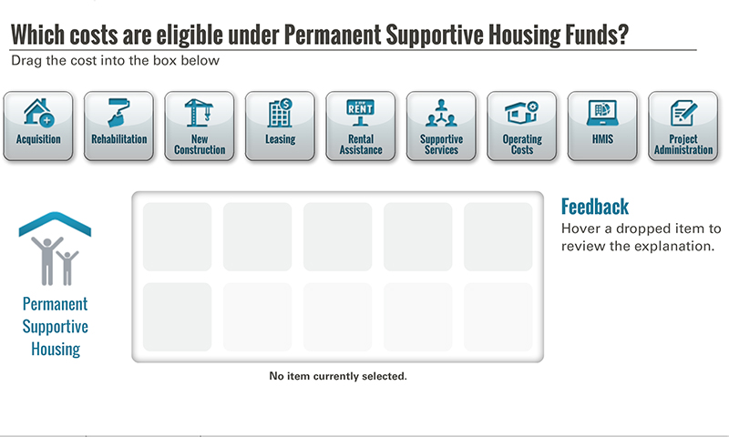
Template | D1-COC
Menu Title | Recordkeeping Activity
Drag and Drop | Drag and Drop Static Components  Activity Title Which items require recordkeeping under the CoC?  Activity Prompt Drag the item into the box below  Feedback Title Feedback  Default Feedback Hover a dropped item to review the explanation.  Default Status No item currently selected.  Activity Graphic ${CONTENT_ROOT}/images/interactives/icons/record-keeping.png  Activity Graphic Label Recordkeeping  Drag and Drop Item 1  Label Homeless Status  Icon Path ${CONTENT_ROOT}/images/interactives/_0005_Vector-Smart-Object.png  Feedback For all CoC projects, recipients or subrecipients must document that participants meet the HUD criteria of homelessness, or at risk of homelessness for high-performing community prevention projects.  Status Record whether a person is homeless or at risk of homelessness.  Correct true  Drag and Drop Item 2  Label Disability Status  Icon Path ${CONTENT_ROOT}/images/interactives/_0004_Vector-Smart-Object.png  Feedback The recipient needs to document eligibility criteria, such as disability of participants in Permanent Supportive Housing projects.  Status Recording a person’s disability status is required under the CoC.  Correct true  Drag and Drop Item 3  Label Threat of Harm  Icon Path ${CONTENT_ROOT}/images/interactives/_0003_Vector-Smart-Object.png  Feedback A CoC project must document when it provides funding assistance for someone who has been placed in a different CoC geographic area due to imminent threat of further domestic violence, dating violence, sexual assault, or stalking.  Status Documentation should occur when project participants are believed to be in imminent threat of harm.  Correct true  Drag and Drop Item 4  Label Services Provided  Icon Path ${CONTENT_ROOT}/images/interactives/_0002_Vector-Smart-Object.png  Feedback The recipient or subrecipient must maintain records for each program participant that document the services and assistance provided to that participant.  Status CoC projects should keep a record of services provided to each participant.  Correct true  Drag and Drop Item 5  Label Annual Assessment of Services  Icon Path ${CONTENT_ROOT}/images/interactives/_0001_Vector-Smart-Object.png  Feedback Recipients and subrecipients should have evidence that an annual assessment of services has been conducted for those program participants that remain in the program for more than a year. The project should adjust the service package accordingly.  Status Annual assessment of services should be clearly documented.  Correct true  Drag and Drop Item 6  Label Termination of Assistance  Icon Path ${CONTENT_ROOT}/images/interactives/_0000_Vector-Smart-Object.png  Feedback If a CoC Program participant is terminated from the project, the recipient must maintain records that the project complied with termination requirements.  Status The CoC project should clearly document termination of assistance.  Correct true
Notes | These will not be included in course output

Object | Content
Unit Title | Unit 5: Required Organizational Policies
Abbreviated Title | Unit 5: Required Organizational Policies
Notes | These will not be included in course output

Object | Content
Layout
Template | A2-COC
Menu Title | Establishing Requirements
Image | ${CONTENT_ROOT}/images/slideimages/coc-v-image_0026_iStock_000007565657XSmall.jpg
Header | Required Organizational Policies
Column Text | For details see:  CoC Program interim Rule Subpart F —Program Requirements
Image Sequence | Image Source Time Cue Audio Cue  /content/shared/images/placeholders/placeholder.jpg 0:00
Bullets | Establish policies for ensuring that CoC Program funds are used appropriately. 0:01  Document compliance with the general organizational requirements specified in the CoC Program interim rule. 0:03
Audio File | /content/shared/audio/placeholders/placeholder.mp3
Audio Title | Establishing Organizational Policies
Audio CC | The recipient and its subrecipients must establish policies for ensuring that CoC Program funds are used appropriately and they must document compliance with the general organizational requirements specified in the CoC Program interim rule.
Notes

Page Title

Object | Content
Layout
Template | A2-COC
Menu Title | Conflict of Interest
Image | ${CONTENT_ROOT}/images/slideimages/coc-v-image_0007_donovan-fenty-p.jpg
Header | Avoid Conflicts of Interest
Column Text
Image Sequence | Image Source Time Cue Audio Cue  /content/shared/images/placeholders/placeholder.jpg 0:00
Bullets | Avoid conflicts of interest by ensuring people with decision-making power do not gain from a CoC grant. 0:01  Conflicts of interest exist for decision-makers, their family members, partners, and those they employ. 0:03
Audio File | /content/shared/audio/placeholders/placeholder.mp3
Audio Title | What is Conflict of Interest?
Audio CC | What is individual conflict of interest? Simply put, people in decision-making positions in an organization cannot obtain personal benefit or gain from the CoC grant. This continues for one year after the position has ended and includes the person, their family members, partner or those they employ.
Notes

Page Title

Object | Content
Layout
Template | A2-COC
Menu Title | Conflict of Interest
Image | /content/shared/images/placeholders/placeholder.jpg
Header | Write a Conflict of Interest Policy
Column Text
Image Sequence | Image Source Time Cue Audio Cue  /content/shared/images/placeholders/placeholder.jpg 0:00
Bullets | Organizational conflicts of interest: An agency representative cannot make funding decisions that involve his or her agency. An employee cannot determine rent or HQS for property his or her agency owns. 0:01  Individual conflicts of interest: Agency decision makers cannot obtain personal benefit or gain from CoC Program funds. 0:07  HUD can grant exceptions. 0:11
Audio File | /content/shared/audio/placeholders/placeholder.mp3
Audio Title | Two Types of Conflict of Interest
Audio CC | The first policy that every CoC-funded project needs to have on the books is a written conflict of interest policy.  The CoC program distinguishes between two types of conflict of interest; one related to organizations (both recipients and subrecipients) that carry out the project, and the other for individuals involved in implementing the program. Depending upon the circumstances, HUD can grant exceptions for individuals or organizations.
Notes

Page Title

Page Title
Object | Content
Layout
Template | T3-COC
Menu Title | Conflict of Interest Quiz
Title | Quiz: A Scenario
Column 1 | The CoC for the city of “Sunny Street” has selected the review committee for the six applications that were submitted, including Bigfund’s new PH project. The review committee will be voting to determine the applications that will be submitted for funding in the new CoC Program competition. The chair of the committee is Ms. Green, a Bigfund board member who was certain to exclude all employees from the review process to avoid any conflict of interest.
Column 2 | Before starting the ranking process, Ms. Green asked the group if there was anyone with a known conflict of interest. One person raised their hand, stating that they were not comfortable with Ms. Green participating in discussions or voting, knowing she was a board member of Bigfund.
Column 3 | As a participant in the review process and a current Bigfund board member, does Ms. Green represent a conflict of interest?  Click forward to find out.
Notes | These will not be included in course output

Object | Content
Layout
Template | Q1-COC
Menu Title | Conflict of Interest Quiz
Title | Unit 5: Quiz
Quiz | Code Mode Randomize Questions Randomize Answers Points Max Attempts  quiz-1 formative false true 100 2  Question As a participant in the review process and a current Bigfund board member, does Ms. Green represent a conflict of interest?  Correct Feedback Answer Options  false incorrect-fb a) No, there is no conflict of interest  false incorrect-fb b) Yes, but only in voting, not in the discussion  true correct-fb c) Yes, the board member should not participate in the discussion or vote  ID Feedback Text  correct-fb Correct, the answer is C. The CoC Program interim rule specifically calls out this example. “Such an organizational conflict would arise when a board member of an applicant participates in decision of the applicant concerning the award of a grant, or provision of other financial benefits, to the organization that such member represents.” [24 CFR part 587.95]  incorrect-fb Incorrect
Notes | These will not be included in course output

Quiz Page Title

Page Title
Object | Content
Layout
Template | S3-COC
Menu Title | More Organizational Policies
Header | Requiring Participation in Services
Body Text | Recipients may require participation in supportive services as long as services are not disability-related.  For example, if the purpose of the project is the provision of substance abuse services, recipients may require participation in the services as a condition of the project participation.  If the program purpose is not substance abuse treatment, however, recipients cannot require treatment as a condition of occupancy.
Notes | These will not be included in course output

Page Title
Object | Content
Layout
Template | T3-COC
Menu Title | Other Federal Requirements
Title | Other Federal Requirements
Column 1 | The CoC program is governed by several statutory and regulatory requirements that regulate most HUD programs. Recipients and subrecipients must ensure that they comply with these provisions when they advertise their units, rehabilitate their properties, and administer their programs.
Column 2 | Examples include:  - Nondiscrimination and Equal Opportunity  - Transparency Act Reporting  - Uniform Administrative Requirements  - Environmental Review  - Davis-Bacon Act  - Coastal Barrier Resources Act of 1982  - Procurement of Recovered Materials  - Audit Requirements
Column 3
Notes | These will not be included in course output

Page Title
Object | Content
Layout
Template | T1b-COC
Menu Title | Thank You
Title | Thank You
Subtitle | This concludes the online training module on the CoC Program: Grant Administration and Program Requirements.
Column 1 | This training provided information on Grant Administration and Program Requirements of the CoC Program. Please be sure to review the other training resources on the One CPD Resource Exchange to ensure that you are aware of and able to comply with the complete array of CoC program requirements. Also visit the CoC Program Grants Administration User Guide.
Column 2
Column 3
Notes | These will not be included in course output

